UNITED STATES

SECURITIES AND EXCHANGE COMMISSION

Washington, DC 20549

SCHEDULE 14A

PROXY STATEMENT PURSUANT TO SECTION 14(a)

OF THE SECURITIES EXCHANGE ACT OF 1934
(Amendment No. )

Filed by the Registrant Filed by a Party other than the Registrant
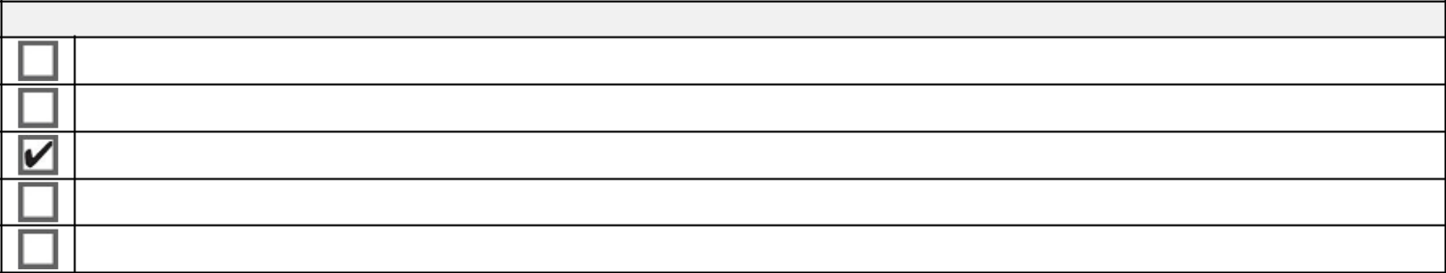

Check the appropriate box:

Preliminary Proxy Statement

Confidential, for Use of the Commission Only (as permitted by Rule 14A-6(E)(2))

Definitive Proxy Statement

Definitive Additional Materials

Soliciting Material under §240.14a-12

Middleby Corp.


(Name of Registrant as Specified in Its Charter)

(Name of Person(s) Filing Proxy Statement, if other than the Registrant)
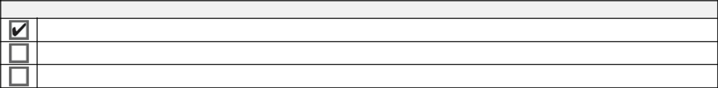

Payment of Filing Fee (Check all boxes that apply):

No fee required.

Fee paid previously with preliminary materials.

Fee computed on table in exhibit required by Item 25(b) per Exchange Act Rules 14a-6(i)(1) and 0-11.

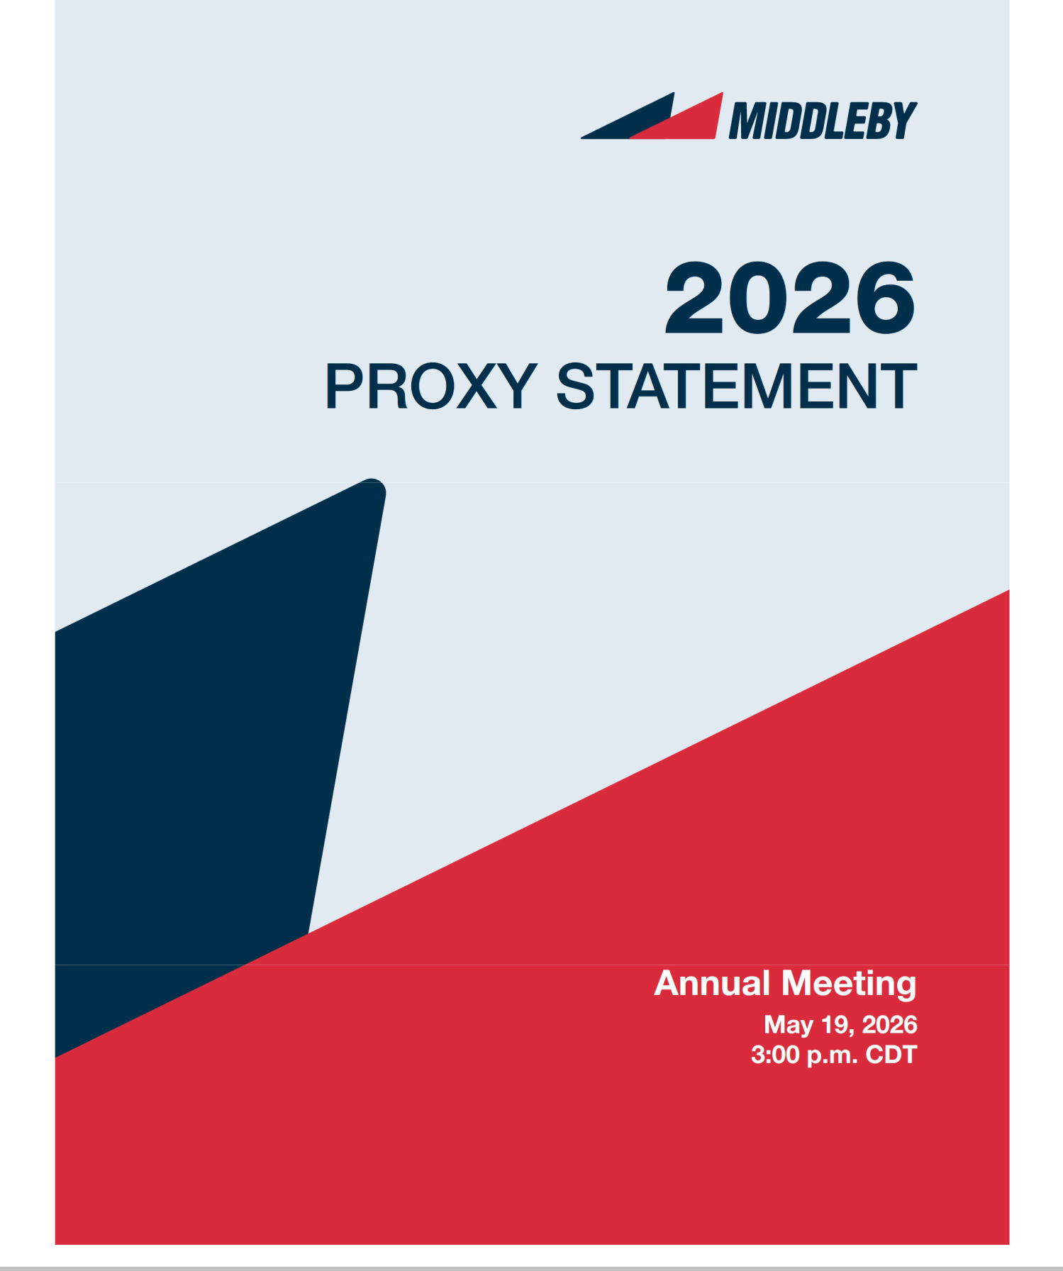

This is Middleby

Middleby is a global leader in the foodservice industry. The company develops and manufactures a broad line of solutions used in commercial foodservice and food processing. Middleby showcases its advanced solutions in the Middleby Innovation Kitchens for commercial foodservice, and industrial baking and protein Innovation Centers for food processing solutions.

We are committed to delivering new, innovative solutions to the markets we serve, which are quickly evolving in both of our business segments. These innovations deliver speed, versatility, automation, safety, energy savings and other sustainable operating benefits to our customers.

While we are dedicated to our global customer base, Middleby also prioritizes connecting with the communities where we live and work through philanthropic efforts and sustainable initiatives. We endeavor to set the standard for tomorrow, with a goal of serving excellence in everything we do today.

Commercial Foodservice


Middleby is the worldwide leader in innovative solutions for commercial foodservice. We develop and manufacture advanced cooking, warming, and beverage equipment, along with innovative IoT and automation solutions to enhance operations for commercial foodservice operators. Middleby brands can be found in a wide array of foodservice businesses, including quick service, fast casual, pizza, independent restaurants, casual and fine dining establishments, grocery and convenience stores and institutional commissaries and stadiums.

Food Processing


Middleby develops innovative, industry-leading solutions for industrial protein processing, high-volume baking, snack food, packaging and other specialty areas where automated and large scale food production is required. With a broad offering of highly respected brands and advanced technologies, Middleby has the ability to fully integrate a wide array of total line solutions to deliver efficiency, flexibility, quality and consistency.


May 19, 2026

3:00 p.m. CDT

Virtual Meeting

www.virtualshareholdermeeting.com/MIDD2026


The Annual Meeting of Stockholders of The Middleby Corporation will be held for the following purposes:

AGENDA

- To elect eleven directors to hold office until the 2027 Annual Meeting.

- To approve, on an advisory basis, the compensation of our named executive officers.

- To ratify the selection of Ernst & Young LLP as Middleby’s independent registered public accountants for the fiscal year ending January 2, 2027.

- To transact such other business as may properly come before the Annual Meeting or any adjournment or postponement thereof.

RECORD DATE:

March 20, 2026

By Order of the Board of Directors

Michael D. Thompson

General Counsel and Secretary

NOTICE


of Annual Meeting of Stockholders

WHO MAY VOTE:

Your vote is important to us. Even if you plan to attend the Annual Meeting virtually, we urge you to return your proxy promptly. For more information about how to vote, please see “Information About the Annual Meeting,” which begins on page 58.

HOW TO ATTEND:

To attend and register for the virtual meeting, please see “Information About the Annual Meeting,” which begins on page 58.

DELIVERY OF ANNUAL MEETING MATERIALS:

The Notice of Internet Availability of Proxy Materials, this Proxy Statement, and Middleby’s Annual Report on Form 10-K for the fiscal year ended January 3, 2026, are being distributed or made available to stockholders on or about April 8, 2026.


We are holding the Annual Meeting virtually. In order to attend and participate in the Annual Meeting, you will need the 16-digit control number included on your Notice of Internet Availability of Proxy Materials, proxy card, or voting instruction card. You may also ask questions and vote online by following the instructions provided at www.virtualshareholdermeeting.com/MIDD2026 during the Annual Meeting. A list of stockholders entitled to vote at the annual meeting will be available for stockholders as of the record date upon request by sending an email to legal@middleby.com.

REVIEW YOUR PROXY STATEMENT
AND VOTE IN ONE OF FOUR WAYS:
Please refer to the enclosed proxy materials or the | INTERNET | BY TELEPHONE | BY MAIL | IN PERSON
information forwarded by your bank, broker or other holder | Visit the website | Call the telephone | Sign, date and | Attend the annual
of record to see which voting methods are available to you. | on your proxy card. | number on | return your | meeting virtually.
 |  | your proxy card. | proxy card in the | See page 58 for
 |  |  | enclosed envelope. | instructions on how
 |  |  |  | to attend.
 |  |  | 2026 PROXY STATEMENT |  | 3





TABLE OF

CONTENTS

Proxy Summary | 5
Proposal 1: Election of Directors | 16
How We Select Directors | 16
Director Nominees | 17
Governance | 23
Board Leadership Structure | 23
Independence | 23
Risk Oversight | 23
Annual Board Evaluation and Skillset Assessment | 24
Stockholder Engagement | 24
Director Onboarding and Continuing Education | 24
Succession Planning | 25
Board Meetings | 25
Committees of the Board | 25
Service on Other Boards | 26
Age and Term Limits | 26
Stockholder Communications With the Board | 26
Related Party Transactions | 27
Governance Documents | 27
Director Compensation | 27
Sustainability | 29
Executive Officers | 31
Proposal 2: Advisory Vote to Approve Named Executive Officer Compensation | 32
Vote Required for Approval; Board Recommendation | 32
Executive Compensation | 33
Compensation Discussion and Analysis | 33
Report of the Compensation Committee of the Board of Directors | 42
Executive Compensation Tables | 43
Security Ownership of Certain Beneficial Owners and Management | 54
Proposal 3: Ratification of Selection of Independent Registered Public Accountants | 56
Vote Required for Approval; Board Recommendation | 56
Report of the Audit Committee | 57
Information About the Annual Meeting | 58
Annex A - Non-GAAP Financial Measures | 60
2026 PROXY STATEMENT |  | 4


Back to Contents

Proxy Summary

THIS SUMMARY HIGHLIGHTS CERTAIN INFORMATION FROM THIS PROXY STATEMENT, BUT DOES NOT CONTAIN ALL THE INFORMATION THAT YOU SHOULD CONSIDER. PLEASE READ THE ENTIRE PROXY STATEMENT BEFORE VOTING YOUR SHARES. FOR MORE COMPLETE INFORMATION REGARDING MIDDLEBY’S 2025 PERFORMANCE, PLEASE REVIEW OUR ANNUAL REPORT ON FORM 10-K FOR THE FISCAL YEAR ENDED JANUARY 3, 2026.




WHEN | WHERE | RECORD DATE
Tuesday, May 19, 2026, | Virtual Meeting | March 20, 2026
at 3:00 p.m. (CDT) | www.virtualshareholdermeeting.com/
 | MIDD2026

Meeting Agenda

The matters we will act upon at the Annual Meeting are:
 | Board voting | Where to find
Proposal | recommendation | more information
Elect eleven directors for a one-year term | FOR | Page 16
Elect eleven directors for a one-year term | each nominee | Page 16
Approve, on an advisory basis, the compensation of Middleby’s named executive officers | FOR | Page 32
Ratify the selection of Ernst & Young LLP as Middleby’s independent registered public accounting | FOR | Page 56
firm for fiscal year 2026 | FOR | Page 56


What’s

New?

In February 2026, we completed the divestiture of a majority interest in our residential kitchen equipment business segment (the “Residential Transaction”), as part of our broader portfolio transformation into a pure-play commercial foodservice equipment company. At the closing of the Residential Transaction, we received net cash proceeds of approximately $565 million and a $135 million promissory note, subject to future closing adjustments. This strategic transaction will enhance our ability to invest in organic growth and innovation opportunities and return capital to our shareholders. Following completion of the Residential Transaction, we retain a 49% noncontrolling interest in the new standalone joint venture holding the business and will have continuing involvement with the business through various commercial arrangements, including by supporting pursuant to which we will support the joint venture on a transitional basis.

We published our 2025 Sustainability Metrics Update showcasing our commitment to iteratively improve our data collection methods to provide data to stakeholders.

We expanded the breadth and depth of our Board of Directors by adding two new directors in 2026 with experience in driving stockholder value via strategic and financial planning and execution and by augmenting organic growth via sales and operational enhancements. In 2025, we added two new directors with similar experience in augmenting organic growth via sales and operational enhancements as well as driving stockholder value via strategic and financial planning and execution. In 2024, we added two new directors with experience in financial execution, technology innovation, acquisition, and cybersecurity.

We continue to expand our robust information security training and compliance program for all new and existing employees. Our Audit Committee oversees the Company’s cybersecurity and information security program and receives periodic updates from senior management on cybersecurity and information security matters.

We hope our proxy statement continues to demonstrate our commitment to transparency and responsiveness to the expectations and needs of all of our stakeholders.

2026 PROXY STATEMENT | 5

Back to Contents

Director Nominees

 |  |  | Director
Name | Occupation | Age | since | Independent Committees
 |  |  |  | • Compensation
Julie M. Bowerman | Former Chief Marketing Officer at Kellanova | 57 | 2025 | • | Nominating and Corporate
 |  |  |  |  | Governance
Sarah Palisi Chapin | Principal of Chapin Creative, LLC | 64 | 2013 | • | Nominating and Corporate
 |  |  |  |  | Governance (chair)
Glenn A. Eisenberg | Former EVP and CFO of Laboratory Corporation | 64 | 2026 | • Nominating and Corporate
Glenn A. Eisenberg | of America Holdings | 64 | 2026 |  | Governance
Timothy J. FitzGerald | Chief Executive Officer of The Middleby | 56 | 2019
Timothy J. FitzGerald | Corporation | 56 | 2019
 |  |  |  | • Compensation
Edward P. Garden | Chairman and CEO of Garden Investments | 64 | 2025 | • Nominating and Corporate
 |  |  |  |  | Governance
Christopher M. Hix | Former EVP and CFO of Enovis Corporation | 64 | 2026 | • Audit*
 | President and Chief Executive Officer of Cross |  |  | • | Audit (chair)*
Cathy L. McCarthy | President and Chief Executive Officer of Cross | 78 | 2015 | • Nominating and Corporate
Cathy L. McCarthy | Tack Consulting, Inc. | 78 | 2015
 | Tack Consulting, Inc. |  |  |  | Governance
Robert A. Nerbonne | Former CEO and President of multiple | 68 | 2019 | • | Nominating and Corporate
Robert A. Nerbonne | commercial foodservice equipment companies | 68 | 2019 |  | Governance
Gordon J. O’Brien | Managing Partner at Cannon Capital | 60 | 2005 | • Compensation
Chairman of the Board
Stephen R. Scherger | Executive Vice President and Chief Financial | 61 | 2024 | • | Audit*
Stephen R. Scherger | Officer of Amcor plc | 61 | 2024 | • | Compensation (chair)
Tejas P. Shah | Chief Executive Officer of Palo Alto Labs | 46 | 2024 | • | Audit*


- Audit Committee Financial Expert
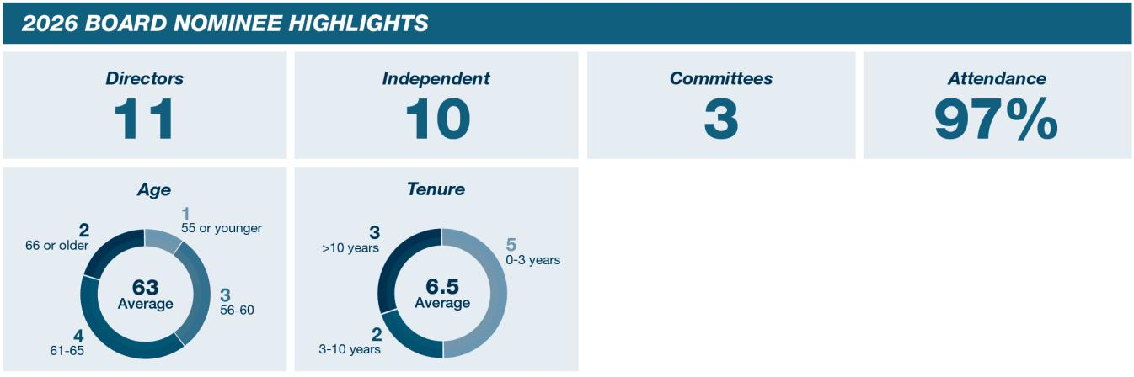

2026 PROXY STATEMENT | 6

Back to Contents

Strategic Developments

During 2025, Middleby successfully advanced its portfolio transformation strategy to separate its three foodservice equipment businesses into standalone companies. These actions are intended to create independent, best-in-class businesses, better position each company for long-term growth, and unlock shareholder value. We also executed on strategic growth investments expanding market opportunities and further strengthening both our Commercial Foodservice and Food Processing businesses.
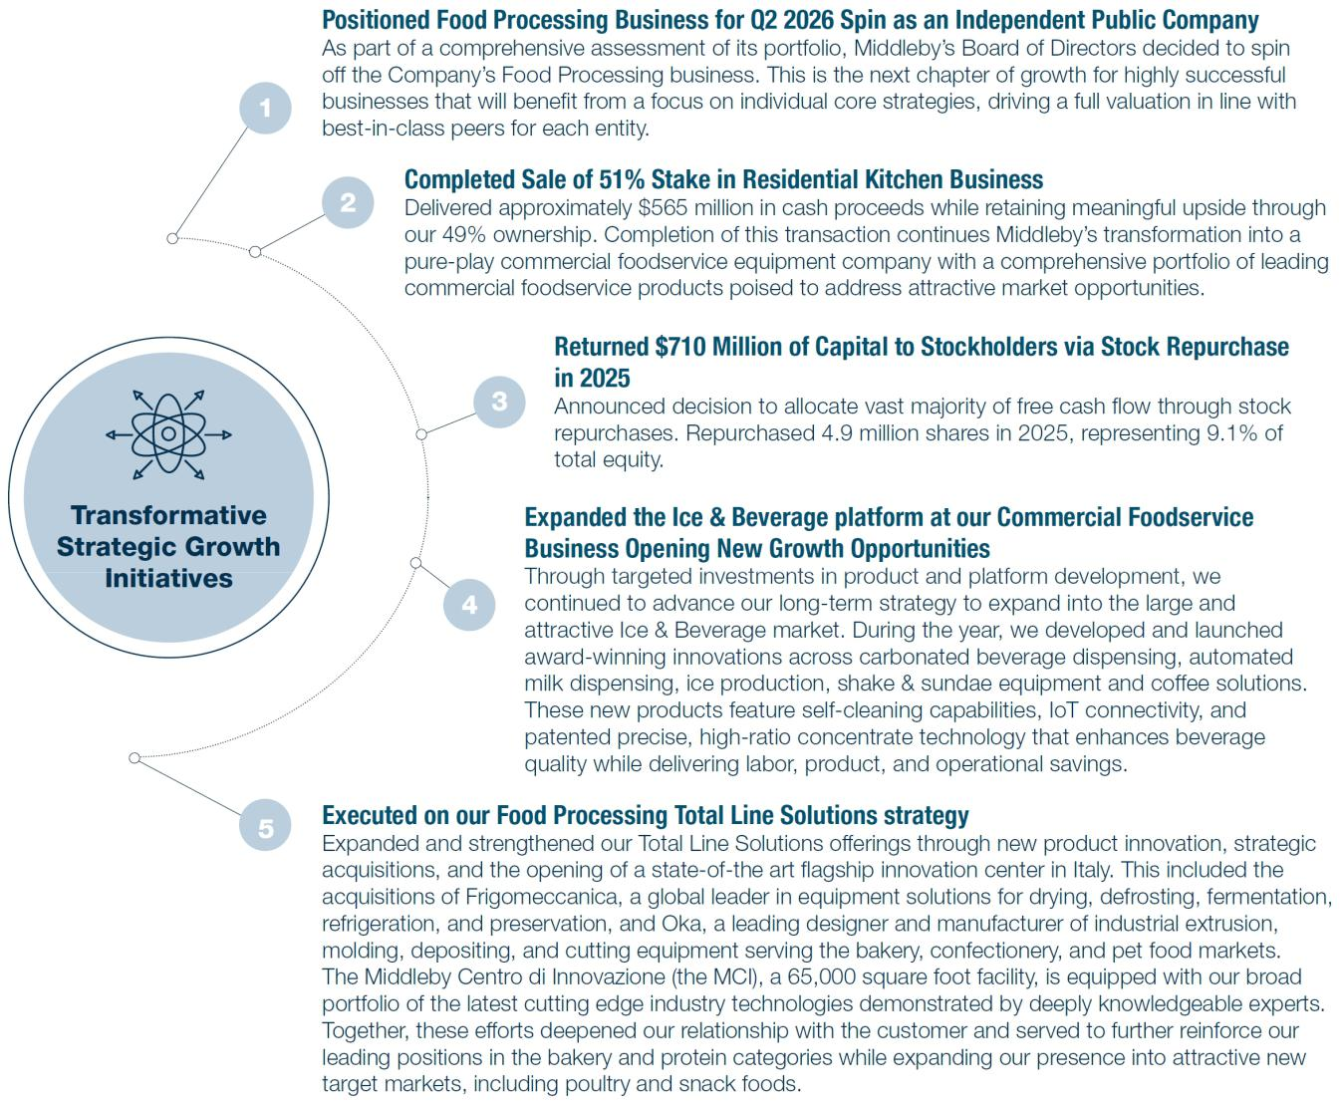

2026 PROXY STATEMENT | 7

Back to Contents
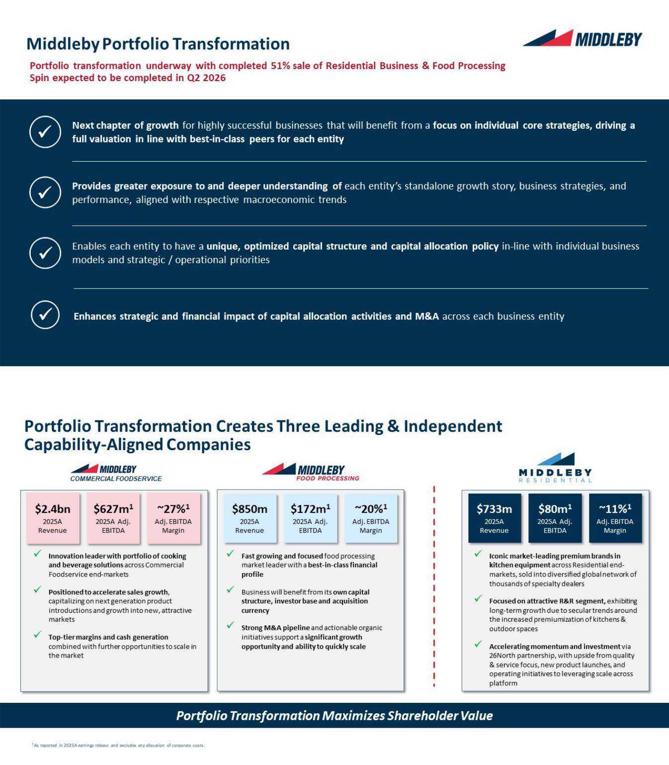

2026 PROXY STATEMENT | 8

Back to Contents
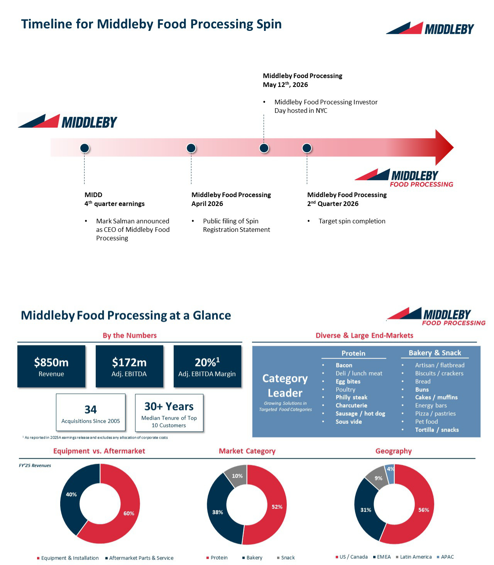

2026 PROXY STATEMENT | 9

Back to Contents
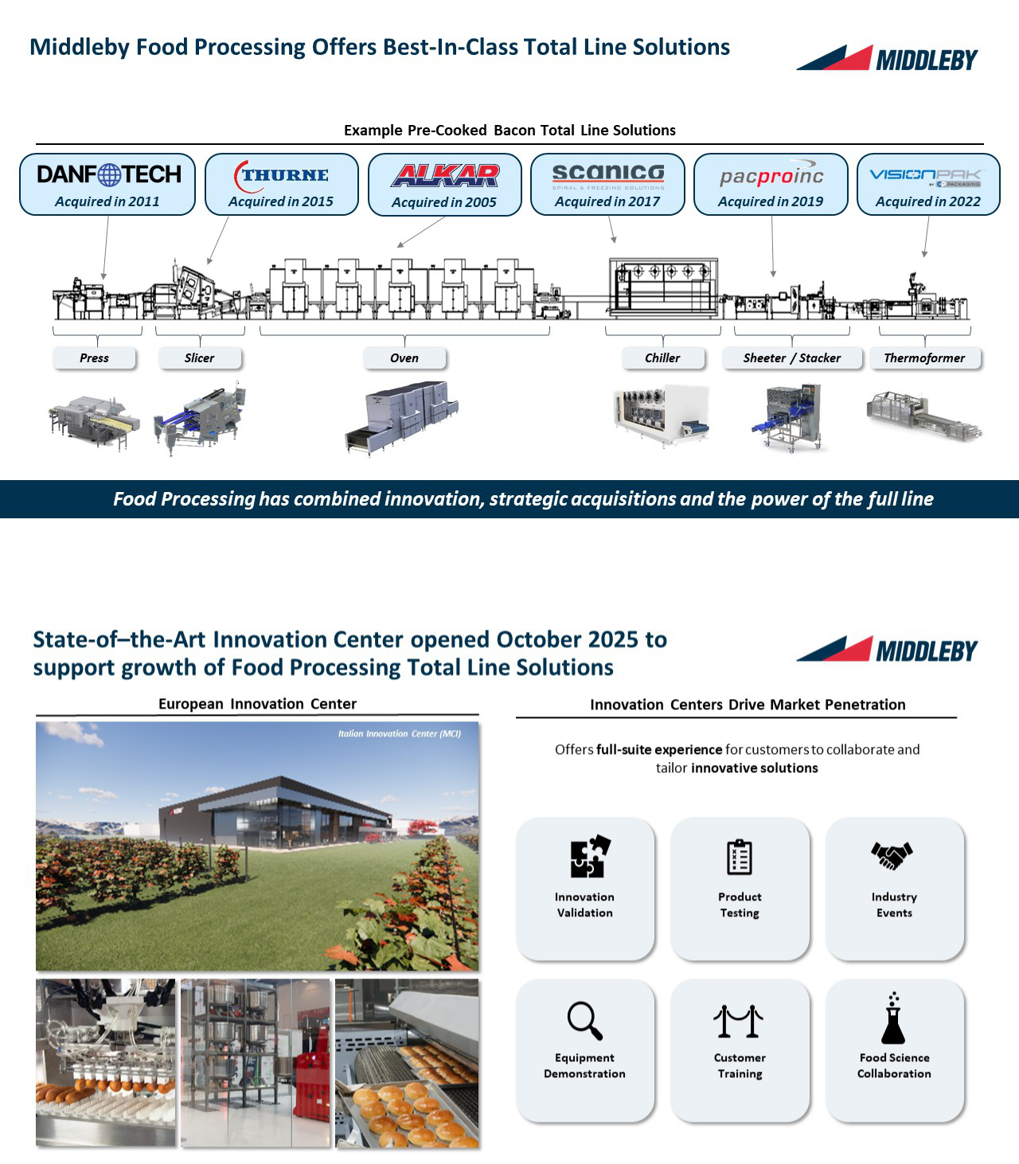

2026 PROXY STATEMENT 10

Back to Contents
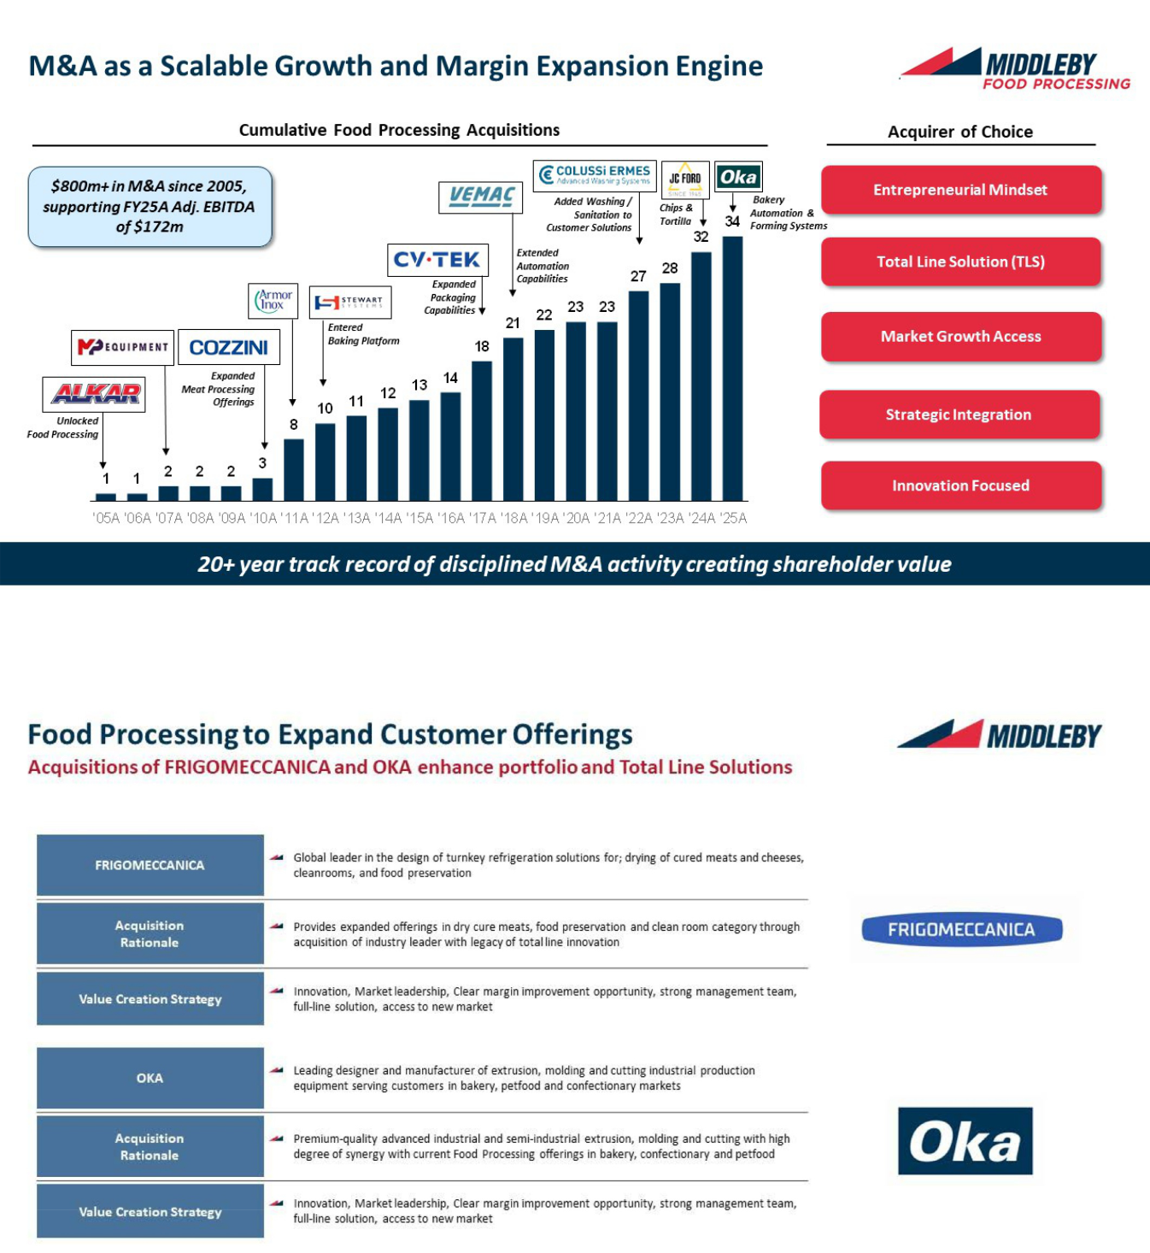

2026 PROXY STATEMENT 11

Back to Contents
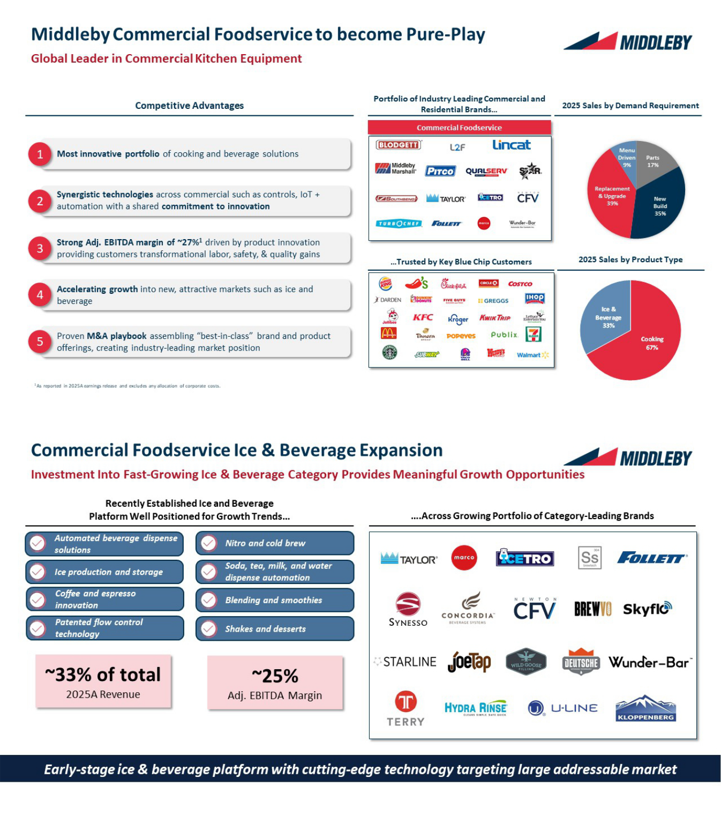

2026 PROXY STATEMENT 12

Back to Contents
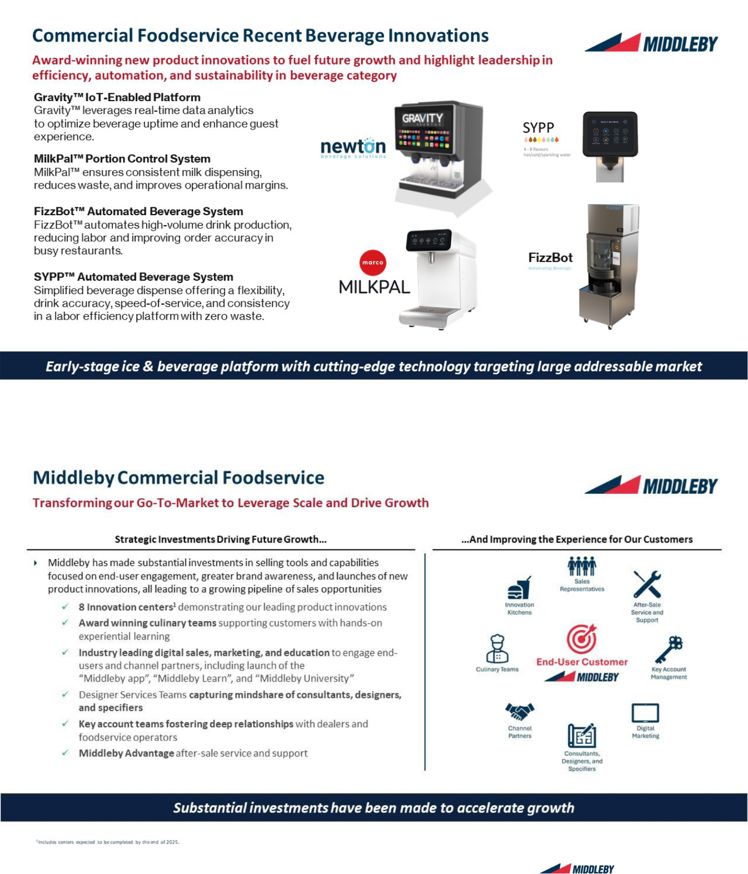

2026 PROXY STATEMENT 13

Back to Contents

Compensation Highlights

Our executive compensation program strikes a balance of fixed and variable elements with short- and long-term objectives. As shown below, in fiscal year 2025, 66% of target compensation for our Chief Executive Officer and 63% of target compensation (on average) for our other Named Executive Officers (the “NEOs”) was performance-based and at risk.

As discussed in the Compensation Discussion and Analysis, our executive compensation program features a combination of base salary, an annual performance-based cash bonus incentive plan, and long-term equity incentive awards. The short- and long-term incentive programs have distinct performance metrics.
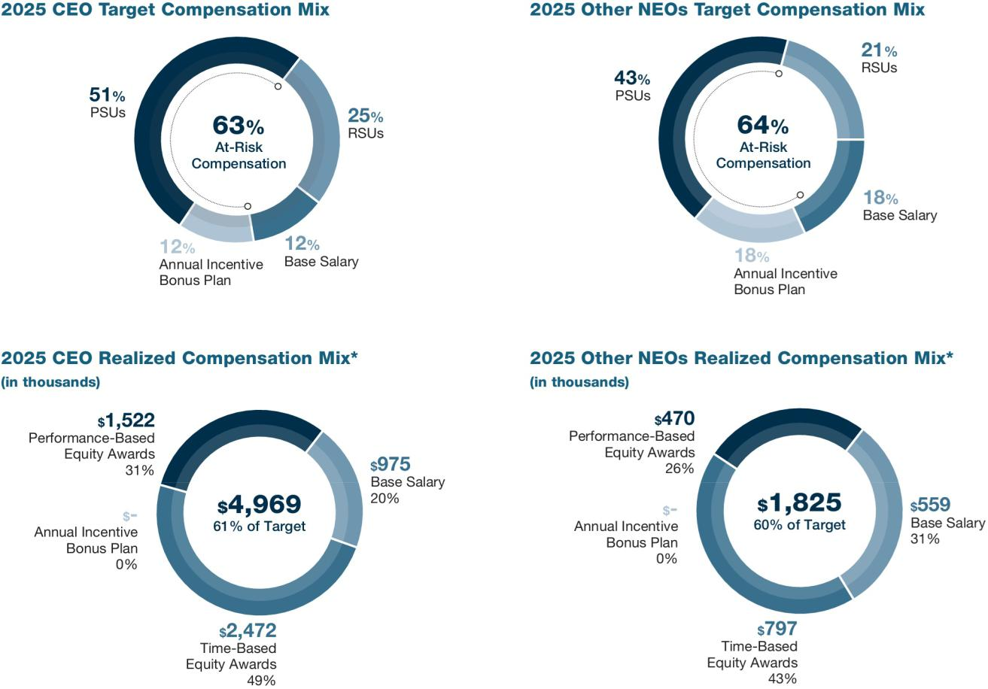

- 2025 Realized Compensation includes the following:

Base Salary represents the fixed cash remuneration paid in fiscal year 2025.

Annual Incentive Bonus Plan represents the annual cash incentive paid with respect to services performed in fiscal year 2025.

Time-Based RSU Awards represents the vesting date value of time-based RSUs that vested in the first quarter of 2026 with respect to services performed in the 2025 fiscal year.

Performance-Based PSU Awards represents the value on the vesting date of performance-based PSUs that vested in the first quarter of 2026 with respect to services performed in the 2025 fiscal year.

2026 PROXY STATEMENT 14

Back to Contents

Corporate Governance Highlights

We believe that robust corporate governance is critical for making prudent decisions in the long-term interests of stockholders. Below are key elements of our corporate governance practices.

What We Do


Majority vote standard for uncontested director elections

Eleven out of twelve directors are independent

Completely independent Board committees

Separate Chairman and CEO roles

Independent Chairman

Annual stockholder engagement program

Independent reviews by the Board and Audit Committee of the Company’s strategy, business, and the related key risks and mitigation activities
Executive sessions at every in-person or virtual Board and committee meeting without management present
Clawback Policy applicable to all executive officers and other covered officers


Confidential, multilingual Anonymous Ethics and Compliance Hotline

The Compensation Committee is advised by an independent compensation consultant

Comprehensive Sustainability Report refreshed on periodic basis

Annual Board skillset evaluation

Corporate Governance Guidelines

Annual Board and committee self-evaluations

Stock ownership guidelines for executive officers and non-employee directors


Middleby Code of Conduct and related training and compliance programs

EHS Policy, Equal Employment Opportunity Policy and Human Rights Policy made publicly available on Company website

Supplier Code of Conduct applicable to all suppliers to the Company

Annual Code of Conduct training for all employees

Enhanced disclosure of robust cybersecurity training programs

Anti-Bribery Policy made publicly available on Company’s website

What We Don’t Do


No golden parachute tax gross-ups for executive officers

No poison pill in place

No stock option repricing without stockholder approval

No excessive perquisites for executive officers

No dividends paid or accumulated on unvested RSUs or PSUs

No hedging, pledging and short selling of Company stock per our Insider Trading Compliance Program

2026 PROXY STATEMENT 15

Back to Contents

Proposal No. 1

Election of Directors

The Board has nominated eleven current directors to serve as directors until the 2027 Annual Meeting of Stockholders and until their successors are duly elected and

qualified or until their earlier death, resignation, or removal.⁽¹⁾ Each of the nominees has consented to serve as a director if elected. The Board knows of no reason why any nominee would be unavailable to serve, but, in the event of any such unavailability, the proxies received will be voted for any substitute nominees the Board recommends. Nassem Ziyad is not standing for re-election at the Annual Meeting. The Board would like to recognize Mr. Ziyad for his service and contributions as a member of the Board.

How We Select Directors

The Nominating and Corporate Governance Committee (“NCGC”) periodically reviews the overall composition of the Board and recommends, if necessary, measures to help ensure the Board reflects an appropriate balance of knowledge, experience, skills and expertise. This process unfolds in two phases:
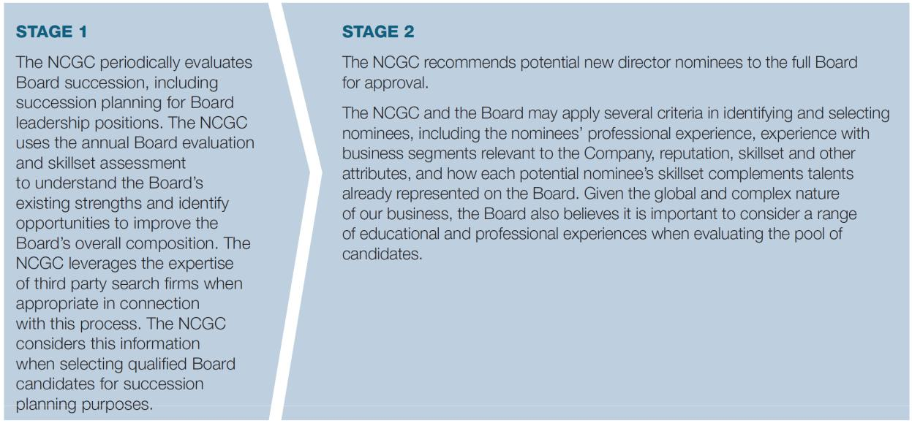

- We anticipate that there will be changes to the composition of our Board of Directors following completion of the pending spin-off the Company’s Food Processing business into an independent publicly traded company, which is currently anticipated to occur after the Annual Meeting. Any such changes to our Board of Directors will be disclosed in future SEC filings.

2026 PROXY STATEMENT 16

Back to Contents

Director Nominees

Julie M. Bowerman


Age: 57 | Professional background
Director | Ms. Bowerman most recently served as Chief Marketing Officer, North America, for Kellanova, where she led the company’s overall
since: 2025 | marketing organization and guided the marketing and omni commercial transformation associated with the company’s separation from
INDEPENDENT | the Kellogg Company.

Committees:

- Nominating and Corporate Governance
- Compensation*

Before that, she served as Chief Global Digital Consumer and Customer Experience Officer for the Kellogg Company, where she oversaw global digital strategy, ecommerce initiatives, and the development of new digital platforms.

Earlier in her career, Ms. Bowerman spent 20+ years at The Coca Cola Company in senior roles spanning brand marketing, shopper marketing, digital transformation, and ecommerce. Her leadership included guiding global omni shopper marketing, developing Coca Cola North America’s first ecommerce operating model, and leading the company’s digital marketing transformation and key consumer engagement platforms. She began her career holding marketing and media roles at Coca Cola Enterprises and J. Walter Thompson.

Service on other public boards

- Brixmor Property Group Inc. (since 2019)

(nominating and corporate governance committee chair)

Relevant skills

Ms. Bowerman’s development and implementation of revenue growth and profit generation via physical and digital commerce, marketing, and go to market strategies as well as her experience and track record of driving value creation in consumer products businesses provides an important perspective to the Board’s oversight of the development and execution of the Company’s strategic plan.

* Effective March 9, 2026

Sarah Palisi Chapin

Age: 64 | Professional background
Director | Ms. Chapin has been Principal of Chapin Creative, LLC, a business incubation, strategy, and marketing advisory firm, since 2016. Ms.
since: 2013 | Chapin has served as an advisor to Michael Graves Design Group, Inc., since 2025. For seven years before founding Chapin Creative,
INDEPENDENT | she was Chief Executive Officer and a board member of Hail Merry, a marketer and manufacturer of gluten-free, vegan, refrigerated
INDEPENDENT | plant ingredient snacks. Earlier in her career, she was Chief Executive Officer, then Chairman, of Enersyst Development Center, an
Committees: | intellectual property development and licensing firm in food processing, vending, and foodservice, from 1995 to 2003. She served as
• Nominating and | Vice President of Worldwide Business Strategy of Burger King Corporation from 1990 to 1995, including as co-leader for development
Corporate Governance | of Restaurant Services, Inc., Burger King’s purchasing coop. She began her career in food service as Director of New Concepts and
(chair) | Engineering for Pizza Hut from 1985 to 1990.

Service on other public boards

- Caribou Coffee Company (2007-2013)

(compensation committee chair and nominating and corporate governance committee member)

Service on private boards

- FlowTrans LLC, a liquid food grade tanker transportation and logistics business (since 2021)
- Yummy Spoonfuls, an organic baby and toddler food company (2014-2018)

- Hail Merry, a plant-based food brand (2009-2016)

- PrimeSource Foodservice Equipment Distributors (2002-2012)

- IRM, a data analytics subscription company (1998-2008)

- Enersyst Development Center (1995-2002)

- Lakeside Food Equipment Manufacturing (1998-2007)

Relevant skills

Ms. Chapin’s more than three decades of experience in the food service and food processing industries give her a comprehensive understanding of strategy, franchising, commercial kitchen technology, brand management, product development, marketing, operational excellence, market expansion, and acquisition strategy.

2026 PROXY STATEMENT 17

Back to Contents

Glenn A. Eisenberg


Age: 64 | Professional background
Director | Mr. Eisenberg has served as Executive Vice President and Chief Financial Officer of Labcorp (NYSE: LH), a global life sciences
since: 2026 | company, from June 2014 until December 2024 when he announced his retirement and currently serves as a Special Advisor. From
INDEPENDENT | 2002 until joining the Company, he served as the Executive Vice President of Finance and Administration and Chief Financial Officer at
INDEPENDENT | The Timken Company, a leading global manufacturer of highly engineered bearings and alloy steels and related products and services.
Committees: | Previously, he served as President and Chief Operating Officer of United Dominion Industries, a diversified industrial manufacturer, now
• Nominating and | a subsidiary of SPX Corporation, after working in several roles in finance, including Executive Vice President and Chief Financial Officer
Corporate Governance* | and President of its Test Instrumentation segment.

Mr. Eisenberg serves on the Board of Directors of Solventum (NYSE: SOLV) since April 2024, where he chairs the Audit Committee and Lumexa Imaging (NASDAQ: LMRI) since March 2025, where he chairs the Audit Committee and is a member of the Compensation Committee. Previously, he served on the public Boards of US Ecology, Inc. until May 2022, where he chaired the Audit Committee; Family Dollar Stores Inc. until July 2015, where he chaired the Audit Committee; Alpha Natural Resources Inc. until May 2015, where he was the lead independent director and chaired the Nominating and Corporate Governance Committee, and Perspecta Inc. until May 2021, where he served on the Audit Committee.

Service on other public boards

- MiniMed Group, Inc. (since 2026) (audit committee member)
- Lumexa Imaging (since 2025)

(audit committee chair and compensation committee member)

- Solventum Corporation (since 2024) (audit committee chair)

- US Ecology, Inc. (2018-2022)

- Family Dollar Stores Inc. (2002-2015) (audit committee chair)

- Alpha Natural Resources Inc. (2009-2015)

(lead independent director and nominating & corporate governance committee chair)

- Perspecta Inc. (2019-2022) (audit committee member)
Relevant skills

Mr. Eisenberg’s experience as a public company finance executive provides the Board with significant financial expertise. He also brings extensive audit committee expertise and valuable experience in portfolio optimization.

- Effective March 5, 2026

Timothy J. FitzGerald

Age: 56 | Professional background
Director | Mr. FitzGerald has been Chief Executive Officer of Middleby since February 2019. Before assuming that role, he held many positions
since: 2019 | with Middleby and its principal subsidiary, Middleby Marshall Inc. (“MM”), including Vice President and Chief Financial Officer of
Committees: | Middleby and MM from 2003 to 2019; and Corporate Controller of Middleby and MM from 1998 to 2003. Before joining Middleby, Mr.
Committees: | FitzGerald was a manager with Arthur Anderson LLP for seven years providing transaction advisory, business consulting and audit
• None | services.

Service on other public boards

- Alliance Laundry Holdings Inc., a manufacturer of commercial and residential laundry equipment (since 2021)

Relevant skills

Mr. FitzGerald’s extensive history at the subsidiary and corporate level of the Company and his day to day leadership as CEO provide the Board with intimate knowledge and an invaluable perspective regarding Middleby’s sales activities, products, operations, risk management, and business strategy. Mr. FitzGerald has extensive mergers and acquisitions experience leading the company’s business development activities since joining the company in 1998. Mr. FitzGerald also has extensive international experience, developing Middleby’s global sales and distribution network.

2026 PROXY STATEMENT 18

Back to Contents

Edward P. Garden


Age: 64 | Professional background
Director | Mr. Garden is the Founding Partner and CEO of Garden Investments. From 2005 to 2023, he served as Chief Investment Officer and
since: 2025 | Founding Partner of Trian Fund Management. Prior to founding Trian, Ed was Vice Chairman and Director of Triarc Companies
INDEPENDENT | (subsequently The Wendy’s Company and previously Wendy’s/Arby’s Group). Earlier in his career Ed was a Managing Director at
INDEPENDENT | Credit Suisse First Boston, where he served as a senior investment banker, and BT Alex Brown, where he was co-head of Equity
Committees: | Capital Markets.
- Compensation

- Nominating and Corporate Governance*
Service on other public boards

- Fortune Brands Innovations (since 2026)

- General Electric Company doing business as GE Aerospace (since 2017)

- Janus Henderson Group (2022-2023)

- Invesco Ltd. (2020-2022)

- Legg Mason, Inc. (2019-2020)

- The Bank of New York Mellon Corporation (2014-2019)

- The Wendy’s Company (2004-2015)

- Family Dollar Stores (2011-2015)

- Pentair plc (2016-2018)

Relevant skills

Mr. Garden’s significant public company board experience, extensive investment and financial expertise, as well as a strong track record of enhancing value for shareholders, provide the Board with valuable strategy and financial oversight capabilities.

Mr. Garden was nominated as a director pursuant to the terms of the Cooperation Agreement (as defined and described under “Cooperation Agreement” below).

- Effective March 9, 2026

Christopher M. Hix


Age: 64 | Professional background
Director | Mr. Hix served as the Executive Vice President and Chief Financial Officer of Enovis Corporation from 2016 to 2022 (and its
since: 2026 | predecessor Colfax Corporation). He previously served as the Senior Vice President and Chief Financial Officer of OM Group, and as
INDEPENDENT | the Senior Vice President and Chief Financial Officer of Robbins & Myers. Prior to Robbins & Myers, he spent 14 years with Roper
INDEPENDENT | Industries (now Roper Technologies) in a variety of operating, financial and strategic roles.

Committees:

- Audit*

Service on other public boards

- Brady Corporation (2024-2026) (Chair of the Audit Committee)

- ESAB Corporation (2021-2024)

Relevant skills

Mr. Hix brings a deep background and extensive knowledge in finance, global business operations, and mergers and acquisitions from his past experiences as the Chief Financial Officer of public companies.

- Effective February 1, 2026

Cathy L. McCarthy

Age: 78 |  | Professional background
Director |  | Since 2011, Ms. McCarthy has served as President and Chief Executive Officer of Cross Tack Consulting, Inc., a management
since: 2015 |  | consulting firm. From 2007 to 2011, Ms. McCarthy served as President and Chief Executive Officer of SM&A, a public company that
INDEPENDENT |  | provides business strategy, competition management, and project management consulting services. Before becoming President, Ms.
 |  | McCarthy served in various senior executive positions at SM&A, including Executive Vice President, Chief Financial Officer, and
Committees: |  | Corporate Secretary from 2005 to mid-2007. Prior to SM&A, Ms. McCarthy was Chief Financial Officer of PIA Merchandising, an in-
• | Audit (Chair) | store merchandising company; Giant Group, Ltd., an investment firm; and Wherehouse Entertainment, a major music and video retailer.
• | Nominating and | Ms. McCarthy began her career at Mellon Bank, N.A., where she was Vice President of several lending departments responsible for
 | Corporate Governance | oversight of highly leveraged and distressed assets and commercial lending.

Service on other public boards

- Rigetti Computing, Inc. (2022-2025)

- Solta Medical, Inc. (2007-2014)

- SM&A (2007-2008)

Relevant skills

Ms. McCarthy’s operating experience as a Chief Executive Officer and a Chief Financial Officer of numerous public and private companies, combined with her extensive background in strategy, mergers and acquisitions, financial reporting, and internal controls, provide the Board with valuable strategy and financial oversight capabilities.

2026 PROXY STATEMENT 19

Back to Contents

Robert A. Nerbonne

Age: 68 | Professional background
Director | Mr. Nerbonne was formerly the CEO and President of multiple commercial foodservice equipment companies. He was an officer and
since: 2019 | board member of Cooper-Atkins Corporation, a company that manufactures thermometers, timers, and wireless monitoring solutions,
INDEPENDENT | from 2014 to 2018. He was a consultant for Cooper-Atkins Corporation from 2012 to 2014. Earlier in his career, Mr. Nerbonne was
INDEPENDENT | Chief Executive Officer of Ali Group North America, a manufacturer of equipment for the food service industry, from 2009 to 2011. He
Committees: | was Group President, Americas of Enodis (today Welbilt), and held other senior roles at that company, from 2002 to 2009. Prior to
• Nominating and | 2002, he held various leadership positions in the commercial food service industry, including President of Pitco from 1988 to 1998,
Corporate Governance | before Middleby acquired that company.

Service on private boards

- Cooper-Atkins Corporation (2014-2018)

Relevant skills

Mr. Nerbonne’s extensive and varied leadership roles within the commercial food service industry, as well as his mergers and acquisition background, provide the Board with valuable insight on how to proactively address market conditions and develop long-term strategy.

Gordon J. O’Brien


Age: 60 | Professional background
Director | Mr. O’Brien has been Managing Partner at Cannon Capital since 2017. In addition, from 2020 until mid-2022, he served as Chief
since: 2005 | Investment Officer and Chief Financial Officer at Re:Build Manufacturing, LLC. Before that, he was President of Specialty Finance and
Non-Executive | Operations of American Capital Strategies from 2008 to 2017, and Principal and Managing Director of American Capital Strategies from
Non-Executive | 1998 to 2008. Earlier in his career, he was Vice President of Pennington Partners/PENMAN Partners, a private equity firm, from 1995
Chairman | to 1998.
since: 2019
INDEPENDENT

Committees:

- Compensation

Relevant skills

Mr. O’Brien’s extensive experience with capital markets and acquisition strategy, as well as his private equity experience as a director on numerous other boards, is valuable in Board discussions regarding Middleby’s capital structure, liquidity needs, and acquisition strategy.

Stephen R. Scherger


Age: 61 |  | Professional background
Director |  | Since 2025, Mr. Scherger has served as the Executive Vice President and Chief Financial Officer of Amcor plc, a global leader in
since: 2024 |  | consumer packaging and dispensing solutions for nutrition, health, beauty and wellness. From 2015 to 2025, Mr. Scherger served as
INDEPENDENT |  | the Executive Vice President and Chief Financial Officer of Graphic Packaging Holding Company, a leading provider of sustainable
 |  | fiber-based packaging solutions. From October 1, 2014 through December 31, 2014, Mr. Scherger was the Senior Vice President –
Committees: |  | Finance at Graphic Packaging Holding Company. From April 2012 through September 2014, Mr. Scherger served as Senior Vice
• | Audit | President, Consumer Packaging Division at Graphic Packaging Holding Company. Mr. Scherger joined Graphic Packaging Holding
• | Compensation | Company in April of 2012 from MeadWestvaco Corporation, where he served as President, Beverage and Consumer Electronics. Mr.
 |  | Scherger was with MeadWestvaco Corporation from 1986 to 2012 and held positions including Vice President, Corporate Strategy;
Vice President and General Manager, Beverage Packaging; Vice President and Chief Financial Officer, Papers Group, Vice President Asia Pacific and Latin America, Beverage Packaging, Chief Financial Officer Beverage Packaging and other executive-level positions.

Relevant skills

Mr. Scherger is a multi-dimensional executive who brings extensive experience as both a public company Chief Financial Officer and a key business segment leader. He has been a key member of a C-suite at multiple companies and contributes valuable insights to the Board on driving growth, mergers and acquisitions, and asset productivity.

2026 PROXY STATEMENT 20

Back to Contents

Tejas P. Shah

Age: 46 | Professional background
Director | Since 2025, Mr. Shah serves as Founder and Chief Executive Officer of Palo Alto Labs, a management consulting firm specializing in
since: 2024 | AI-led product innovation and business transformation. From 2023 to 2025, Mr. Shah served as Chief Information Officer of Fluence
INDEPENDENT | Energy Inc., a public company that provides market-leading energy storage products and services and cloud-based software for
INDEPENDENT | renewables and storage assets. From 2022 to 2023, Mr. Shah served as Chief Information Officer at Tonal. From 2018 to 2022, Mr.
Committees: | Shah served in various roles at Arlo Technologies Inc., where he was promoted from Chief Information Officer to Senior Vice President,
• Audit | Product and Chief Information Officer, to Senior Vice President, Software, SaaS, and Services and Chief Information Officer.

Service on private boards

- Board advisor for Bugcrowd, Inc., crowdsourced cybersecurity platform (since 2019)

Relevant skills

Mr. Shah brings experience in consumer product connectivity, which is highly complementary to current Middleby technology pursuits, and a strong track record of applying technology to shape different business models and growth strategies. His experience with advanced energy management is highly relevant as Middleby continues to develop customer solutions in electrification and decreased energy usage.

The Board has a policy that requires any director who does not receive a majority of votes cast in an uncontested election to promptly tender a resignation. The NCGC will consider any such resignation and recommend appropriate action to the Board. The Board is required to take formal action on the NCGC’s recommendation no later than 90 days following the date of the stockholders’ meeting at which the election of directors occurred. The Board will consider the information, factors, and alternatives reviewed by the NCGC and such additional information, factors, and alternatives as the Board deems relevant. Within four business days after the Board decides whether to accept or reject a director resignation, the Company will publicly disclose that decision in a Form 8-K filed with the Securities and Exchange Commission (“SEC”), including an explanation of the process by which the decision was made and, if applicable, the Board’s reason(s) for rejecting the tendered resignation.

THE BOARD OF DIRECTORS RECOMMENDS THAT STOCKHOLDERS VOTE “FOR” EACH OF THE ABOVE NAMED NOMINEES AS A DIRECTOR OF THE COMPANY


2026 PROXY STATEMENT 21

Back to Contents

The following matrix shows the diversity of relevant skills and experience among our nominees.


Competency | Bowerman Chapin Eisenberg FitzGerald Garden Hix McCarthy Nerbonne O’Brien Scherger Shah
Senior Leadership Experience

Financial Expertise

Industry Knowledge

Risk & Technology (Cyber, Al, IT)

Governance, Compliance & Sustainability

Strategic Planning

Sales, Marketing, Branding, Social

Media & Digital Engagement Mergers & Acquisitions
International Markets Human Capital & Succession Stockholder Engagement Investment & Portfolio Management Technology Experience

The NCGC’s policy is to consider any candidate recommended by stockholders by evaluating the needs of the Board and the qualifications of the candidate. The NCGC may establish formal procedures regarding stockholder submission of candidates in the future.

2026 PROXY STATEMENT 22

Back to Contents

Governance

This section summarizes the Board’s responsibilities and significant policies. For more complete information, see Middleby’s Corporate Governance Guidelines, which are available on our website, www.middleby.com, under “Investors—Corporate Governance.”

Board Leadership Structure

The Board oversees management’s performance to help ensure that Middleby operates in an effective, efficient, and ethical manner in order to produce value for our stockholders. To achieve this goal, the Board monitors both the performance of the Company (in relation to goals, strategy, and competitors) and the performance of the Chief Executive Officer, and offers constructive advice and feedback.

Our Corporate Governance Guidelines require the offices of the Chairman of the Board and the Chief Executive Officer to be separate. We believe having an independent director serve as Chairman of the Board best serves the Company and our stockholders, as we believe this leadership structure provides a broader depth of experience that informs strategy, strengthens the Board’s integrity and independence, and reduces potential conflicts in the areas of performance evaluation, executive compensation, succession planning, and the recruitment of new directors.

Currently, the Board is led by Gordon J. O’Brien, who has been Middleby’s independent Chairman since February 2019. Mr. O’Brien previously served as Lead Independent Director of the Board for nine years. In his capacity as independent Chairman of the Board, Mr. O’Brien is able to focus on and tangibly oversee Middleby’s senior management (including the CEO), Board leadership, and governance-related matters, while Mr. FitzGerald, our CEO, is able to exclusively focus on the Company’s strategy, day-to-day operations, and financial organizational health. Mr. O’Brien’s long-term relationship with Middleby and extensive knowledge of the Company’s operating structure and culture provides him with a broad and deep perspective that informs his judgment.

Independence

A majority of Middleby’s directors must be “independent” as such term is defined under Nasdaq listing standards. The Board reviews annually the relationships that each director has with the Company (either directly or as a partner, stockholder, or officer of an organization that has a relationship with the Company). The Board has determined that every director except Mr. FitzGerald, our CEO, is independent.

Risk Oversight

The Board has responsibility for oversight of risk management including with respect to cybersecurity threats, artificial intelligence adoption, supply chain disruption, and regulatory change. The Board and its committees regularly review information regarding Middleby’s credit, liquidity, and operations and other reports that are designed to inform the Board and its committees about how we identify, assess, and manage critical risks and our risk mitigation strategies.

The Compensation Committee is responsible for overseeing the management of risks relating to our executive compensation plans, Board of Directors compensation, and executive incentive plan design.

The Audit Committee oversees management of financial risks, financial reporting, disclosure requirements, internal controls over financial reporting, credit and liquidity matters, and our operational infrastructure. In addition, the Audit Committee is responsible for oversight of cybersecurity risk management, regulatory matters, and compliance programs. It oversees the Company’s cybersecurity and information security program and receives periodic updates from senior management on cybersecurity and information security matters.

The Nominating and Corporate Governance Committee is responsible for evaluating risk associated with director and management succession planning, overseeing our sustainability reporting, maintaining director training programs, and evaluating the Company’s environmental, social and governance policies and initiatives.

Management advises the Board about material risks as part of its broader responsibility to keep the Board well informed on all matters of significance to the Company. The Board believes its current leadership structure facilitates this clear delineation of responsibility with respect to risk management. Additionally, maintaining an independent Board with an independent Chairman promotes open discussion and assessment of the Company’s ability to manage risk.

2026 PROXY STATEMENT 23

Back to Contents

Annual Board Evaluation and Skillset Assessment

The NCGC coordinates an annual evaluation and skillset assessment of the Board as a whole and of each Board committee. The assessment includes a review of any areas in which the Board or management believe the Board can make a better contribution to the Company. The NCGC utilizes third party experts to conduct skillset assessments in the context of the Company’s overall corporate strategy. The NCGC discusses the results of the evaluation and skillset assessment with the full Board and each individual committee. In addition, the results are used to evaluate and determine the characteristics and critical skills required of prospective candidates for election to the Board and to make recommendations with respect to assignments of directors to various committees and leadership positions.

Stockholder Engagement

We believe it is important for our governance process to have meaningful engagement with our stockholders and to understand their perspectives on corporate governance, executive compensation, and other issues that are important to them and to the Company.

We value opportunities to proactively engage directly with our stockholders on topics of concern or interest, and use that feedback directly to inform our business decision-making process. The Company regularly shares information with stockholders via quarterly earnings releases, investor presentations posted on Middleby’s website, and attendance at investor conferences, trade shows, and other industry events.

Beginning in 2019, the Company has annually engaged in an open dialogue with stockholders to help ensure leadership was hearing stockholder perspectives regarding our executive compensation practices, sustainability practices, and other topics of stockholder interest. We strive to reach out to holders of at least 75% of the Company’s common stock and to have meetings with holders of at least 25% of the Company’s common stock. These meetings are typically scheduled in the first quarter to inform decision-making and priorities for the upcoming fiscal year. Meetings are usually attended by the CFO and General Counsel and one or more Board members upon stockholder request.

In March 2026, we engaged with stockholders to discuss the Company’s sustainability initiatives and to request feedback generally from our stockholders. For this outreach program, we contacted Middleby’s top 25 stockholders, representing approximately 87% of our total outstanding shares. We conducted meetings with stockholders representing approximately 48.9% of our outstanding shares. Stockholders representing approximately 13.4% of our outstanding shares responded that they appreciated the opportunity to connect but had no substantial concerns with the Company’s compensation and governance programs to merit further discussion.

Among other things, we discussed our sustainability reporting practices and processes designed to provide information to the Company’s decision makers and stakeholders to drive stockholder value and fulfill the expectations of our stakeholders. Our investors encouraged us to continue evolving our sustainability reporting to meet customer, investor and regulatory expectations and requirements.

Our investors also encouraged us to continue to emphasize how our product innovations drive sustainable solutions for our customers.

Our engagement efforts gave us valuable insight that has helped to inform the Company’s business practices and strategic decision-making. We will continue our stockholder engagement program annually with the goal of evolving our practices to best meet the needs of the Company and our stakeholders.

Cooperation Agreement

On January 6, 2026, the Company entered into an Amendment to Cooperation Agreement (the “Amendment to Cooperation Agreement”) with Garden Investment Management, L.P. (“GI”). Pursuant to the Amendment to Cooperation Agreement, the Company agreed to include Mr. Garden in the Company’s slate of nominees for the election of directors at the Company’s 2026 Annual Meeting of Stockholders.

Under the terms of the Amendment to Cooperation Agreement: (i) GI will continue to abide by customary standstill restrictions (subjects to certain exceptions relating to private communications to the Company, among others) until the expiration of the Standstill Period (as defined in the Amendment to Cooperation Agreement); (ii) GI agreed to certain voting commitments with respect to the 2026 Annual Meeting of Stockholders; and (iii) the Company and GI agreed to continue to abide by a customary mutual non-disparagement provision.

A summary of the Amendment to Cooperation Agreement is included in the Company’s Current Report on Form 8-K, filed with the SEC on January 6, 2026 (the “Form 8-K”). The full Amendment to Cooperation Agreement is filed as Exhibit 10.1 to the Form 8-K.

Director Onboarding and Continuing Education

The Company provides new directors with an orientation program to familiarize them with our business; strategic plans; significant financial, accounting, and risk-management issues; compliance programs; conflicts policies; Code of Conduct; Corporate Governance Guidelines; principal officers; and internal auditors and independent registered public accountants. Board members who have not been associated with a publicly traded company previously also are required to attend public company director education selected by the NCGC.

2026 PROXY STATEMENT 24

Back to Contents

Every director is expected to participate in continuing educational programs in order to maintain the necessary level of expertise to function as a director. The NCGC requires all standing Board members to maintain membership with the National Association of Corporate Directors (“NACD”) and annually arranges for Board members to attend NACD training programs and other corporate governance training initiatives. The Company pays all reasonable expenses relating to continuing director education.

Succession Planning

The Board is responsible for succession planning for the Chief Executive Officer and other executive officers. The Board of Directors and the Chief Executive Officer meet in a private session two times each fiscal year to discuss succession planning, a review of the executive management team, executive development initiatives, and other executive matters. The Chairperson of the NCGC acts as the Chairperson and maintains minutes of these succession planning meetings.

Board Meetings

The Board held three in-person meetings and twenty-six virtual meetings during the fiscal year ended January 3, 2026. Directors collectively had 97% attendance at full Board meetings and 95% attendance when including attendance at committee meetings. Executive sessions of the independent directors are held in conjunction with regularly scheduled meetings of the Board and otherwise as deemed necessary. The independent directors met in executive session six times without the presence of management.

Directors are expected to physically or virtually attend the annual meeting of stockholders. All of the directors at the time virtually attended the 2025 Annual Meeting of Stockholders.

The independent directors are required, unless waived by the Board, to attend an annual strategic review meeting in the third or fourth quarter each year.

Members of senior management who are not directors may be invited to participate in Board meetings or other Board functions when appropriate. The Board encourages the Chief Executive Officer to bring members of management from time to time into Board meetings to provide insight into items being discussed by the Board, to make presentations to the Board on particular matters, and to help ensure the Board has an opportunity to interact with managers who have significant potential.

Committees of the Board

Middleby’s Board currently has an Audit Committee, established in accordance with Section 3(a)(58)(A) of the Securities Exchange Act of 1934 (as amended, the “Exchange Act”), a Compensation Committee, and a Nominating and Corporate Governance Committee. The charters for these three committees are available on our website, www.middleby.com, on the “Investors—Corporate Governance” page. All three committees are composed entirely of independent directors. The Board and each committee actively oversees management of risks as discussed further, in “Governance–Risk Oversight”.

Audit Committee

Members: | The Audit Committee is responsible for:
• McCarthy (Chairperson), | • | selecting Middleby’s independent registered public accountants;
Hix*, Scherger, Shah and | • | reviewing the arrangements for and scope of the audit and pre-approving permitted non-audit services;
Ziyad** | • | reviewing the Company’s interim and annual financial statements or other results of the audit;
Meetings in fiscal year | • | reviewing the Company’s internal accounting procedures and controls and the recommendations of the independent registered public
2025: |  | accountants;
• six times virtually | • | overseeing cyber risk management, regulatory matters and compliance programs; and
 | • | reviewing the external audit process.

The Board has determined that Ms. McCarthy, Mr. Hix, Mr. Scherger and Mr. Shah are “financially sophisticated,” as required by Nasdaq Rule 5605(c)(2), and qualify as “audit committee financial experts,” as such term is defined in SEC rules. All of the members have been determined by the Board to meet the additional independence criteria for audit committee members set forth in Nasdaq Rule 5605(c)(2).

* Since February 1, 2026

** Mr. Ziyad is not standing for re-election at the Annual Meeting.

2026 PROXY STATEMENT 25

Back to Contents

Compensation Committee

Members: |  | The Compensation Committee is responsible for:
• | Scherger (Chairperson), | • | making recommendations concerning the compensation of the non-employee members of the Board and all executive officers;
 | Bowerman*, Garden, and | • | administering the Value Creation Incentive Plan, our annual incentive compensation program, including establishing and certifying
 | O’Brien |  | performance goals; and
Meetings in fiscal year |  | • | administering and making grants to executive officers under the Company’s 2021 Long-Term Incentive Plan (the “LTIP”).
2025:
• | three times virtually, three
 | times in person

All of the members of the Compensation Committee have been determined by the Board to be independent as defined under applicable Nasdaq listing standards.

There are no compensation committee interlocks.

* Since March 9, 2026

Nominating and Corporate Governance Committee

Members: |  | The Nominating and Corporate Governance Committee is responsible for:
• | Chapin (Chairperson), | • | discussing, reviewing, evaluating, and maintaining a slate of potential director nominees, and recommending potential director
 | Bowerman, Eisenberg*, |  | nominees to the Board;
 | Garden**, McCarthy, and | • | administering the annual Board evaluation and skillset assessment process;
 | Nerbonne | • | maintaining Middleby’s director training programs;
Meetings in fiscal |  | • | developing and recommending to the Board corporate governance principles applicable to the Company;
year 2025: |  | • | overseeing succession planning for Board and committee members;
• | twenty one times virtually, | • | overseeing and reviewing sustainability policies and procedures; and
 | three times in person | • | evaluation of the Board and Middleby’s executive officers, including with respect to the Board’s composition and procedures.

- Since March 5, 2026 ** Since March 9, 2026

Service on Other Boards

We do not have a policy limiting the number of other public company boards of directors upon which a director may sit. However, the NCGC considers the number of other public company boards and comparable governing bodies on which a prospective nominee or a director is a member. In addition, we expect directors to be fully committed to devoting as much time as necessary to fulfilling their Board responsibilities, both in terms of preparation for, and attendance and participation at, meetings.

Directors must provide prior written notice to the Chairperson of the NCGC before accepting a seat on the board of a public or private entity.

In recognition of the enhanced time commitment associated with membership on a public company’s audit committee, the Board has adopted a policy that no member of the Audit Committee may serve simultaneously on the audit committees of more than two other public companies.

Age and Term Limits

We believe the Board operates most effectively with a mix of incumbent directors who have a deep understanding of Middleby and new directors who offer fresh perspectives. The Board does not currently have term limits or a mandatory retirement age.

However, the NCGC and Board consistently evaluates the contributions of individual Board members to the Board and the Company. The NCGC reviews all directors annually before deciding on our nominees.

Stockholder Communications With the Board

Stockholders may contact the Board of Directors about bona fide issues or questions concerning the Company by sending an email to legal@middleby.com or by writing to the Corporate Secretary at the Company’s principal executive offices at 1400 Toastmaster Drive, Elgin, Illinois, 60120. Any matter intended for the Board of Directors, or for any individual member or members of the Board of Directors, should be directed to the email or physical address noted above, with a request to forward the communication to the intended recipient(s). In general, any stockholder communication about bona fide issues concerning the Company delivered to the Corporate Secretary will be forwarded in accordance with the stockholder’s instructions.

2026 PROXY STATEMENT 26

Back to Contents

Related Party Transactions

There have been no reportable related person transactions since the beginning of fiscal year 2025. The Audit Committee is responsible for reviewing, and approving related person transactions. In fulfilling this responsibility, the Audit Committee considers whether the transaction would be on fair and reasonable terms no less favorable to the Company than those that would be available in a comparable transaction in arm’s-length dealings with an unrelated third party.

Governance Documents

In 2022, Middleby adopted refreshed Stock Ownership Guidelines that apply to all directors and executive officers and refreshed and made publicly available its Anti-Bribery Policy. In 2021, Middleby adopted a refreshed Code of Conduct that applies to all directors, officers, and employees. In 2020, we adopted Corporate Governance Guidelines, which, in conjunction with our Restated Certificate of Incorporation, as amended, Fifth Amended and Restated Bylaws and charters of the Board’s committees, constitute the framework of our corporate governance. The Code of Conduct and Corporate Governance Guidelines, as well as the charters for our committees, are available on our website, www. middleby.com, under “Investors—Corporate Governance.” We will post any amendment to, or waiver from, the Code of Conduct, on our website.

We have adopted an Insider Trading Compliance Program, which governs the purchase, sale, and/or other dispositions of the Company’s securities by our directors, officers and employees which we believe is reasonably designed to promote compliance with insider trading laws, rules and regulations, and any listing standards applicable to the Company. A copy of our Insider Trading Compliance Program is filed as Exhibit 19.1 to our Annual Report on Form 10-K for the year ended January 3, 2026.

The following additional documents are available on our website, www.middleby.com, under “Investors—Corporate Governance”:

- Conflict Minerals Policy

- Insider Trading Compliance Program

- 2025 Sustainabilty Metrics Update

- 2024 Sustainability Metrics Update

- 2023 Sustainability Report Update

- 2021 Sustainability Report

- Accounting Complaint Procedures

- Clawback Policy

- EHS Policy

- Equal Employment Opportunity Policy

- Human Rights Policy

- Supplier Code of Conduct

Director Stock Ownership Guidelines

Company guidelines require our non-employee directors to own a prescribed amount of Middleby common stock, expressed as five times their annual cash compensation. Unvested time-based restricted stock units (“RSUs”) count toward a non-employee director’s required holdings. New non-employee directors who have not yet met their stock ownership requirements are required to meet their stock ownership requirements within five years after becoming a non-employee director. Stock options are not counted in the ownership calculation.

As of January 3, 2026, all of our non-employee directors exceeded the minimum stock ownership requirements (to the extent applicable).

Director Compensation

The Company believes that having highly qualified non-employee directors is critical to our success. Non-employee directors represent the interests of our stockholders, and they contribute their experience and wisdom to guide our Company, our strategy, and our management. The Board believes that compensation for directors should reflect the work required in both their ongoing oversight and governance role and their continuous focus on driving long-term performance and stockholder value.

The Compensation Committee, consisting solely of independent directors, is responsible for reviewing director compensation and considering any changes to how directors are compensated.

The full Board reviews the Compensation Committee’s recommendations and approves director compensation arrangements.

In December 2024, the Compensation Committee engaged Aon’s Human Capital Solutions practice, a division of Aon plc (“Aon”), an independent compensation consultant, to conduct a director compensation assessment using the same peer group that was used to assess executive compensation. The Board compensation assessment analyzed peer company director compensation levels and practices, evaluated the competitiveness of the Company’s director compensation program from multiple perspectives relative

2026 PROXY STATEMENT 27

Back to Contents

to the peer group, and described recent market trends in director compensation. Based on Aon’s analysis and the Company’s long-term performance, the Compensation Committee determined to make no changes to director compensation with respect to the 2025 fiscal year.

Non-employee director compensation for fiscal year 2025 consisted of cash and equity components. The following table shows the compensation structure. Directors do not receive meeting fees.

Type of compensation | How paid | Amount
Annual cash compensation for every non-employee | Cash, paid in quarterly installments | $100,000
director
Additional cash compensation for Chairman of the Board | Cash, paid in quarterly installments | $25,000
Additional cash compensation for chairpersons of the | Cash, paid in quarterly installments | $25,000
Audit Committee, the Compensation Committee and the
Nominating and Corporate Governance Committee
Additional cash compensation for Audit Committee | Cash, paid in quarterly installments | $12,500
members
Additional cash compensation for Compensation | Cash, paid in quarterly installments | $7,500
Committee and Nominating and Corporate Governance
Committee members

Equity for every non-employee director RSUs awarded in March of each year with a one-year

vesting period

Aggregate value of $175,000 based on the price of Middleby’s common stock at the close of business on the grant date

Director Compensation for Fiscal Year 2025

The following table shows the annual and long-term compensation for services to the Company performed by the non-employee directors during fiscal year 2025. Mr. FitzGerald’s compensation is discussed in the Compensation Discussion and Analysis section of this Proxy Statement and presented in “Summary Compensation Table for Fiscal Year 2025”. He did not receive any additional compensation for his service as a director.

 | Fees Earned or | Stock Awards
 | Paid in Cash | Stock Awards | Total
Name | ($) | ($)⁽¹⁾ | ($)
Julie M. Bowerman | 107,500 | 175,142 | 282,642
Sarah Palisi Chapin | 126,875 | 175,142 | 302,017
Nominating and Corporate Governance Committee Chairperson
Edward P. Garden | 107,500 | 175,142 | 282,642
John R. Miller III⁽²⁾ | 33,125 | — | 33,125
Cathy L. McCarthy | 132,500 | 175,142 | 307,642
Audit Committee Chairperson
Robert A. Nerbonne | 107,500 | 175,142 | 282,642
Gordon J. O’Brien | 132,500 | 175,142 | 307,642
Chairman of the Board
Stephen R. Scherger | 132,500 | 175,142 | 307,642
Compensation Committee Chairperson
Tejas P. Shah | 112,500 | 175,142 | 287,642
Nassem A. Ziyad | 112,500 | 175,142 | 287,642

- On March 6, 2025, each non-employee member of the Board (other than Mr. Miller) was awarded RSUs having a grant date fair value equal to $175,142 on such date pursuant to the LTIP. These RSUs vested on March 6, 2026. The amounts reported in this column reflect the aggregate grant date fair value of the RSUs granted in 2025 computed in accordance with Financial Accounting Standard Board Accounting Standards Codification Topic 718 (“FASB ASC Topic 718”). The valuation assumptions used in determining these amounts are described in Note 3(o) to our consolidated financial statements included in our Annual Report on Form 10-K for the fiscal year ended January 3, 2026. As of January 3, 2026, each then-serving non-employee director held 1,108 outstanding RSUs.

- Mr. Miller retired from the Board, effective March 15, 2025.

2026 PROXY STATEMENT 28

Back to Contents

Sustainability

In October 2025, we released Middleby’s 2025 Sustainability Metrics Update, featuring further alignment and expansion of our data collection and reporting of this information to our customers, investors and other stakeholders. Middleby is uniquely positioned to develop sustainable equipment solutions that impact the many customers we touch around the world involved in restaurants and food manufacturing operations as well as cooking at home. Our financial investments and product innovation efforts are focused on solutions that reduce energy consumption, lessen water usage and food waste, minimize emissions and carbon footprint, and enhance safety. We have built these sustainability objectives into our development and innovation processes, so they are core to our culture. In our 2025 Sustainability Metrics Update, we included updated data with respect to energy, greenhouse gas (GHG) emissions, water usage and waste metrics. We look forward to expanding further the metrics we disclose in our future sustainability reporting. We intend to publish an updated Sustainability Report in 2026.

For complete information, please see our most recent Sustainability Metrics Update, which is available on our website, www.middleby. com, under “About— Sustainability.”

Sustainability Priorities and Management Process

Middleby’s sustainability priorities are focused on reducing environmental impact to air, water, and land across our footprint and specifically with respect to our customers; improving data analysis and benchmarking to identify opportunities for improvement; identifying and implementing cost-effective and innovative solutions to reduce energy usage; and encouraging more environmentally friendly business practices within our business units. Our management process uses consistent data collection and benchmarking to identify risks, plan management strategies, implement solutions, measure success rates, and adjust systems for continuous improvement across our environmental management activities.

Data collection and reporting were conducted in alignment with a number of different frameworks, including the framework used by the Sustainability Accounting Standards Board (SASB) in developing their standards. For purposes of reporting, we selected aspects of the environment that we have control of and can make a meaningful impact on. The four key aspects measured at our operations are Energy Consumption, Greenhouse Gas (GHG) Emissions, Water Usage and Waste Management. These aspects are considered to meet the SASB requirements: they are of interest to investors, are relevant across the industry, have a potential to affect corporate value, reflect stakeholder feedback, and are actionable by Middleby.

Human Capital

We believe Middleby’s success is a direct result of the people we employ around the world. When our employees have the best environment, they can be their best. We strive to create a culture that encourages and celebrates collaboration, creativity, and confidence. Ultimately, we want a workplace that enables employees to develop their individual paths toward their career goals and encourages a long-term working relationship with us.

Middleby leadership encourages internal promotion to fill all job openings by supporting organized succession planning and employee development initiatives across all of its divisions.

We encourage our employees to present new ideas and empower them to move their ideas forward. We believe that giving our employees autonomy fosters an environment of inclusion and empowerment, and encourages them to recognize that they play a part in Middleby’s success.

Employee Safety

Middleby actively promotes a safe workplace for all of our employees around the world because a culture of safety reduces the risk of injury to employees, decreases expenses, and increases production. Each of our manufacturing locations maintains an active safety committee that frequently reviews and assesses the conditions of the local work environment. We invest in safety training, share best practices, and review claim activity to continually minimize employee workplace injuries. We understand that our ongoing efforts to promote a safe environment today will drive long-term sustained improvement to workplace safety across the Company in the future.

Our Recordable Case Rate (work-related injuries per 100 full-time employees) declined from 6.30 in 2017 to 3.68 in 2024. Our Lost Time Incident Rate declined from 1.37 in 2017 to 0.04 in 2024. A number of factors contribute to these metrics and trends. Each year, the data collected includes more locations than the prior year due to acquisition activity and expansion of locations for existing Middleby divisions. Middleby uses these metrics to inform decision-making and contribute to the culture of safety companywide.

2026 PROXY STATEMENT 29

Back to Contents

HEALTH AND SAFETY METRICS
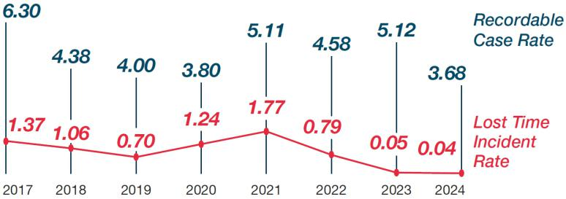

* Calculated per 100 employees at year-end.

Community

Middleby recognizes the importance of supporting our industry and the communities in which we live and work. The Middleby Cares corporate giving program invests in not-for-profit organizations addressing the following initiatives:

- Food Insecurity

- Education Initiatives

- Youth Programs

- Needs for Shelter

- Basic Living Necessities

The cornerstone of our philanthropic efforts is the motto “we feed people.” In 2025, we supported Feeding America, as a corporate partner. Feeding America distributed Middleby directed funds to dozens of their food banks in communities where our employees live and work. Many in our domestic employee base also volunteered with these food banks, making an impact locally.

Middleby Cares also supports Ronald McDonald House. We participated in their Global Giving Collective, as well as a formal program to upgrade foodservice at Ronald McDonald House locations by providing equipment donations. We were proud to support more than a dozen locations worldwide with in-kind equipment in 2025, to help Ronald McDonald House best serve families of ill and injured children receiving treatment at local hospitals.

Consistent with our mission to feed people, we are a partner of World Central Kitchen both financially and through vehicle support and equipment donations. Additionally, Middleby is the national equipment partner of Café Momentum, an organization serving justice-involved youth throughout the U.S. Other organizations we proudly support include The Red Cross Disaster Relief Fund, Habitat for Humanity, Alzheimer’s Association, St. Jude, Mercy Chefs, local PADS and many more organizations that reflect our mission. We offer culinary education support to Elgin Community College, National Louis University, Dallas College Foundation and others. We also are involved in many regional organizations that meet our giving parameters and mirror our values.

We encourage all global locations to be engaged in their own charitable local efforts and volunteering. We believe in community impact and support our employees serving their communities in a meaningful way. Our operating locations direct their own local philanthropic activities, reflective of the needs of their communities.

Additional information regarding the Middleby Cares corporate giving program is available at www.middleby.com/middleby-cares.

2026 PROXY STATEMENT 30

Back to Contents

Executive Officers

The following is a summary of the professional experience of the Company’s executive officers. The ages set forth below are as of March 31, 2026.

Name | Age | Professional Background
Timothy J. FitzGerald | 56 | Mr. FitzGerald’s professional biography appears above under Election of Directors.
Bryan E. Mittelman⁽¹⁾ | 55 | Chief Financial Officer of the Company from February 2019 to March 2026, and Chief Accounting Officer from July 2018 to
 |  | February 2019. Vice President, Controller at Knowles Corporation from December 2013 to July 2018. Corporate Controller at
 |  | Morningstar, Inc. from December 2011 to September 2013.
Brittany C. Cerwin⁽²⁾ | 42 | Chief Financial Officer of the Company since March 2026, and Chief Accounting Officer from May 2023 to March 2026,
 |  | Corporate Controller from 2018 to 2023. Director of Financial Reporting from 2017 to 2018. Manager of Financial Reporting from
 |  | 2012 to 2017. Senior Financial Analyst from 2011 to 2012. Auditor at Grant Thornton from 2006 to 2011.
James K. Pool III | 54 | Chief Technology and Operations Officer of the Company since February 2021. Company Group President and President of
 |  | TurboChef Technologies, LLC from 2011 to February 2021.
Steven P. Spittle | 45 | Chief Commercial Officer of the Company since February 2021. Group President of Pitco Frialator and G.S. Blodgett from March
 |  | 2017 to February 2021. President of Pitco Frialator from April 2015 to May 2017.
Matthew R. Fuchsen⁽³⁾ | 55 | Chief Development Officer of the Company since May 2023. Vice President, Mergers, Acquisitions and Tax from February 2018
 |  | to May 2023. Vice President of Tax from March 2014 to February 2018. Senior Tax Manager from November 2011 to March
 |  | 2014.

- Effective March 24, 2026, Mr. Mittelman transitioned from his position as Chief Financial Officer of the Company to a non-officer position as a Special Advisor to the Chief Executive Officer.

- Effective March 24, 2026, Ms. Cerwin was appointed as Chief Financial Officer of the Company.

- Mr. Fuchsen has been announced as the Chief Strategy Officer of the Middleby Food Processing business, effective upon completion of the spin-off of the Middleby Food Processing business as a stand-alone public company.

2026 PROXY STATEMENT 31

Back to Contents

Proposal No. 2

Advisory Vote to Approve Named Executive Officer Compensation

Every year we give our stockholders the opportunity to vote on a non-binding, advisory basis, to approve the compensation of our Named Executive Officers. This proposal is commonly referred to as “Say on Pay.” We are asking stockholders to vote FOR the adoption of the following resolution:

“Resolved, the compensation paid to the Company’s Named Executive Officers, as disclosed pursuant to Item 402 of Regulation S-K of the Securities Exchange Act of 1934, including the Compensation Discussion and Analysis, compensation tables and narrative discussion, is hereby APPROVED.”

This vote is advisory and therefore not binding on the Company, the Compensation Committee or the Board. However, the Board and the Compensation Committee value the opinion of Middleby stockholders. The Board and the Compensation Committee will consider the views of our stockholders expressed through the advisory vote and, based on the results of the vote, the Compensation Committee will evaluate whether any actions are necessary to address stockholder concerns.

As outlined in the Compensation Discussion and Analysis (“CD&A”) section that follows, our compensation program is designed to maximize achievement of strategic

Company goals based on the following objectives:

- attract and retain executive talent;

- link executive compensation with operating performance;

- align executive long-term compensation with stockholder interests; and

- facilitate a high-growth company strategy.

The Compensation Committee and the Board believe that the policies and procedures articulated in the CD&A are effective in achieving these goals and that the compensation of the Named Executive Officers reported in this Proxy Statement has contributed to the Company’s long-term success. The Company encourages stockholders to review the executive compensation section, executive compensation tables and pay versus performance section for details of how our executive compensation policies and procedures operate and are designed to achieve the Company’s compensation objectives.

Vote Required for Approval; Board Recommendation

The vote of a majority of votes cast is necessary for advisory approval of this proposal. Although this vote is advisory in nature and does not require any action by the Company or the Compensation Committee, the Company strongly encourages all stockholders to vote on this matter.

THE BOARD OF DIRECTORS UNANIMOUSLY RECOMMENDS THAT STOCKHOLDERS VOTE “FOR” THE APPROVAL OF THE COMPANY’S NAMED EXECUTIVE OFFICER COMPENSATION AS DISCLOSED IN THIS PROXY STATEMENT.


2026 PROXY STATEMENT 32

Back to Contents

Executive Compensation

Table of Contents
Compensation Discussion and Analysis | 33
Executive Summary | 33
Stockholder Engagement Following the 2025 Annual Meeting | 34
Compensation Objectives and Philosophy | 34
Parties Involved in Compensation Decisions | 35
Fiscal Year 2025 Compensation Decisions | 36
Vesting of Equity Incentive Awards for 2023-2025 Performance Period | 39
Stock Ownership Guidelines | 40
Clawback Policy | 41
Additional Compensation Information | 41
Report of the Compensation Committee of the Board of Directors | 42

Compensation Discussion and Analysis

The following Compensation Discussion and Analysis (“CD&A”) describes the material elements of compensation for the Company’s fiscal year 2025 “Named Executive Officers,” or NEOs, identified below.

Timothy J. FitzGerald | Chief Executive Officer
Bryan E. Mittelman⁽¹⁾ | Chief Financial Officer
James K. Pool III | Chief Technology and Operations Officer
Steven P. Spittle | Chief Commercial Officer
Matthew R. Fuchsen | Chief Development Officer

- Effective March 24, 2026, Mr. Mittelman transitioned from his position as Chief Financial Officer of the Company to a non-officer position as a Special Advisor to the Chief Executive Officer.

Executive Summary

We seek to closely align the interests of our Named Executive Officers with the interests of our stockholders. As described in this CD&A, our compensation program features a pay for performance design that rewards our Named Executive Officers for achieving short-term and long-term financial goals.

2025 Highlights and Performance

In 2025, Middleby and its management team executed decisive portfolio actions to unlock significant stockholder value. We recently completed the sale of a 51% stake in our Residential Kitchen business at an $885 million enterprise valuation, first announced in December, delivering approximately $565 million in cash proceeds while retaining meaningful upside through our 49% ownership. In anticipation of the proceeds from this transaction, combined with one of the most aggressive capital return programs in our industry, we deployed $710 million in share repurchases in 2025, reducing our share count by approximately 9%. We remain on track to complete the separation of our Food Processing business in the second quarter of 2026, creating two independent, pure-play industry leaders with enhanced focus and optimized capital structures.

Achievement of our 3-year long term equity incentives over the 2023-2025 performance period reflected below target results that were adjusted downward by our 3-year TSR modifier, resulting in long term equity incentives earned at below target. This demonstrates the alignment between our long term equity incentive program and the interests of our stockholders. Likewise, annual incentive compensation for our executives for FY2025 results was at 0% of target, reflecting below target achievement on our annual incentive program’s organic adjusted EBITDA$ and organic adjusted EBITDA% targets.

$10,000 Compound Investment Growth - 5 Year
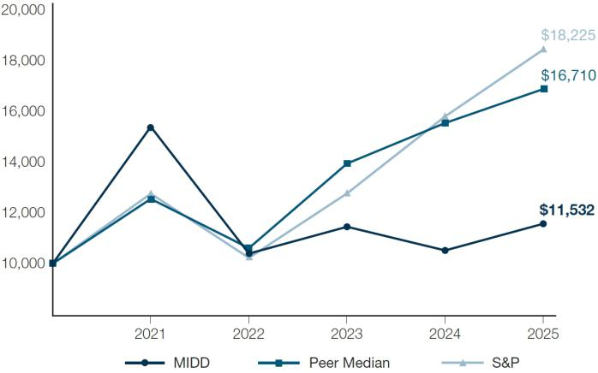

2026 PROXY STATEMENT 33

Back to Contents

Highlights of 2025 Compensation Program

The following chart summarizes the elements of direct compensation paid to our Named Executive Officers in fiscal year 2025.

Compensation
element | How paid | Metrics and vesting
Base salary | Cash | Typically based on the Company’s current business environment, the individual’s level of
 |  | responsibility and merit within the Company, and peer reference data.
Annual incentive | Cash | The annual incentive compensation program is a performance-based plan that rewards
compensation |  | performance against goals for earnings before interest, taxes, depreciation, and amortization
 |  | on an organic adjusted basis (“EBITDA”) in dollars (“EBITDA$”), and EBITDA as a
 |  | percentage of total revenue (“EBITDA%”).
Long-term equity incentives | 2/3 performance-based | The 2025 awards of PSUs will cliff vest, to the extent earned, at the end of a three-year
 | performance stock units (PSUs) | performance period based on continued employment and performance against goals for
 |  | Adjusted EPS Growth (65%) and Return on Invested Capital (35%). Final awards may be
 |  | modified (+/- 30%) based on Middleby’s TSR compared to TSR for our peer group.
 | 1/3 time-based restricted stock | The RSUs will vest in three equal tranches in the March following each of the three fiscal
 | units (RSUs) | years of the performance period for the PSUs awarded on the same date, subject to
 |  | continued employment. Shares underlying the vested RSUs must be held until the end of the
 |  | three fiscal year period to which they relate.

Stockholder Engagement Following the 2025 Annual Meeting

We actively seek and consider stockholder feedback in designing and managing our executive compensation program, our corporate governance practices, and all other matters of interest to our stockholders. At the 2025 Annual Meeting, support for the Say on Pay proposal was approximately 95%. This level of support affirms our stockholders’ overall support for our compensation practices. In 2025, the Compensation Committee modified the long-term equity incentive program to include Adjusted EPS Growth, Return on Invested Capital, and retain TSR performance metrics, shifting away from our prior usage of an Enterprise Value Growth Per Share metric. The Compensation Committee made these modifications based on stockholder feedback as well as feedback from Company management and Aon, our independent compensation consultant.

In 2025, the Company’s incorporation of stockholder feedback continued to be valuable to the Company and its stockholders. This year, we proactively engaged with our stockholders regarding executive compensation and other corporate governance matters throughout the year, as discussed further in “Governance—Stockholder Engagement.”

Compensation Objectives and Philosophy

The Company’s compensation and benefits programs are influenced by our business culture and are designed to maximize strategic Company goals. The objectives of our compensation program are described below.

Attract and Retain Executive Talent—The Company offers compensation packages that aim to attract and retain qualified executive talent and deliver increasing rewards for extraordinary performance.

Link Executive Compensation with Financial and Operating Performance—The Compensation Committee structures a portion of the compensation for our Named Executive Officers and senior management to vary based on the Company’s financial and operating performance in order to drive a sustained increase in stockholder value. In a typical year, a significant portion of an executive’s annual compensation is at risk and linked to the achievement of corporate goals that are tailored to the Company’s strategic plan.

Link Executive Equity Incentive Compensation with Stockholder Interests—Long-term equity incentive compensation granted to our Named Executive Officers in fiscal year 2025 was divided between performance-based (67%) and time-based restricted stock units (33%) (assuming target performance levels for the PSUs) to (i) align our Named Executive Officers’ interests with stockholder interests through the shared experience of stock ownership; (ii) tie performance goals and payouts directly to metrics that are critical drivers of financial and operational success, stockholder value creation, and strategic objectives; (iii) enhance the alignment between Company performance and executive pay by weighing the performance-based portion of LTI more heavily than time-based vesting, and (iv) include a time-based component that encourages executive retention and discourages excess risk-taking by executives.

Facilitate a High-Growth Company Strategy—The Company provides incentive compensation that rewards executives for strong growth in earnings, which is expected to generate strong stockholder return. Performance goals are generally consistent with the Company’s performance expectations, but are tiered to help ensure that awards will increase when Middleby out-performs its performance targets. Likewise, our incentive compensation programs are designed to result in no payouts when Middleby underperforms threshold goals.

2026 PROXY STATEMENT 34

Back to Contents

Parties Involved in Compensation Decisions

Role of the Compensation Committee

The Compensation Committee, consisting entirely of independent directors, is responsible for establishing, implementing, and monitoring the Company’s compensation program and providing input to the Board with respect to management development and succession planning.

The Compensation Committee evaluates the CEO’s performance and makes recommendations to the Board with respect to the CEO’s compensation based on this evaluation. The Compensation Committee also evaluates the other Named Executive Officers’ performance and, either as a committee or together with the other independent directors (as directed by the Board), determines and approves their compensation.

Role of the Compensation Committee’s Independent Compensation Consultant

The Compensation Committee has the power to retain independent compensation consultants, legal counsel, or other advisors as it may deem appropriate to assist it in the performance of its duties and responsibilities, without consulting or obtaining the approval of management. The Compensation Committee recognizes the importance of objective, independent expertise and advice in carrying out its responsibilities.

Since November 2017, the Compensation Committee has retained Aon’s Human Capital Solutions practice, a division of Aon plc (“Aon”), as its independent consultant. Aon reports directly to, and is directly accountable to, the Compensation Committee, and the Compensation Committee has the sole authority to retain, terminate, and obtain Aon’s advice at the Company’s expense. The Compensation Committee selected Aon as consultants because of Aon’s public company compensation experience, understanding of compensation governance and access to market competitive data.

With Aon’s assistance, the Compensation Committee monitors market compensation practices and developments, as well as the appropriateness of the various components of Middleby’s executive pay program. The Compensation Committee believes that obtaining relevant market and benchmark data is very important because it provides helpful context and a solid reference point for making decisions. When making determinations about compensation for our executives, the Compensation Committee also considers corporate and individual performance, any shifts in the current or anticipated future duties and function of the executive officers, the competitive market for executive talent and the overall labor market, and the input of other directors who are not members of the Compensation Committee.

In the past, the Compensation Committee has worked with Aon to: assess our executive compensation philosophy, objectives and components; develop a peer group of companies for compensation comparison purposes; review considerations and market practices related to the design of cash and equity incentive plans and trends in the capital goods industry; review our equity compensation strategy; and review director compensation market practices. For fiscal year 2025 specifically, Aon assisted the Compensation Committee with evaluating the appropriateness of the peer group for alignment with the Company’s strategy and business mix, providing CEO and NEO benchmark compensation data, designing our incentive plans, assessing the competitiveness of Board of Director compensation, and understanding developing compensation and governance trends. While the Compensation Committee takes into consideration the review and recommendations of Aon when making decisions about the Company’s executive compensation program, ultimately the Compensation Committee makes its own independent decisions about compensation matters.

The Compensation Committee has assessed the independence of Aon pursuant to SEC and Nasdaq rules, considering each of the relevant factors with respect to a compensation consultant’s independence. The Compensation Committee also considered the nature and amount of work performed for the Compensation Committee and the fees paid for those services in relation to Aon’s total revenues. Aon provides no services to the Company other than its services to the Compensation Committee, has no other ties to management that could jeopardize its fully independent status, and has strong internal governance policies that help ensure it maintains its independence. Aon has conducted a review of its performance, and has prepared an independence letter for the Compensation Committee that provides assurances and confirmation of the consultant’s independent status under the standards. None of the Compensation Committee members and none of our executive officers or directors have any personal relationship or other conflicts of interest with Aon.

Role of the CEO

The CEO annually reviews the performance of each executive officer other than himself. For each such executive, this review includes an analysis of actual operating performance versus pre-determined operating performance targets, measures taken to improve efficiency of operations within the executive’s area of responsibility, completion of special projects, and an assessment of the executive’s commitment to the Company’s core operating principles. Based on his review, the CEO develops a recommendation to the Compensation Committee for each executive’s annual base salary, annual incentive plan opportunity and the basis for long-term equity-based grants.

The Compensation Committee uses the same methodology to establish the compensation package for the CEO.

Market Factors in Setting Compensation

The Compensation Committee uses comparative compensation information from a relevant group of peer companies as one of several points of reference when setting the compensation of our CEO and other NEOs. The Compensation Committee considers data from the companies in the peer group to compare total compensation and individual compensation elements for our CEO and other NEOs with compensation for officers in comparable positions. The Compensation Committee retains discretion in determining how it will use peer group data. The Committee typically reviews peer company compensation data on an annual basis.

2026 PROXY STATEMENT 35

Back to Contents

In the fourth quarter of 2024, with Aon’s assistance, the Compensation Committee reviewed the peer group used to benchmark compensation levels and practices. In reviewing the peer group, the Committee considered the following criteria: revenue, market capitalization, EBITDA, industry, brand leadership, and international scope. Based on an assessment of the peer group by the Compensation Committee in light of the factors noted above, the Committee determined to add the following companies to the 2025 peer group (“Peer Group”): Fortune Brands Innovations, Owens Corning and Resideo Technologies. The 2025 Peer Group is summarized below:

AMETEK, Inc. | John Bean Technologies Corporation
Carlisle Companies Incorporated | Lincoln Electric Holdings, Inc.
Crane Co. | Nordson Corporation
Dover Corporation | Owens Corning
Flowserve Corporation | Pentair plc
Fortune Brands Innovations | Regal Rexnord Corporation
Graco Inc. | Resideo Technologies
Helen of Troy Limited | Rockwell Automation, Inc.
Hubbell Incorporated | Snap-on Incorporated
IDEX Corporation | The Timken Company
Ingersoll Rand Inc. | Woodward, Inc.
ITT Inc. | Xylem Inc.

At the time the 2025 Peer Group was determined in 2024, Middleby was positioned slightly below the median based on trailing twelve months EBITDA and slightly below the median based on revenue.
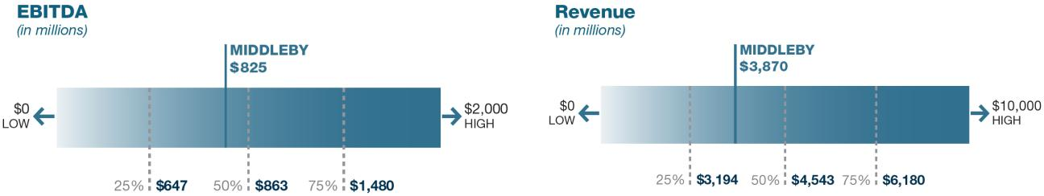

For fiscal year 2025 compensation purposes, Aon presented the Compensation Committee with data regarding compensation for the NEOs. Aon collected this information from the Peer Group.

Aon compiled compensation data at the 25th percentile, median, and 75th percentile levels from the Peer Group, for base salaries, target annual cash incentive awards, target long-term equity awards, and total target direct compensation for individual executive officer positions. Using this data and considering the other factors described above under the heading “Role of the Compensation Committee’s Independent Compensation Consultant”, the Compensation Committee approved adjustments to 2025 compensation packages for our NEOs to maintain an appropriate level of total compensation in comparison to the market that is consistent with emphasizing pay for performance.

Fiscal Year 2025 Compensation Decisions

The Company’s compensation program is generally divided into three elements: base salary, annual cash incentive, and long-term equity-based incentive. We use the mix of these elements to emphasize pay for performance and to recognize the different value brought by individual jobs within the Company. For example, our CEO has the greatest responsibility for the operation and performance of the business and, accordingly, the most potential upside in compensation, but he also has the most compensation at risk, depending on Middleby’s financial performance.

Base Salary

Base salary is fixed and provides some stable income since the other elements of our NEOs’ compensation packages are at significant risk. Annual base salary levels and any increases are budgeted based on the Company’s current business environment and the individual’s level of responsibility and merit within the Company.

2026 PROXY STATEMENT 36

Back to Contents

The base salary of our CEO, Mr. FitzGerald, has remained unchanged since his promotion to CEO in February 2019. For fiscal year 2025, the Compensation Committee approved increases to base salaries of our other NEOs in alignment with market compensation data provided by Aon. Among other factors, the Compensation Committee also recognized additional duties and responsibilities for each position, the importance of retaining key executive talent and the status of the labor market generally.

 | 2024 Base | 2025 Base | Percentage
Named Executive Officer | Salary | Salary | Change
Timothy J. FitzGerald (CEO) | $975,000 | $975,000 | 0%
Bryan E. Mittelman (CFO) | $550,000 | $566,500 | 3.00%
James K. Pool III (Chief Technology and Operations Officer) | $600,000 | $618,000 | 3.00%
Steven P. Spittle (Chief Commercial Officer) | $600,000 | $618,000 | 3.00%
Matthew R. Fuchsen (Chief Development Officer) | $420,000 | $432,600 | 3.00%

Annual Performance-Based Incentive Program

The Company provides annual performance-based cash incentives pursuant to the Value Creation Incentive Plan (“VCIP”). Under the VCIP, the Compensation Committee can establish performance goals utilizing multiple metrics, with the flexibility to adjust metrics and goals to address changing business needs. The VCIP is intended to provide an incentive for strong performance and to motivate eligible employees toward the highest level of achievement and business results by tying their goals and interests to those of the Company and our stockholders.

In fiscal year 2025, the Compensation Committee approved and implemented an annual cash-based incentive compensation program under the VCIP for all of the NEOs. The annual incentive compensation program for 2025 includes bonus opportunities based upon performance against goals for organic adjusted EBITDA$ (“EBITDA$”) and organic adjusted EBITDA% (“EBITDA%”) for fiscal year 2025. These metrics, which emphasize different aspects of our performance than the metrics used for the long-term incentive plan, were implemented in part due to prior stockholder outreach, are consistent with leading governance practices, and serve as an effective reference for senior managers when making decisions for their respective operations. The Compensation Committee retains discretion regarding the determination of achievement of the performance metrics.

The following table shows 2025 actual EBITDA$ and EBITDA% as compared to the target EBITDA$ and EBITDA% goals and the corresponding annual performance-based cash compensation for each NEO under the VCIP. Each NEO’s target bonus opportunity under the VCIP for fiscal year 2025 was set at 100% of base salary and a maximum of 200% of base salary, as set forth below:

2025 ANNUAL PERFORMANCE-BASED CASH INCENTIVE PLAN PERFORMANCE

 |  |  |  |  |  |  |  |  |  |  |  |  | Annual
 |  |  |  |  |  |  |  |  |  |  |  |  | Performance-
 | Relative |  |  |  |  |  |  |  | Reported |  | Adjusted |  | Based Cash
Performance Metric | Weighting | Threshold |  |  | Target | Target+ | Maximum |  |  | Result |  | Result | Compensation*
EBITDA$ (in millions)** | 65% | $ | 880 | $ | 900 | $ 920 | $ | 940 | $ | 798 | $ | 797
Percentage of Base Salary |  |  | 33% |  | 65% | 98% |  | 130% |  |  |  |  | 0%
EBITDA%** | 35% |  | 22.05% |  | 22.30% | 22.55% |  | 22.80% |  | 20.28% |  | 20.24%
Percentage of Base Salary |  |  | 18% |  | 35% | 53% |  | 70% |  |  |  |  | 0%

- When applicable, EBITDA$and EBITDA% Annual Performance-Based Cash Compensation is calculated based upon the percentage of base salary at the adjusted result, calculated on a linear basis between the performance targets.

- EBITDA$and EBITDA% are not prepared in accordance with GAAP. For a reconciliation of EBITDA$to the most directly comparable GAAP financial measure and insight into how these non-GAAP measures are considered by management, please see Annex A, where EBITDA$is referred to as Adjusted EBITDA. EBITDA% is calculated as EBITDA$divided by GAAP revenue.

2026 PROXY STATEMENT 37

Back to Contents

For fiscal year 2025, the Compensation Committee determined that the EBITDA$ and EBITDA% performance metrics had results as set forth in the table above. Results were evaluated based on an as reported basis in US dollars. The Compensation Committee determined the EBITDA$ achieved amounted to $797 million and the EBITDA% performance amounted to 20.24%. The Compensation Committee exercised discretion to reduce achievement of the performance metrics by taking into account the effects of certain non-recurring expenses. After adjustment taking into account these factors, the Compensation Committee approved the EBITDA$ and EBITDA% performance metrics as reduced in the table above, resulting in annual performance-based cash compensation to the NEOs for the EBITDA$ performance metric at 0% of base salary and for the EBITDA% performance metric at 0% of base salary. Absent such adjustments, the annual performance-based cash compensation for the NEOs for performance during fiscal year 2025 would have been as follows: Mr. FitzGerald $0, Mr. Mittelman $0, Mr. Pool $0, Mr. Spittle $0, and Mr. Fuchsen $0.

 | Annual Performance-Based
Named Executive Officer | Cash Compensation for 2025
Timothy J. FitzGerald (CEO) | $ | 0
Bryan E. Mittelman (CFO) | $ | 0
James K. Pool III (Chief Technology and Operations Officer) | $ | 0
Steven P. Spittle (Chief Commercial Officer) | $ | 0
Matthew R. Fuchsen (Chief Development Officer) | $ | 0

For 2025, the annual-performance based cash compensation earned by the NEOs at 0% of target demonstrates the alignment of the Company’s annual incentive compensation with the Company’s short-term performance and the interests of the Company’s stockholders.

Equity-Based Incentive Compensation

We believe that our LTI structure is consistent with leading governance practices, serves as an effective reference for senior managers when making decisions for their respective operations, and further aligns management with stockholder interests.

The LTI award granted to the NEOs in fiscal year 2025 contained all of the features of the current LTI program described above and summarized below.

Component | Current LTI Practices
Award Type | Performance-based PSUs (2/3 weight)
 | Time-based RSUs (1/3 weight)
Award Timing | LTI awards made annually
Term | Three years
Performance and Vesting Period | Time-based awards: ratable over three years, but shares must be held until the end of the three fiscal year period
 | to which they relate
 | Performance-based awards: cliff vest to the extent earned, at the end of the three-year performance period
Performance Criteria | Adjusted EPS Growth (65% weight)
 | Return on Invested Capital (35% weight)
TSR Modifier | • | Vested performance shares increase by 30% for three-year TSR performance that is at or above the 75th
 |  | percentile versus the Peer Group
 | • | Vested performance shares are unchanged for three-year TSR performance that is between the 25th and 75th
 |  | percentile versus Peer Group
 | • | Vested performance shares decrease by 30% for three-year TSR performance that is at or below the 25th
 |  | percentile versus the Peer Group

2025 Long-Term Equity Incentive Awards

In May 2025, the Compensation Committee approved LTI equity awards to our Named Executive Officers consisting of performance-based PSUs (66.7% of target LTI value) and time-based RSUs (33.3% of target LTI value). The performance period for the performance-based PSUs covers fiscal years 2025, 2026 and 2027, and vesting, if any, will be approved by the Compensation Committee in the first quarter of fiscal year 2028. The time-based RSUs will vest, subject to the NEO’s continued employment, in equal increments, in March 2026, March 2027 and March 2028. The shares underlying the time-based RSUs must be held until the end of the three fiscal year period to which they relate. All future performance-based equity grants made during our annual grant cycle are currently expected also to have a three-year performance and vesting period.

The Compensation Committee sets the grant date target value for LTI awards for our Named Executive Officers other than the CEO. Using market-based long-term equity grant values and incentive plan design information provided by the Compensation Committee’s independent compensation consultants as a guide, Mr. FitzGerald recommends to the Compensation Committee awards for our Named Executive Officers (other than himself) and members of senior management.

2026 PROXY STATEMENT 38

Back to Contents

The Board established Mr. FitzGerald’s target LTI award based upon the recommendations of the Compensation Committee. In forming its recommendation, the Compensation Committee reviewed competitive compensation data for the Peer Group provided by Aon and considered other relevant factors.

Target LTI awards for our Named Executive Officers are shown below.
 |  |  | Target
 |  | Grant date | performance- | Target
 | target value of |  | based | time-based
 |  | award* | PSUs | RSUs
Executive |  | ($) | (#) | (#)
Timothy J. FitzGerald | $ | 6,540,573 | 29,086 | 14,544
Bryan E. Mittelman | $ | 1,957,075 | 8,703 | 4,352
James K. Pool III | $ | 2,678,142 | 11,910 | 5,955
Steven P. Spittle | $ | 2,678,142 | 11,910 | 5,955
Matthew R. Fuchsen | $ | 1,467,319 | 6,527 | 3,264

- The Compensation Committee determined the number of PSUs and RSUs to grant based on the price of Middleby common stock on May 13, 2025, which was $149.91 per share. The numbers in this column will differ from the fiscal 2025 numbers in the “Stock Awards” column in the Summary Compensation Table for Fiscal Year 2025 and the “Grant Date Fair Value of Stock and Option Awards” column in the Grants of Plan-Based Awards in Fiscal Year 2025 below, because in those tables, values are calculated in accordance with FASB ASC Topic 718.

Performance Targets for 2025 LTI Awards

The performance-based PSUs have two primary metrics: Adjusted EPS Growth (65%) and Return on Invested Capital (35%).

Metric | Definition | Rationale
Adjusted EPS Growth | Net Earnings plus the following: amortization, restructuring | This is an easily understood metric that is reported in Middleby’s
 | expenses, acquisition-related inventory step-up charges, facility | earnings releases, that closely aligns with stockholder growth
 | consolidation expense, net periodic pension benefit other than | expectations, and that is closely aligned with the valuation of the
 | service costs, one-time restructuring costs, and income tax effect | Company.
 | of pre-tax adjustments, with the result divided by shares
 | outstanding.

Return on Adjusted net operating profit after tax for a fiscal year period

Invested Capital divided by average invested capital for the same fiscal year period.

This metric closely aligns to stockholder value creation by measuring how well the Company is using its capital it has invested to generate profit. It rewards the improvement of EBITDA while using resources wisely, supporting smart investments, and focusing on long-term value.

Performance targets are set based on management’s multi-year forecast of Adjusted EPS Growth and Return on Invested Capital. The maximum possible payout is 200% of target based on our performance against goals for these measures, subject to a further TSR modifier as described below. We disclose the targets for Adjusted EPS Growth and Return on Invested Capital retrospectively due to the competitive harm that could result from disclosing these targets prospectively. However, consistent with stockholder feedback, the performance targets for the performance period that spans fiscal years 2025, 2026 and 2027 reflect rigorous performance goals that are challenging to achieve. The Compensation Committee retains discretion regarding the determination of achievement of the performance metrics.

Once awards are calculated based on Middleby’s performance for the three-year performance period (“Pre-TSR Vested Shares”), the Compensation Committee will

calculate whether the TSR modifier applies. If Middleby’s TSR for the three-year performance period is at or above the 75th percentile versus the Peer Group, the final grants to our Named Executive Officers will equal the number of Pre-TSR Vested Shares multiplied by 130%. Conversely, if Middleby’s TSR for the three-year
performance period is at or below the 25th percentile versus the Peer Group, the final grants to our Named Executive Officers will equal the number of Pre-TSR Vested Shares multiplied by 70% (meaning that there is a negative adjustment of 30%). Final awards will equal the number Pre-TSR Vested Shares if Middleby’s TSR for the
three-year performance period falls between the 25th and 75th percentiles versus the Peer Group.

Time-Based RSUs; Holding Period

The time-based LTI awards vest ratably over three years, so long as the recipient is still employed by the Company. However, the shares underlying the vested RSUs may not be sold or otherwise transferred until the associated performance-based PSUs vest (or fail to vest based on performance). The TSR modifier will not affect the number of time-based RSUs that vest.

Vesting of Equity Incentive Awards for 2023-2025 Performance Period

On August 9, 2023, the Company granted performance-based PSU and time-based RSU awards to the NEOs. The performance-based component of the award provided that a portion of the award, up to the maximum number of shares subject to the award, would be earned at the end of a three-year performance period based on the achievement of a multi-year forecast in Adjusted EPS Growth and Enterprise Value Growth (Less Net Debt) per share (as certified by the Compensation Committee in early 2026). The three-year performance period for these awards began on December 31, 2022 and ended on January 3, 2026. The time-based RSU component vested in 1/3 increments on each of March 1, 2024, March 1, 2025 and March 1, 2026, subject to continued employment on each such date.

2026 PROXY STATEMENT 39

Back to Contents

Three-Year Performance Period for 2023-2025

The aggregate maximum number of performance-based PSUs that were eligible to vest over the three-year performance period ended January 3, 2026 (after including the +-30% TSR modifier) equaled 72,378 for Mr. FitzGerald, 20,598 for Mr. Mittelman, 28,246 for Mr. Pool, 28,264 for Mr. Spittle, and 16,032 for Mr. Fuchsen. The performance criteria for the Adjusted EPS Growth and Enterprise Value Growth (Less Net Debt) per share performance metrics is the growth achieved over the base year as compared to the average of the results for each year in the performance period. The following chart illustrates the percentage of awarded PSUs that were eligible to vest at various levels of Adjusted EPS Growth and Enterprise Value Growth (Less Net Debt) per share achievement over the three-year performance period ending January 3, 2026 prior to adjustment pursuant to the +-30% TSR modifier:

 |  | 3 Year Enterprise Value Growth (Less Net Debt) per share
 |  | 10% | 17.5% | 32.5%
3 Year Adjusted EPS Growth |  | (threshold) | (target) | (max)
7.5% (threshold) |  | 50% | 75% | 150%
15% | (target) | 75% | 100% | 150%
30% | (max) | 150% | 150% | 200%

For the three-year performance period ended January 3, 2026 the Compensation Committee determined that the Adjusted EPS Growth and Enterprise Value Growth, (Less Net Debt) Per Share performance metrics were 50.4% and 58.8%, respectively, and that the TSR performance metric was below the 25th percentile, resulting in a negative adjustment of 30%. Accordingly, the Compensation Committee approved vesting of the Adjusted EPS Growth PSUs for the 2023-2025 performance period at 35% of target (also reflecting the downward adjustment pursuant to the +-30% TSR modifier), and vesting of the Enterprise Value Growth, (Less Net Debt) Per Share PSUs for the 2023-2025 performance period at 41% of target (also reflecting the downward adjustment pursuant to the +-30% TSR modifier). Shares vested for each NEO as set forth in the chart below.

Named Executive Officer | Vested Performance-Based PSUs
Timothy J. FitzGerald (CEO) | 10,579
Bryan E. Mittelman (CFO) | 3,012
James K. Pool III (Chief Technology and Operations Officer) | 4,130
Steven P. Spittle (Chief Commercial Officer) | 4,130
Matthew R. Fuchsen (Chief Development Officer) | 2,345

For the 2023-2025 performance period, the long-term equity incentives earned by the NEOs at approximately 38% of target demonstrates the alignment of the Company’s long term incentive program with the Company’s long-term performance and achievement of the Company’s strategic plan in the interests of the Company’s stockholders.

The number of shares of time-based RSUs that were awarded to the NEOs on August 8, 2023 totaled 13,919 shares to Mr. FitzGerald, 3,960 shares to Mr. Mittelman, 5,431 shares to Mr. Pool, 5,431 shares to Mr. Spittle, and 3,084 shares to Mr. Fuchsen. 1/3 of these awards vested on March 1, 2026.

Stock Ownership Guidelines

Company guidelines require our Named Executive Officers to own a prescribed amount of Middleby common stock, expressed as a multiple of their respective base salaries. The base salary multiples are set by the Compensation Committee at levels consistent with the individual’s level of responsibility within the Company. Unvested time-based RSUs count toward an executive’s required holdings, but unvested performance-based equity does not. Any covered executives who have not yet met their stock ownership requirements are required to retain 50% of all net shares (post tax) that vest until the minimum share ownership requirement is achieved. Stock options are not counted in the ownership calculation.

As of December 31, 2025, all of our Named Executive Officers exceeded the minimum stock ownership requirements, as shown below.
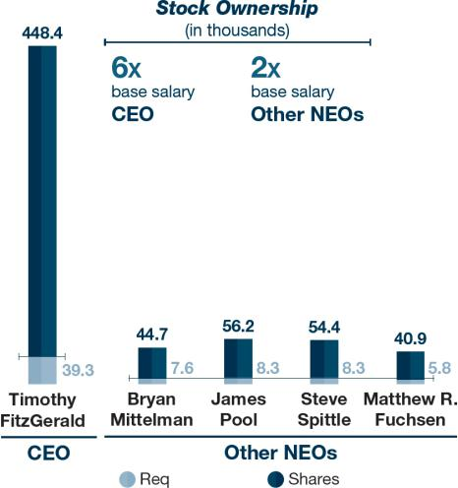

2026 PROXY STATEMENT 40

Back to Contents

Clawback Policy

The Company maintains a Clawback Policy, which requires reimbursement or forfeiture of all or a portion of any incentive compensation (which includes annual bonuses and other short-and long-term cash incentives, stock options, stock appreciation rights, restricted stock, restricted stock units, performance shares and performance units) received by a current or former executive officer during the preceding three completed fiscal years in the event that:

- the Company is required to prepare an accounting restatement of its financial statements due to material noncompliance with any financial reporting requirement under securities law, and

- the restated result indicates that an executive officer received additional incentive compensation based on the erroneous data.

The Company is entitled to recover the amount of excess incentive compensation paid to any executive officer over the incentive compensation that would have been paid to the executive officer had it been based on the restated results, as determined by the Board. The Clawback Policy is intended to comply with Exchange Act Rule 10D-1 and the Nasdaq listing standards regarding recovery of erroneously awarded compensation in the event of an accounting restatement.

Additional Compensation Information

Derivatives Trading, Hedging and Pledging

Pursuant to our Insider Trading Compliance Program, all employees, officers, and directors are prohibited from engaging in any speculative transactions in Middleby stock, including engaging in short sales; transactions involving put options, call options, or other derivative securities; or any other forms of hedging transaction, such as collars or forward sale contracts, designed to decrease the risks associated with holding Middleby stock, except in certain circumstances that must be pre-cleared with the Company’s insider trading compliance officers.

Post-Employment Benefits

The Company provides certain limited post-employment benefits, as described under “Potential Payments Upon Termination or Change in Control.”

Limited Perquisites 401(k) Plan

Our Named Executive Officers and senior executives receive only limited perquisites. Middleby does not offer our NEOs automobile allowances, club memberships, or other professional fee reimbursements.

We maintain a 401(k) retirement savings plan for our employees in the United States, including our Named Executive Officers. Our Named Executive Officers are eligible to participate in the 401(k) plan on the same terms as other full-time employees. Our Named Executive Officers do not participate in any other Company retirement plans.

Employment Agreements

To attract and retain highly skilled executives and to provide for certainty regarding rights and obligations, the Company has historically provided employment agreements to our Chief Executive Officer and certain other executive officers. None of the NEOs other than Mr. FitzGerald have an employment agreement with the Company. For more information, see “Employment Agreements with Named Executive Officers.”

Risk Assessment Regarding Company Compensation Program

The Compensation Committee is committed to ensuring that none of Middleby’s compensation policies and practices—particularly the performance-based compensation—pose excessive risks. The Compensation Committee, together with the Chairperson of the Audit Committee and executive management, has considered the risks arising from the Company’s compensation policies and practices and concluded that those policies and practices are not reasonably likely to have a material adverse effect on the Company. In particular, the Compensation Committee determined that Middleby’s executive compensation program includes several “risk mitigating” elements, such as a Clawback Policy, stock ownership requirements for our NEOs and other senior executives, substantial time-based components in the total compensation mix, the use of multiple performance metrics in our incentive plans, and limitations on the payouts that can be earned through the incentive plans.

Equity Grant Practices

Although we do not have a formal policy regarding the timing of equity award grants, we generally grant annual equity awards to our Named Executive Officers on a pre-established date and we do not grant any form of equity compensation in anticipation of the release of material, non-public information. Similarly, we do not time the release of material, non-public information based on equity award grant dates for the purpose of affecting the value of any equity award. The Compensation Committee also does not take material, non-public information into account when determining the timing and terms of equity award grants, provided that, if material, non-public information becomes known to the Compensation Committee prior to granting an equity award, the Compensation Committee takes the existence of such information into consideration and uses its business judgment to determine whether to delay the grant of equity to avoid any impropriety. During fiscal 2025, we did not grant any options to our employees.

Tax and Accounting Considerations

Deductibility of Executive Compensation

Section 162(m) of the Internal Revenue Code generally imposes a $1 million cap on the federal income tax deduction for compensation paid to our “covered employees” during any fiscal year. While the Compensation Committee considers the deductibility of awards as one factor in determining Named Executive Officer compensation, the Compensation Committee also looks at other factors in making its decisions, and, in the exercise of its business judgment and in accordance with its compensation philosophy, the Compensation Committee retains the flexibility to award compensation even if the compensation is not deductible by us for tax purposes, and to modify compensation that was initially intended to be tax deductible if it determines such modifications are consistent with our business needs.

Accounting for Stock-Based Compensation

The Compensation Committee takes accounting considerations into account in designing compensation plans and arrangements for our Named Executive Officers and other employees. We follow FASB ASC Topic 718 for our stock-based compensation awards. FASB ASC Topic 718 requires us to measure the compensation expense for all share-based payment awards based on the grant date “fair value” of these awards.

2026 PROXY STATEMENT 41

Back to Contents

Report of the Compensation Committee of the Board of Directors

The Compensation Committee, consisting entirely of independent directors, reviewed and discussed the above Compensation Discussion and Analysis with the Company’s management. Based on this review and discussion, the Compensation Committee has recommended to the Company’s Board that the CD&A be included in these proxy materials and in Middleby’s Annual Report on Form 10-K for the year ended January 3, 2026.

The Compensation Committee:

Stephen R. Scherger, Chairman,

Edward P. Garden and Gordon J. O’Brien

2026 PROXY STATEMENT 42

Back to Contents

Executive Compensation Tables

Summary Compensation Table for Fiscal Year 2025

The following table sets forth information concerning the annual and long-term compensation for services to the Company in all capacities received by the following individuals, who are collectively referred to as the Company’s “Named Executive Officers” for fiscal year 2025: the Chief Executive Officer, the Chief Financial Officer, and the three other most highly compensated executive officers. The table covers compensation for fiscal years 2023, 2024 and 2025.

 |  |  |  | Stock |  | Non-Equity
 |  |  |  | Stock | Option | Incentive Plan | All Other
Name and | Fiscal | Salary | Bonus | Awards | Awards | Compensation | Compensation | Total
Principal Position | Year | ($) | ($) | ($)⁽¹⁾ | ($) | ($) | ($) | ($)
Timothy J. FitzGerald | 2025 | 975,000 |  | 7,220,604 |  | 0 | 12,245⁽²⁾ | 8,207,849
Chief Executive Officer | 2024 | 975,000 |  | 6,343,205 |  | 186,781 | 20,495 | 7,525,481
 | 2023 | 975,000 |  | 6,140,784 |  | 1,300,650 | 18,445 | 8,434,879
Bryan E. Mittelman | 2025 | 566,500 |  | 2,160,551 |  | 0 | 12,245⁽³⁾ | 2,739,296
Chief Financial Officer | 2024 | 550,000 |  | 1,898,021 |  | 105,364 | 14,088 | 2,567,473
 | 2023 | 525,000 |  | 1,747,367 |  | 700,350 | 13,580 | 2,986,297
James K. Pool III | 2025 | 618,000 |  | 2,956,598 |  | 0 | 9,209⁽⁴⁾ | 3,583,807
Chief Technology and Operations | 2024 | 600,000 |  | 2,597,255 |  | 114,942 | 9,195 | 3,321,392
Officer | 2024 | 600,000 |  | 2,597,255 |  | 114,942 | 9,195 | 3,321,392
Officer | 2023 | 575,000 |  | 2,396,342 |  | 767,050 | 8,945 | 3,747,337
Steven P. Spittle | 2025 | 618,000 |  | 2,956,598 |  | 0 | 9,275⁽⁵⁾ | 3,583,873
Chief Commercial Officer | 2024 | 600,000 |  | 2,597,255 |  | 114,942 | 13,775 | 3,325,972
 | 2023 | 575,000 |  | 2,396,342 |  | 767,050 | 13,525 | 3,751,917
Matthew R. Fuchsen | 2025 | 432,600 |  | 1,620,370 |  | 0 | 12,245⁽⁶⁾ | 2,065,215
Chief Development Officer | 2024 | 420,000 |  | 1,423,516 |  | 80,460 | 12,118 | 1,936,094
 | 2023 | 400,000 | — | 1,360,305 | — | 533,600 | 16,627 | 2,310,532

- The amounts reported in the “Stock Awards” column of the table reflect the fair value on the grant date of equity awards granted to our NEOs determined in accordance with FASB ASC Topic 718, excluding the effect of estimated forfeitures. For time-based RSUs, fair value is computed by multiplying the total number of shares subject to the award (or target number of shares, if applicable) by the closing price per share of our common stock as reported on the date of grant. For the PSUs, fair value has been calculated based on the probable outcome of the applicable performance conditions and a Monte Carlo simulation valuation model. The closing trading value of our common stock was $149.91 per share on May 13, 2025. The fair value on the grant date of the PSUs granted to our NEOs during 2025 based upon the maximum possible level of achievement under such awards would be $13,104,814 for Mr. FitzGerald, $3,921,171 for Mr. Mittelman, $5,366,098 for Mr. Pool, $5,366,098 for Mr. Spittle, and $2,940,766 for Mr. Fuchsen. Refer to the footnotes to the Grants of Plan-Based Awards table for the assumptions made when calculating the grant date fair values of the fiscal year 2025 grants of RSUs and PSUs.

- All other compensation amounts in 2025 for Mr. FitzGerald include a $1,375 Company contribution to a health savings account, $3,870 in Company-paid life insurance premiums, and a 401(k) Company matching contribution of $7,000.
- All other compensation amounts in 2025 for Mr. Mittelman include a $1,375 Company contribution to a health savings account, $3,870 in Company-paid life insurance premiums, and a 401(k) Company matching contribution of $7,000.
- All other compensation amounts in 2025 for Mr. Pool may include a $1,375 Company contribution to a health savings account, $2,070 in Company-paid life insurance premiums, and a 401(k) Company matching contribution of $5,764.
- All other compensation amounts in 2025 for Mr. Spittle include a $1,375 Company contribution to a health savings account, $900 in Company-paid life insurance premiums, and a 401(k) Company matching contribution of $7,000.
- All other compensation amounts in 2025 for Mr. Fuchsen include a $1,375 Company contribution to a health savings account, $3,870 in Company-paid life insurance premiums, and a 401(k) Company matching contribution of $7,000.

2026 PROXY STATEMENT 43

Back to Contents

Employment Agreements with Named Executive Officers

Timothy J. FitzGerald

On March 10, 2022, the Company and MM entered into an employment agreement with Mr. FitzGerald. This employment agreement supersedes his previous employment agreement and memorializes Mr. FitzGerald’s current base salary of $975,000 (which remains unchanged since his promotion to CEO in 2019) and his eligibility to participate in the Company’s management incentive programs. The initial term of such employment agreement ended on December 31, 2024 and was extended automatically upon the same terms and conditions for additional one-year periods.

The terms of the employment agreement relating to the termination of Mr. FitzGerald’s employment are discussed below under the heading “Potential Payments Upon Termination or Change in Control.”

Any summaries of Mr. FitzGerald’s employment agreement are qualified in their entirety by reference to the employment agreement, which is filed as an exhibit to the Company’s Annual Report on Form 10-K for the fiscal year ended January 3, 2026.

Grants of Plan-Based Awards in Fiscal Year 2025

The following table sets forth information concerning cash incentive opportunities and grants of RSUs and PSUs made to our NEOs during fiscal year 2025. The grant dates set forth below indicate the date on which the Board granted the award.

 |  | Estimated Future Payouts |  |  |  | Estimated Future Payouts
 |  | Under Non-Equity Incentive |  |  |  | Under Equity Incentive
 |  | Plan Awards⁽¹⁾ |  |  |  | Plan Awards |  |  |  |  | Grant Date
 |  |  |  |  |  |  |  |  |  | All Other Stock | Fair Value
 |  |  |  |  |  |  |  |  |  | Awards: Number | of Stock
 |  |  |  |  |  |  |  |  |  | of Shares of | and Option
 | Grant | Threshold | Target | Max |  | Threshold | Target | Max |  | Stock or Units | Awards
Name | Date | ($) | ($) | ($) |  | (#) | (#) | (#) |  | (#) | _{($)}(2)
Timothy J. FitzGerald
 | (1) | 170,625 | 975,000 | 1,950,000
 | 5/13/25⁽³⁾⁽⁴⁾ |  |  |  |  | 10,181 | 29,086 | 75,264 |  |  | 5,040,313
 | 5/13/25⁽⁵⁾ |  |  |  |  |  |  |  |  | 14,544 | 2,180,291
Bryan E. Mittelman
 | (1) | 99,138 | 566,500 | 1,133,000
 | 5/13/25⁽³⁾⁽⁴⁾ |  |  |  |  | 3,047 | 8,703 | 22,628 |  |  | 1,508,143
 | 5/13/25⁽⁵⁾ |  |  |  |  |  |  |  |  | 4,352 | 652,408
James K. Pool III
 | (1) | 108,150 | 618,000 | 1,236,000
 | 5/13/25⁽³⁾⁽⁴⁾ |  |  |  |  | 4,169 | 11,910 | 30,966 |  |  | 2,063,884
 | 5/13/25⁽⁵⁾ |  |  |  |  |  |  |  |  | 5,955 | 892,714
Steven P. Spittle
 | (1) | 108,150 | 618,000 | 1,236,000
 | 5/13/25⁽³⁾⁽⁴⁾ |  |  |  |  | 4,169 | 11,910 | 30,966 |  |  | 2,063,884
 | 5/13/25⁽⁵⁾ |  |  |  |  |  |  |  |  | 5,955 | 892,714
Matthew R. Fuchsen
 | (1) | 75,705 | 432,600 | 865,200
 | 5/13/25⁽³⁾⁽⁴⁾ |  |  |  |  | 2,285 | 6,527 | 16,971 |  |  | 1,131,064
 | 5/13/25⁽⁵⁾ |  |  |  |  |  |  |  |  | 3,264 | 489,306

- Annual incentive plan award granted pursuant to the VCIP utilizing EBITDA$and EBITDA% performance metrics.

- Represents the fair value on the grant date of equity awards granted to our Named Executive Officers, consistent with the estimate of the aggregate compensation cost to be recognized over the applicable service period determined in accordance with FASB ASC Topic 718, excluding the effect of estimated forfeitures. For the RSUs, fair value is computed by multiplying the total number of shares subject to the award by the closing price per share of our common stock as reported on the date of grant. The closing trading value of our common stock was $149.91 per share on May 13, 2025. The dollar amounts for the PSUs are calculated in accordance with FASB ASC Topic 718 and assume payment of PSUs at target using a Monte Carlo simulation valuation model to reflect the impact of the TSR modifier, incorporating the following significant assumptions with respect to the May 13, 2025 grant (a) a risk-free interest rate of 4.01%, based on the U.S. constant maturity treasury rates commensurate with the expected term; (b) expected dividend yield of 0.0%; (c) expected volatility of 30.6%, based on the historical trading prices of Middleby with look-back periods commensurate with the expected term; and (d) expected term of 2.63 years.

2026 PROXY STATEMENT 44

Back to Contents

- Represents the PSUs granted on May 13, 2025. Amounts shown in the “threshold” column represent the total number of PSUs that could be earned upon achievement of the performance criteria at the threshold level, including application of a negative 30% TSR modifier and assume continued employment through the applicable vesting dates. Amounts shown in the “target” column represent the number of PSUs that could be earned upon achievement of the performance criteria at the target level and assume continued employment through the applicable vesting dates. Amounts shown in the “maximum” column represent the maximum number of PSUs that could be earned upon achievement of the performance criteria at the maximum level, including application of a positive 30% TSR modifier and continued employment through the applicable vesting dates. Threshold, target and maximum reported numbers in the table above assume potential TSR performance below the 25th percentile for the threshold performance tier, between the 25th percentile and the 75th percentile for the target performance tier, and above the 75th percentile for the maximum performance tier.

- On May 13, 2025, each NEO was granted PSUs that vest based upon Adjusted EPS growth and Return on Invested Capital performance metrics with respect to the performance period commencing on December 29, 2024, and ending on January 1, 2028. Vesting of the PSUs is subject to approval by Compensation Committee following certification of 2027 financial results. The PSUs also feature a TSR mechanism that compares the TSR of the Company to the peer group of the Company as reported in the most recent annual proxy statement. The TSR modifier decreases the number of PSUs that can be earned by 30% for Company TSR performance in the bottom quartile measured against the Company peer group and increases the number of PSUs that can be earned by 30% for Company TSR performance in the top quartile measured against the Company peer group.

- On May 13, 2025, each NEO was granted time-based RSUs that vest one-third on each of March 1, 2026, March 1, 2027, and March 1, 2028, subject to continued employment on each such vesting date.

2026 PROXY STATEMENT 45

Back to Contents

Outstanding Equity Awards at 2025 Fiscal Year End

The following table sets forth certain information concerning outstanding stock awards held by each of our Named Executive Officers under the LTIP at the end of fiscal year 2025.

 |  | Option Awards |  |  |  |  |  | Stock Awards
 |  |  |  |  |  |  |  |  |  | Equity
 |  |  |  |  |  |  |  |  | Equity | Incentive
 |  |  |  |  |  |  |  |  | Incentive | Plan
 |  |  | Equity |  |  |  |  |  | Plan | Awards:
 |  |  | Incentive |  |  |  |  |  | Awards: | Market or
 |  |  | Plan |  |  |  |  | Market | Number of | Payout Value
 |  |  | Awards: |  |  |  |  | Value of | Unearned | of Unearned
 |  |  | Number of |  |  |  | Number of | Shares or | Shares, | Shares,
 | Number of | Number of | Securities |  |  |  | Shares or | Units of | Units | Units
 | Securities | Securities | Underlying |  |  |  | Units of | Stock | or Other | or Other
 | Underlying | Underlying | Unexercised | Option |  |  | Stock | That Have | Rights That | Rights That
 | Unexercised | Unexercised | Unearned | Exercise | Option |  | That Have | Not | Have Not | Have Not
 | Options(#) | Options(#) | Options | Price | Expiration |  | Not Vested | Vested | Vested | Vested
Name | Exercisable | Unexercisable | (#) | ($) | Date |  | (#) | ($)⁽¹⁾ | (#) | ($)⁽²⁾
Timothy J. FitzGerald | — | — | — | — | — |  | 15,220⁽³⁾ | 2,294,719 |  | —
 |  |  |  |  |  |  | 10,300⁽⁴⁾ | 1,552,931 | 30,898⁽⁴⁾ | 4,658,491
 |  |  |  |  |  |  | 14,544⁽⁵⁾ | 2,192,799 | 29,086⁽⁵⁾ | 4,385,296
Bryan E. Mittelman | — | — | — | — | — |  | 4,332⁽⁶⁾ | 653,136 |  | —
 |  |  |  |  |  |  | 3,082⁽⁷⁾ | 464,673 | 9,246⁽⁷⁾ | 1,394,019
 |  |  |  |  |  |  | 4,352⁽⁸⁾ | 656,151 | 8,703⁽⁸⁾ | 1,312,151
James K. Pool III | — | — | — | — | — |  | 5,941⁽⁹⁾ | 895,725 |  | —
 |  |  |  |  |  |  | 4,217⁽¹⁰⁾ | 635,797 | 12,652⁽¹⁰⁾ | 1,907,542
 |  |  |  |  |  |  | 5,955⁽¹¹⁾ | 897,835 | 11,910⁽¹¹⁾ | 1,795,671
Steven P. Spittle | — | — | — | — | — |  | 5,941⁽¹²⁾ | 895,725 |  | —
 |  |  |  |  |  |  | 4,217⁽¹³⁾ | 635,797 | 12,652⁽¹³⁾ | 1,907,542
 |  |  |  |  |  |  | 5,955⁽¹⁴⁾ | 897,835 | 11,910⁽¹⁴⁾ | 1,795,671
Matthew R. Fuchsen | — | — | — | — | — |  | 3,373⁽¹⁵⁾ | 508,547 |  | —
 |  |  |  |  |  |  | 2,312⁽¹⁶⁾ | 348,580 | 6,934⁽¹⁶⁾ | 1,045,439
 |  |  |  |  |  |  | 3,264⁽¹⁷⁾ | 492,113 | 6,527⁽¹⁷⁾ | 984,076

- This column reflects time-based RSUs awarded to our NEOs. This column also reflects PSUs that were outstanding at fiscal year end for which the performance period completed on January 3, 2026 based on their actual performance. Market value is computed by multiplying the total number of shares subject to the award by the closing price of our common stock of $150.77 per share on January 2, 2026, our last trading day of fiscal year 2025.

- This column reflects performance-based PSUs awarded to our NEOs. Market value is computed by multiplying the total number of shares subject to the award as reported in the column immediately to the left by the closing price of our common stock of $150.77 per share on January 2, 2026. The PSUs included in in this column and the column immediately to the left are included assuming target performance levels, because performance for such PSUs was tracking between threshold and target performance as of January 3, 2026.

- On August 9, 2023, Mr. FitzGerald was awarded (i) 27,838 target number of PSUs that included potential for maximum vesting of 72,378 PSUs, and (ii) 13,919 RSUs. The RSUs are scheduled to vest in 1/3 increments on each of March 1, 2024, March 1, 2025 and March 1, 2026. 4,639 RSUs vested on each of March 1, 2024 and March 1, 2025. The PSU component of the award provides that shares may be earned based on the achievement of Adjusted EPS growth and EV growth per share performance targets with respect to the January 1, 2023 to December 27, 2025 performance period.

- On May 14, 2024, Mr. FitzGerald was awarded (i) 30,898 target number of PSUs that included potential for maximum vesting of 80,336 PSUs, and (ii) 15,449 RSUs. The RSUs are scheduled to vest in 1/3 increments on each of March 1, 2025, March 1, 2026 and March 1, 2027. 5,149 RSUs vested on March 1, 2025. The PSU component of the award provides that shares may be earned based on the achievement of Adjusted EPS growth and EV growth per share performance targets with respect to the December 31, 2023 to January 2, 2027 performance period.

- On May 13, 2025, Mr. FitzGerald was awarded (i) 29,086 target number of PSUs that included potential for maximum vesting of 75,264 PSUs, and (ii) 14,544 RSUs. The RSUs are scheduled to vest in 1/3 increments on each of March 1, 2026, March 1, 2027, and March 1, 2028. The PSU component of the award provides that shares may be earned based on the achievement of Adjusted EPS growth and Return on Invested Capital performance targets with respect to the December 29, 2024 to January 1, 2028 performance period, subject to a TSR modifier for the three year performance period, and is scheduled to vest in the first quarter of fiscal year 2028.

- On August 9, 2023, Mr. Mittelman was awarded (i) 7,922 target number of PSUs that included potential for maximum vesting of 20,598 PSUs, and (ii) 3,960 RSUs. The RSUs are scheduled to vest in 1/3 increments on each of March 1, 2024, March 1, 2025 and March 1, 2026. 1,320 RSUs vested on each of March 1, 2024 and March 1, 2025. The PSU component of the award provides that shares may be earned based on the achievement of Adjusted EPS growth and EV growth per share performance targets with respect to the January 1, 2023 to December 27, 2025 performance period.

- On May 14, 2024, Mr. Mittelman was awarded (i) 9,246 target number of PSUs that included potential for maximum vesting of 24,040 PSUs, and (ii) 4,622 RSUs. The RSUs are scheduled to vest in 1/3 increments on each of March 1, 2025, March 1, 2026 and March 1, 2027. 1,540 RSUs vested on March 1, 2025. The PSU component of the award provides that shares may be earned based on the achievement of Adjusted EPS growth and EV growth per share performance targets with respect to the December 31, 2023 to January 2, 2027 performance period.

2026 PROXY STATEMENT 46

Back to Contents

- On May 13, 2025, Mr. Mittelman was awarded (i) 8,703 target number of PSUs that included potential for maximum vesting of 22,628 PSUs, and (ii) 4,352 RSUs. The RSUs are scheduled to vest in 1/3 increments on each of March 1, 2026, March 1, 2027, and March 1, 2028. The PSU component of the award provides that shares may be earned based on the achievement of Adjusted EPS growth and Return on Invested Capital performance targets with respect to the December 29, 2024 to January 1, 2028 performance period, subject to a TSR modifier for the three year performance period, and is scheduled to vest in the first quarter of fiscal year 2028.

- On August 9, 2023, Mr. Pool was awarded (i) 10,864 target number of PSUs that included potential for maximum vesting of 28,246 PSUs, and (ii) 5,431 RSUs. The RSUs are scheduled to vest in 1/3 increments on each of March 1, 2024, March 1, 2025 and March 1, 2026. 1,810 RSUs vested on each of March 1, 2024 and March 1, 2025. The PSU component of the award provides that shares may be earned based on the achievement of Adjusted EPS growth and EV growth per share performance targets with respect to the January 1, 2023 to December 27, 2025 performance period.

- On May 14, 2024, Mr. Pool was awarded (i) 12,652 target number of PSUs that included potential for maximum vesting of 32,896 PSUs, and (ii) 6,325 RSUs. The RSUs are scheduled to vest in 1/3 increments on each of March 1, 2025, March 1, 2026 and March 1, 2027. 2,108 RSUs vested as on March 1, 2025. The PSU component of the award provides that shares may be earned based on the achievement of Adjusted EPS growth and EV growth per share performance targets with respect to the December 31, 2023 to January 2, 2027 performance period.

- On May 13, 2025, Mr. Pool was awarded (i) 11,910 target number of PSUs that included potential for maximum vesting of 30,966 PSUs, and (ii) 5,955 RSUs. The RSUs are scheduled to vest in 1/3 increments on each of March 1, 2026, March 1, 2027, and March 1, 2028. The PSU component of the award provides that shares may be earned based on the achievement of Adjusted EPS growth and Return on Invested Capital performance targets with respect to the December 29, 2024 to January 1, 2028 performance period, subject to a TSR modifier for the three year performance period, and is scheduled to vest in the first quarter of fiscal year 2028.

- On August 9, 2023, Mr. Spittle was awarded (i) 10,864 target number of PSUs that included potential for maximum vesting of 28,246 PSUs, and (ii) 5,431 RSUs. The RSUs are scheduled to vest in 1/3 increments on each of March 1, 2024, March 1, 2025 and March 1, 2026. 1,810 RSUs vested on each of March 1, 2024 and March 1, 2025. The PSU component of the award provides that shares may be earned based on the achievement of Adjusted EPS growth and EV growth per share performance targets with respect to the January 1, 2023 to December 27, 2025 performance period.

- On May 14, 2024, Mr. Spittle was awarded (i) 12,652 target number of PSUs that included potential for maximum vesting of 32,896 PSUs, and (ii) 6,325 RSUs. The RSUs are scheduled to vest in 1/3 increments on each of March 1, 2025, March 1, 2026 and March 1, 2027. 2,108 RSUs vested on March 1, 2025. The PSU component of the award provides that shares may be earned based on the achievement of Adjusted EPS growth and EV growth per share performance targets with respect to the December 31, 2023 to January 2, 2027 performance period.

- On May 13, 2025, Mr. Spittle was awarded (i) 11,910 target number of PSUs that included potential for maximum vesting of 30,966 PSUs, and (ii) 5,955 RSUs. The RSUs are scheduled to vest in 1/3 increments on each of March 1, 2026, March 1, 2027, and March 1, 2028. The PSU component of the award provides that shares may be earned based on the achievement of Adjusted EPS growth and Return on Invested Capital performance targets with respect to the December 29, 2024 to January 1, 2028 performance period, subject to a TSR modifier for the three year performance period, and is scheduled to vest in the first quarter of fiscal year 2028.

- On August 9, 2023, Mr. Fuchsen was awarded (i) 6,166 target number of PSUs that included potential for maximum vesting of 16,032 PSUs, and (ii) 3,084 RSUs. The RSUs are scheduled to vest in 1/3 increments on each of March 1, 2024, March 1, 2025 and March 1, 2026. 1,028 RSUs vested on each of March 1, 2024 and March 1, 2025. The PSU component of the award provides that shares may be earned based on the achievement of Adjusted EPS growth and EV growth per share performance targets with respect to the January 1, 2023 to December 27, 2025 performance period.

- On May 14, 2024, Mr. Fuchsen was awarded (i) 6,934 target number of PSUs that included potential for maximum vesting of 18,030 PSUs, and (ii) 3,467 RSUs. The RSUs are scheduled to vest in 1/3 increments on each of March 1, 2025, March 1, 2026 and March 1, 2027. 1,155 RSUs vested on March 1, 2025. The PSU component of the award provides that shares may be earned based on the achievement of Adjusted EPS growth and EV growth per share performance targets with respect to the December 31, 2023 to January 2, 2027 performance period.

- On May 13, 2025, Mr. Fuchsen was awarded (i) 6,527 target number of PSUs that included potential for maximum vesting of 16,971 PSUs, and (ii) 3,264 RSUs. The RSUs are scheduled to vest in 1/3 increments on each of March 1, 2026, March 1, 2027, and March 1, 2028. The PSU component of the award provides that shares may be earned based on the achievement of Adjusted EPS growth and Return on Invested Capital performance targets with respect to the December 29, 2024 to January 1, 2028 performance period, subject to a TSR modifier for the three year performance period, and is scheduled to vest in the first quarter of fiscal year 2028.

2026 PROXY STATEMENT 47

Back to Contents

Stock Vested for Fiscal Year 2025

The following table sets forth the aggregate amounts received or realized in connection with the vesting of stock awards under the LTIP during the 2025 fiscal year by each of the Named Executive Officers. There were no stock option exercises by the Named Executive Officers during the 2025 fiscal year.

 | Number of Shares | Value Realized on
 | Acquired on Vesting | Vesting
Name | (#) | ($)
Timothy J. FitzGerald⁽¹⁾ | 40,061 | 6,696,037
Bryan E. Mittelman⁽²⁾ | 10,738 | 1,794,270
James K. Pool III⁽³⁾ | 13,764 | 2,299,322
Steven P. Spittle⁽⁴⁾ | 13,764 | 2,299,322
Matthew R. Fuchsen⁽⁵⁾ | 8,031 | 1,341,839

- 4,891 RSUs that were awarded on May 15, 2022 vested on March 1, 2025. 25,382 PSUs that were awarded on May 15, 2022 vested on February 24, 2025. 4,639 RSUs that were awarded on August 9, 2023 vested on March 1, 2025. 5,149 RSUs that were awarded on May 14, 2024 vested on March 1, 2025.
- 1,273 RSUs that were awarded on May 15, 2022 vested on March 1, 2025. 6,605 PSUs that were awarded on May 15, 2022 vested on February 24, 2025. 1,320 RSUs that were awarded on August 9, 2023 vested on March 1, 2025. 1,540 RSUs that were awarded on May 14, 2024 vested on March 1, 2025.
- 1,591 RSUs that were awarded on May 15, 2022 vested on March 1, 2025. 8,255 PSUs that were awarded on May 15, 2022 vested on February 24, 2025. 1,810 RSUs that were awarded on August 9, 2023 vested on March 1, 2025. 2,108 RSUs that were awarded on May 14, 2024 vested on March 1, 2025.
- 1,591 RSUs that were awarded on May 15, 2022 vested on March 1, 2025. 8,255 PSUs that were awarded on May 15, 2022 vested on February 24, 2025. 1,810 RSUs that were awarded on August 9, 2023 vested on March 1, 2025. 2,108 RSUs that were awarded on May 14, 2024 vested on March 1, 2025.
- 946 RSUs that were awarded on May 15, 2022 vested on March 1, 2025. 4,902 PSUs that were awarded on May 15, 2022 vested on February 24, 2025. 1,028 RSUs that were awarded on August 9, 2023 vested on March 1, 2025. 1,155 RSUs that were awarded on May 14, 2024 vested on March 1, 2025.

Potential Payments Upon Termination or Change in Control

Under Employment Agreements

Timothy J. FitzGerald

During the term of Mr. FitzGerald’s employment agreement, as described above under the heading “Employment Agreements with Named Executive Officers,” Mr.

FitzGerald’s employment can be terminated by the Company or MM or by Mr. FitzGerald at any time, or by the death of Mr. FitzGerald.

If Mr. FitzGerald’s employment is terminated by the Company for reasons other than “cause” (as defined in the employment agreement), or by Mr. FitzGerald due to a material diminution of his duties, or due to his death or disability, Mr. FitzGerald would be entitled to a pro-rata share of any incentive compensation under the VCIP that would otherwise have been payable to him based on actual performance had he remained employed by the Company until the last day of the fiscal year. In addition, if the Company terminates Mr. FitzGerald’s employment without cause, or if Mr. FitzGerald terminates his employment due to a material diminution of his duties, Mr. FitzGerald would be entitled to (i) a lump sum payment equal to three times the sum of (x) his annual base salary as in effect immediately prior to the date of termination and (y) an amount equal to the greater of (I) the amount of his annual incentive bonus with respect to the full calendar year immediately prior to the year of termination and (II) the average of his annual incentive bonuses for each of the three calendar years immediately prior to the year of termination, and (ii) continued coverage under any medical, dental, vision, disability and life insurance program or policy maintained by the Company for twenty-four months at the active employee cost.

If any amount payable to Mr. FitzGerald is deemed under the Internal Revenue Code to be made in connection with a change in control of the Company and would result in imposition of an excise tax, the employment agreement provides that Mr. FitzGerald’s payments will be reduced to an amount that would not result in the imposition of an excise tax, to the extent such reduction would result in a greater after-tax benefit to Mr. FitzGerald.

Under Equity Incentive Plans

In the event of a termination of employment by the Company other than for cause (with respect to Messrs. FitzGerald, Mittelman, Pool, Spittle and Fuchsen), or resignation due to a diminution of duties (with respect to Mr. FitzGerald), a portion of the time-based component of any outstanding share awards would immediately vest on a pro-rata basis. Further, the performance-based component of any outstanding restricted stock or PSU award will vest in that number of shares or PSUs that would have vested based on actual performance, pro-rated for the number of days of the relevant performance period through the date of termination. Any remaining shares or PSUs that do not vest are forfeited.

2026 PROXY STATEMENT 48

Back to Contents

In the event of a “change in control” (as defined in the PSU and RSU agreements), all of the RSUs, to the extent not already vested, would immediately vest as of the date of such change of control. The PSU award would immediately vest in the greater of (i) the target number of PSUs or (ii) the number of PSUs that would have vested based on actual performance measured immediately prior to the date of the change of control as determined by the Compensation Committee. Any remaining PSUs that do not vest are forfeited.

Quantification

The tables below illustrate the potential payments to each Named Executive Officer under each of the circumstances discussed above. The tables assume that the terminations or change in control, as applicable, took place on January 3, 2026, the last day of our 2025 fiscal year, and are based on the applicable executive’s current employment terms and the closing value of our common stock on January 2, 2026, the last trading day of our 2025 fiscal year, which was $150.77 per share.

 |  |  |  |  | Voluntary
 |  |  | Involuntary | Termination due to
 |  |  | Termination | Material Diminution
Name | Type of Payment | Without Cause |  |  | of Duties | Change in Control
Timothy J. FitzGerald | Cash Severance | $ | 7,500,440 | $ | 7,500,440 | $ | 7,500,440⁽¹⁾
 | Benefits | $ | 60,000⁽²⁾ | $ | 60,000⁽²⁾ | $ | 60,000⁽²⁾
 | Accelerated Vesting of Restricted |  | 10,971,684⁽³⁾ |  | 10,971,684⁽³⁾ |  | 17,686,376⁽³⁾
 | Stock, RSUs or PSUs | $ | 10,971,684⁽³⁾ | $ | 10,971,684⁽³⁾ | $ | 17,686,376⁽³⁾
 | Total | $ | 18,532,124 | $ | 18,532,124 | $ | 25,246,816
Bryan E. Mittelman | Cash Severance | $ | — | $ | — | $ | —
 | Accelerated Vesting of Restricted |  | 3,211,200⁽⁴⁾ |  |  |  | 5,220,411⁽⁴⁾
 | Stock, RSUs or PSUs | $ | 3,211,200⁽⁴⁾ | $ | — | $ | 5,220,411⁽⁴⁾
 | Total | $ | 3,211,200 | $ | — | $ | 5,220,411
James K. Pool III | Cash Severance | $ | — | $ | — | $ | —
 | Accelerated Vesting of Restricted |  | 4,398,438⁽⁵⁾ |  |  |  | 7,147,855⁽⁵⁾
 | Stock, RSUs or PSUs | $ | 4,398,438⁽⁵⁾ | $ | — | $ | 7,147,855⁽⁵⁾
 | Total | $ | 4,398,438 | $ | — | $ | 7,147,855
Steven P. Spittle | Cash Severance | $ | — | $ | — | $ | —
 | Accelerated Vesting of Restricted |  | 4,398,438⁽⁶⁾ |  |  |  | 7,147,855⁽⁶⁾
 | Stock, RSUs or PSUs | $ | 4,398,438⁽⁶⁾ | $ | — | $ | 7,147,855⁽⁶⁾
 | Total | $ | 4,398,438 | $ | — | $ | 7,147,855
Matthew R. Fuchsen | Cash Severance | $ | — | $ | — | $ | —
 | Accelerated Vesting of Restricted |  | 2,389,501⁽⁷⁾ |  |  |  | 3,954,848⁽⁷⁾
 | Stock, RSUs or PSUs | $ | 2,389,501⁽⁷⁾ | $ | — | $ | 3,954,848⁽⁷⁾
 | Total | $ | 2,389,501 | $ | — | $ | 3,954,848

- This potential payment upon change in control assumes that upon such change in control Mr. FitzGerald’s employment also was terminated by the Company without cause or there was a voluntary termination due to material diminution of duties. In the event of a change in control not including a qualifying termination, Mr. FitzGerald would be entitled to $0, which is a payment equal to the short-term incentive for the year of the assumed change in control.

- In the event of involuntary termination without cause or voluntary termination due to material diminution of duties, Mr. FitzGerald is entitled to receive continued coverage under any medical, dental, vision, disability and life insurance program or policy maintained by the Company on terms and conditions no less favorable than those applicable to senior executive officers of the Company from time to time (including with respect to payment for the costs thereof) for twenty-four (24) months. This row estimates the value of this benefit.

- Includes 27,838 PSUs and 4,641 RSUs that were granted on August 9, 2023. Includes 30,898 PSUs and 10,300 RSUs that were granted on May 14, 2024. Includes 29,086 PSUs and 14,544 RSUs that were granted on May 13, 2025. In the event of a change of control, such RSUs, to the extent not then vested, would immediately vest in full, such PSUs would immediately vest in the greater of (i) the number of PSUs that would vest at the target level of performance and (ii) the number of PSUs that would otherwise vest based on actual performance measured immediately prior to the change of control, as determined by the Compensation Committee, and such PSUs are estimated in this table to immediately vest at the target number of PSUs. In the event of a termination without cause by the Company or by Mr. FitzGerald due to a material diminution in duties, the RSUs would immediately vest in that number of RSUs that were granted, pro-rated for the period of time employed by the Company during the relevant performance period, and (ii) such PSUs would immediately vest in that number of PSUs that would vest based on actual performance measured as of the end of the performance period, pro-rated for the number of days worked through the date of termination. For purposes of this table, these PSUs were valued at target performance.

2026 PROXY STATEMENT 49

Back to Contents

- Includes 7,922 PSUs and 1,320 RSUs that were granted on August 9, 2023. Includes 9,246 PSUs and 3,082 RSUs that were granted on May 14, 2024. Includes 8,703 PSUs and 4,352 RSUs that were granted on May 13, 2025. In the event of a change of control, such RSUs, to the extent not then vested, would immediately vest in full, and such PSUs would immediately vest in the greater of (i) the number of PSUs that would vest at the target level of performance and (ii) the number of PSUs that would otherwise vest based on actual performance measured immediately prior to the change of control, as determined by the Compensation Committee, and such PSUs are estimated in this table to immediately vest at the target number of PSUs. In the event of a termination without cause by the Company, the RSUs would immediately vest in that number of shares of RSUs that were granted, pro-rated for the period of time employed by the Company during the relevant performance period, and (ii) such PSUs would immediately vest in that number of PSUs that would vest based on actual performance measured as of the end of the performance period, pro-rated for the number of days worked through the date of termination. For purposes of this table, these PSUs were valued at target performance.

- Includes 10,864 PSUs and 1,811 RSUs that were granted on August 9, 2023. Includes 12,652 PSUs and 4,217 RSUs that were granted on May 14, 2024. Includes 11,910 PSUs and 5,955 RSUs that were granted on May 13, 2025. In the event of a change of control, such RSUs, to the extent not then vested, would immediately vest in full, and such PSUs would immediately vest in the greater of (i) the number of PSUs that would vest at the target level of performance and (ii) the number of PSUs that would otherwise vest based on actual performance measured immediately prior to the change of control, as determined by the Compensation Committee, and such PSUs are estimated in this table to immediately vest at the target number of PSUs. In the event of a termination without cause by the Company, the RSUs would immediately vest in that number of shares of RSUs that were granted, pro-rated for the period of time employed by the Company during the relevant performance period, and (ii) such PSUs would immediately vest in that number of PSUs that would vest based on actual performance measured as of the end of the performance period, pro-rated for the number of days worked through the date of termination. For purposes of this table, these PSUs were valued at target performance.

- Includes 10,864 PSUs and 1,811 RSUs that were granted on August 9, 2023. Includes 12,652 PSUs and 4,217 RSUs that were granted on May 14, 2024. Includes 11,910 PSUs and 5,955 RSUs that were granted on May 13, 2025. In the event of a change of control, such RSUs, to the extent not then vested, would immediately vest in full, and such PSUs would immediately vest in the greater of (i) the number of PSUs that would vest at the target level of performance and (ii) the number of PSUs that would otherwise vest based on actual performance measured immediately prior to the change of control, as determined by the Compensation Committee, and such PSUs are estimated in this table to immediately vest at the target number of PSUs. In the event of a termination without cause by the Company, the RSUs would immediately vest in that number of shares of RSUs that were granted, pro-rated for the period of time employed by the Company during the relevant performance period, and (ii) such restricted performance stock or PSUs would immediately vest in that number of shares or PSUs that would vest based on actual performance measured as of the end of the performance period, pro-rated for the number of days worked through the date of termination. For purposes of this table, these PSUs were valued at target performance.

- Includes 6,166 PSUs and 1,028 RSUs that were granted on August 9, 2023. Includes 6,934 PSUs and 2,312 RSUs that were granted on May 14, 2024. Includes 6,527 PSUs and 3,264 RSUs that were granted on May 13, 2025. In the event of a change of control, such RSUs, to the extent not then vested, would immediately vest in full, and such PSUs would immediately vest in the greater of (i) the number of PSUs that would vest at the target level of performance and (ii) the number of PSUs that would otherwise vest based on actual performance measured immediately prior to the change of control, as determined by the Compensation Committee, and such PSUs are estimated in this table to immediately vest at the target number of PSUs. In the event of a termination without cause by the Company, the RSUs would immediately vest in that number of shares of RSUs that were granted, pro-rated for the period of time employed by the Company during the relevant performance period, and (ii) such PSUs would immediately vest in that number of PSUs that would vest based on actual performance measured as of the end of the performance period, pro-rated for the number of days worked through the date of termination. For purposes of this table, these PSUs were valued at target performance.

CEO Compensation Pay Ratio for Fiscal Year 2025

We monitor the relationship between the compensation of our executive officers and the compensation of our non-managerial employees. For 2025, Mr. FitzGerald’s total compensation of $8,207,849 was approximately 152 times the total compensation of a median employee, $53,874. We identified the median employee using base salary and bonus payments (i.e., cash-based compensation) for all individuals, excluding Mr. FitzGerald, who were employed by Middleby on January 3, 2026 (whether employed on a full time, part-time, seasonal, or temporary basis). We used a January 3 measurement date to select our median employee for fiscal year 2025 rather than the December 31 measurement date we used last year, because January 3 was the last day of fiscal year 2025 and December 31 was the last day of fiscal year 2024. After identifying the median employee, we calculated annual total compensation for such employee using the same methodology we use to determine Mr. FitzGerald’s compensation for the Summary Compensation Table.

Middleby is a global company with a total employee population of approximately 8,826 employees as of January 3, 2026. This total is made up of approximately 4,786 U.S-based employees and approximately 4,040 employees located in 24 jurisdictions outside of the U.S. Our employee population studied to determine the median employee consisted of approximately 8,826 individuals.

Pay Versus Performance

Set forth below are certain disclosures related to executive compensation and company performance using selected financial performance measures required by Item 402(v) of Regulation S-K. The table below discloses: (i) the total compensation paid (as reported in the Summary Compensation Table (“SCT”)) and the compensation actually paid (“CAP”) to the individuals who served as the Company’s CEO; (ii) the average of the total compensation paid (as reported in the SCT) and the average CAP to the individuals who served as non-CEO NEOs; (iii) the cumulative total stockholder return of the Company and peer group cumulative total stockholder return; (iv) net income; (v) Adjusted EBITDA, and (vi) Adjusted EPS. CAP is calculated in the manner required by Item 402(v) of Regulation S-K.

2026 PROXY STATEMENT 50

Back to Contents

Please refer to the Compensation Discussion and Analysis for a discussion of the Company’s executive compensation policies and programs and an explanation of the Company’s executive compensation review process.

 |  |  |  |  |  |  |  |  | Value of Initial Fixed
 |  |  |  |  |  |  |  |  | $100 Investment
 |  |  |  |  |  |  |  |  | Based on: |  |  |  |  |  |  |  | Company
 |  |  |  | Average
 |  |  |  | Summary |  | Average |  |  |  |  |  |  |  |  |  | Supplemental | Selected
 | Summary |  |  | Compensation | Compensation |  |  |  |  | Peer Group |  |  |  |  |  | Measure: | Measure:
 | Compensation | Compensation |  | Table Total |  | Actually Paid |  |  | Total |  | Total |  |  |  |  | Adjusted | Adjusted
 | Table Total for | Actually Paid to |  | for Non-CEO |  | to Non-CEO |  | Stockholder |  | Stockholder |  |  |  | Net Income |  | EBITDA | EPS (per
Year | CEO |  | (1)(2)(5) | NEOs |  | NEOs | (1)(2)(5) |  | Return |  | (3) |  | (in Thousands) |  |  | (4) | share) |  | (4)
Year | CEO | CEO |  | NEOs |  | NEOs |  |  | Return |  | Return |  |  |  | (in thousands)
2025 | $8,207,849 | $ | 10,955,546 | $2,993,031 | $ | 3,860,860 |  | $ 115.32 |  | $ | 167.10 |  | $ | 367,267⁽⁶⁾ | $ | 719,490⁽⁶⁾ | $ | 8.39⁽⁶⁾
2024 | $7,525,481 | $ | 10,011,061 | $2,787,733 | $ | 3,714,051 |  | $ 105.07 |  | $ | 154.05 |  | $ | 428,433 | $ | 866,295 | $ | 9.49
2023 | $8,434,879 | $ | 12,211,462 | $3,199,021 | $ | 4,196,866 |  | $ 114.16 |  | $ | 138.46 |  | $ | 400,882 | $ | 900,394 | $ | 9.70
2022 | $9,402,045 | $ | 7,174,921 | $3,353,429 | $ | 2,801,501 |  | $ 103.86 |  | $ | 105.96 |  | $ | 436,569 | $ | 853,408 | $ | 9.10
2021 | $9,406,995 | $ | 15,006,040 | $3,580,324 | $ | 4,894,970 |  | $ 152.62 |  | $ | 124.89 |  | $ | 488,492 | $ | 712,574 | $ | 7.94

- The “Compensation Actually Paid” amounts in these columns are calculated in the manner required by Item 402(v) of Regulation S-K. However, they do not represent the actual amount of compensation the Company considers to be earned by or paid to the NEOs during the applicable year. In particular, with respect to long-term equity incentive awards, “compensation actually paid” does not represent amounts actually paid to the NEO or necessarily the value that will ultimately be realized under long-term equity incentive awards. Rather, it primarily reflects the change in fair market value of equity awards during the applicable year, including for unvested awards subject to the achievement of performance targets in future years. Given the methodology under which CAP is required to be calculated, these amounts are subject to significant fluctuation based on stock price volatility and varying levels of projected and actual achievement with respect to PSU awards.

- The table below sets forth the amounts deducted from and added to SCT total compensation to calculate CAP to the CEO and average CAP to the non-CEO NEOs:

 |  |  |  | 2025
 |  |  |  |  | Average of
 |  |  |  |  | Non-CEO
Adjustments |  |  | CEO |  | NEOs
Total Compensation from SCT | $ |  | 8,207,849 | $ | 2,993,031
Less, Change in Pension Value reported in SCT | $ |  | — | $ | —
Plus, service cost | $ |  | — | $ | —
Plus, prior service cost for plan amendment or new plan | $ |  | — | $ | —
Less, value of Stock Awards and Option Awards reported in SCT | $ |  | 7,220,604 | $ | 2,423,779
Plus, year-end fair value of Stock Awards and Option Awards granted during year that are outstanding and unvested at year-end | $ |  | 6,959,703 | $ | 2,335,960
Plus, change in year-end fair value of Stock Awards and Option Awards granted in any prior year that are outstanding and
unvested at year-end | $ |  | 2,275,206 | $ | 737,569
Plus, change in year-end fair value as of vesting date of any Stock Awards and Option Awards granted in any prior year that
vested during covered year | $ |  | 733,392 | $ | 218,079
Less, fair value at end of prior year of Stock Awards and Option Awards that failed to meet applicable vesting conditions during
year | $ |  | — | $ | —
Plus, dividends or other earnings paid on Stock Awards and Option Awards during year prior to vesting if not otherwise included | $ |  | — | $ | —
in total compensation for year
Compensation Actually Paid | $ |  | 10,955,546 | $ | 3,860,860

- The peer group used in this Pay Versus Performance table is the Peer Group the Compensation Committee confirmed was appropriate as a reference for 2025 pay determinations, as further described in the Compensation Discussion & Analysis. The peer group used in this Pay Versus Performance table changed as compared with the peer group used last year in the Pay Versus Performance table. A detailed list of the peer group used in this Pay Versus Performance table is set forth in “Compensation Discussion and Analysis – Parties Involved in Compensation Decisions” on page 35. The peer group consists of AMETEK, Inc., Carlisle Companies Incorporated, Crane Co., Dover Corporation, Flowserve Corporation, Fortune Brands Innovations, Graco Inc. Helen of Troy Limited, Hubbell Incorporated, IDEX Corporation, Ingersoll Rand Inc., ITT Inc., John Bean Technologies Corporation, Lincoln Electric Holdings, Inc., Nordson Corporation, Owens Corning, Pentair plc, Regal Rexnord Corporation, Resideo Technologies, Rockwell Automation, Inc., Snap-on Incorporated, The Timken Company, Woodward, Inc. and Xylem Inc. The peer group used in this Pay Versus Performance table added Fortune Brands Innovations, Owens Corning and Resideo Technologies, as compared to the peer group used in the peer group used last year in the Pay Versus Performance table. The peer group TSR would have been $126.89, $102.22, $126.99, $156.59 and $182.25 for each of 2021, 2022, 2023, 2024, and 2025 respectively, had the 2024 CD&A peer group remained the same for 2025.

- Pursuant to Item 402(v) of Regulation S-K, we determined Adjusted EPS to be the most important financial performance measure used to link company performance to CAP to our CEO and other NEOs in 2022, 2023, 2024 and 2025. We may determine a different financial performance measure to be the most important such measure in future years. Adjusted EBITDA is included as a supplemental measure. See Annex A for a discussion of these non-GAAP measures.

- Mr. Timothy J. FitzGerald is the only CEO reflected in the Pay Versus Performance Table. For fiscal years 2025, 2024 and 2023, Messrs. Mittelman, Pool, Spittle and Fuchsen are the other NEOs reflected in the Pay Versus Performance Table. For fiscal years 2022 and 2021, Messrs. Mittelman, Martin M. Lindsay, Pool, and Spittle are the other NEOs reflected in the Pay Versus Performance Table.

- In February 2026, we completed the divestiture of a majority interest in our residential kitchen business segment. For 2025, the historical results of this divested business were accounted for as discontinued operations, and accordingly are not reflected in this figure.

2026 PROXY STATEMENT 51

Back to Contents

Relationship Between Compensation Actually Paid and Performance Measures

The charts below provide a graphic description of the relationships between (x) CAP to our CEO and CAP to our Non-CEO NEOs and (y) (i) our total shareholder return and our peer group’s total stockholder return; (ii) our net income; (iii) our Adjusted EBITDA (EBITDA$) and (iv) our Adjusted EPS.

Total Stockholder Return
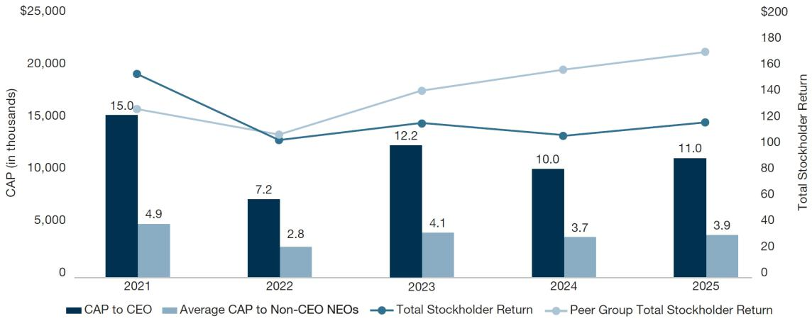

Net Income
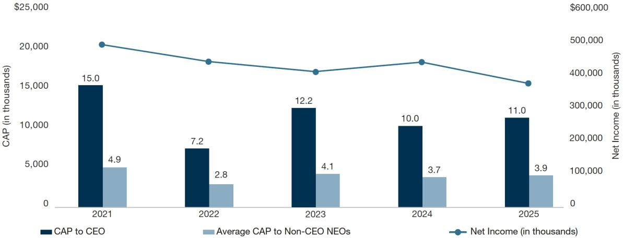

2026 PROXY STATEMENT 52

Back to Contents

Compensation Actually Paid Versus Adjusted EBITDA (EBITDA$)
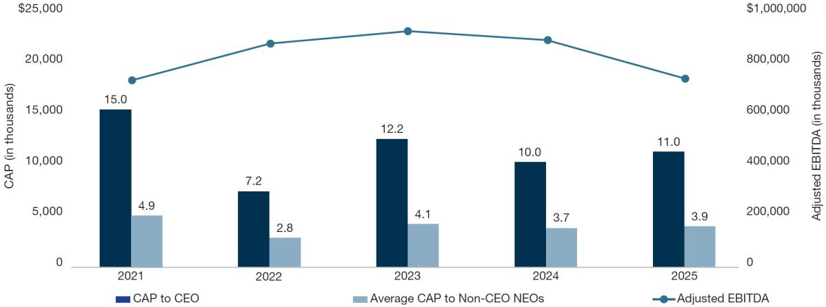

Compensation Actually Paid Versus Adjusted EPS

(Company Selected Measure)
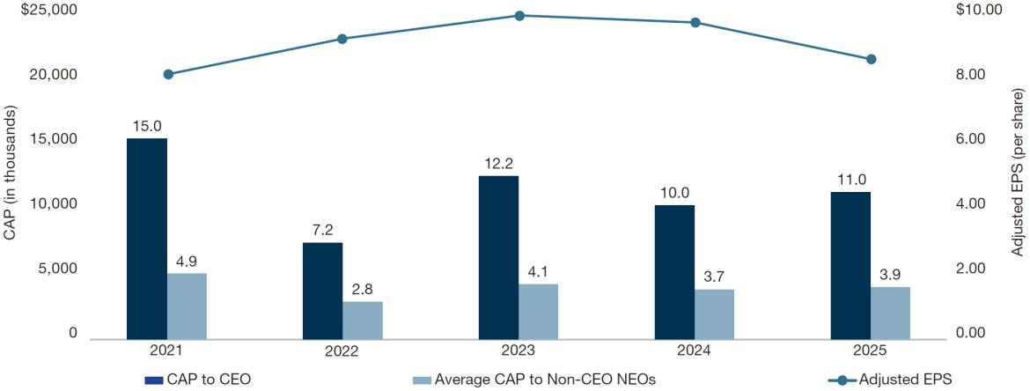

Most Important Financial Measures

The table below contains an unranked list of the most important financial performance measures used to link compensation actually paid to the NEOs to Company performance. Measures that were used to link executive compensation to Company performance are further described in the Compensation Discussion & Analysis.

Most Important Financial Measures

EBITDA$
EBITDA%
Adjusted EPS Growth
Return on Invested Capital

2026 PROXY STATEMENT 53

Back to Contents

Security Ownership of Certain Beneficial Owners and Management

The following table sets forth certain information with respect to the beneficial ownership of shares of Middleby common stock as of March 20, 2026, by each person known by the Company to be the beneficial owner of more than five percent of our common stock, each director and each nominee for director, each Named Executive Officer for fiscal year 2025, and all current directors and executive officers as a group. Unless otherwise indicated below, the address for each person listed below is c/o The Middleby Corporation, 1400 Toastmaster Drive, Elgin, Illinois 60120.

 | Amount and
 | Nature of | Percent
Name of Beneficial Owner | Beneficial Ownership | Of Class
Directors, Director Nominees, and Executive Officers:
Timothy J. FitzGerald | 433,002⁽¹⁾ | *
Bryan E. Mittelman | 39,995 | *
James K. Pool III | 50,327 | *
Steven P. Spittle | 48,512 | *
Matthew R. Fuchsen | 38,268 | *
Julie Bowerman | 1,108
Sarah Palisi Chapin | 7,219 | *
Glenn A. Eisenberg | — | *
Edward Garden⁽²⁾ | 3,379,737 | 7.25%
Christopher M. Hix | — | *
Cathy L. McCarthy | 9,719 | *
Robert A. Nerbonne | 25,001 | *
Gordon J. O’Brien | 42,254 | *
Stephen R. Scherger | 4,248 | *
Tejas P. Shah | 2,248 | *
Nassem A. Ziyad | 13,031 | *
All directors, nominees and executive officers of the Company (16 individuals) | 4,527,671 | 9.71%
T. Rowe Price Associates, Inc.⁽³⁾ | 5,772,273 | 12.38%
1307 Point Street, Baltimore, MD 21231
BlackRock, Inc.⁽⁴⁾ | 4,457,976 | 9.56%
50 Hudson Yards, New York, NY 10001
Select Equity Group⁽⁵⁾ | 3,028,289 | 6.50%
380 Lafayette Street, 6th Floor, New York, NY 10003

- Indicates beneficial ownership of less than 1%.

- Includes 20,000 shares held by Mr. FitzGerald’s spouse as trustee, 56,250 shares held by Mr. FitzGerald as trustee, and 25,200 shares held by Mr. FitzGerald’s spouse and children.

- Reflects 3,379,737 shares held directly by GI SPV I. Mr. Garden is the sole member of Garden Investment Management GP, LLC, which serves as the general partner of Garden Investment Management, L.P., which serves as the management company for GI SPV I. Accordingly, Mr. Garden may be deemed to indirectly beneficially own (as that term is defined in Rule 13d-3 under the Exchange Act) the securities beneficially owned by GI SPV I.

- Based on a Schedule 13G/A filed with the SEC on February 17, 2026 by T. Rowe Price Associates, Inc., T. Rowe Price Associates, Inc. beneficially owns 5,772,273 shares and has (a) sole voting power with respect to 5,465,643 shares and (b) sole dispositive power with respect to 5,772,249 shares.
- Based on a Schedule 13G/A filed with the SEC on January 25, 2024, by BlackRock, Inc., Blackrock, Inc. beneficially owns 4,457,976 shares and has (a) sole voting power with respect to 4,348,606 shares and (b) sole dispositive power with respect to 4,457,976 shares.
- Based on a Schedule 13G/A filed with the SEC on February 17, 2026, by Select Equity Group, L.P. beneficially owns 3,028,089 shares and has (a) shared voting power with respect to 3,028,289 shares and (b) shared dispositive power with respect to 3,028,289 shares.

2026 PROXY STATEMENT 54

Back to Contents

Equity Compensation Plan Information

The following table sets forth information with respect to securities authorized for issuance under our equity compensation plans as of January 3, 2026.

 |  |  |  | Number of securities
 |  |  |  | remaining available for
 |  |  |  | future issuance under
 | Number of securities |  |  | equity compensation
 | to be issued upon exercise |  | Weighted average | plans
 | of outstanding options, |  | exercise price of | (excluding securities
 | warrants | outstanding options, |  | reflected in the first
 | and rights | warrants and rights |  | column)
Plan category | (a) (#) |  | (b) | (c)
Equity compensation plans approved by security holders | 1,394,084⁽¹⁾ | $ | —(2) | 292,453⁽³⁾
Equity compensation plans not approved by security holders | — |  | — | —
Total | 1,394,084 |  | — | 292,453

- Indicates the number of RSUs and PSUs that were outstanding under the LTIP as of January 3, 2026. The PSUs have been calculated based on the maximum outcome of the applicable performance conditions, including maximum TSR modifier.
- There is no exercise price associated with the RSUs and PSUs. Accordingly, the weighted average exercise price does not take these awards into account.

- Represents shares issuable as of January 3, 2026 under the LTIP, the only equity compensation plan under which shares were available for grant of equity compensation awards.

2026 PROXY STATEMENT 55

Back to Contents

Proposal No. 3

Ratification of Selection of Independent Registered Public Accountants

Ernst & Young LLP served as independent registered public accountants for the Company for the fiscal year ended January 3, 2026. The Audit Committee has selected Ernst & Young LLP to continue to provide audit services for the current fiscal year ending January 2, 2027. Accordingly, the Board recommends that stockholders ratify the selection of Ernst & Young LLP as the Company’s independent registered public accountants for the current fiscal year. Representatives of Ernst & Young LLP are expected to attend the annual meeting, to make a statement if they desire to do so, and to be available to respond to appropriate questions.

Vote Required for Approval; Board Recommendation

The vote of a majority of votes cast is necessary to approve the proposal to ratify the selection of Ernst & Young LLP as the Company’s independent registered public accountants.

THE BOARD OF DIRECTORS UNANIMOUSLY RECOMMENDS THAT STOCKHOLDERS VOTE “FOR” THE RATIFICATION OF THE SELECTION OF ERNST & YOUNG LLP.


2026 PROXY STATEMENT 56

Back to Contents

Report of the Audit Committee

The Audit Committee conducts its oversight activities for the Company to fulfill its duties and responsibilities outlined in the Audit Committee charter.

For the fiscal year ended January 3, 2026, the Audit Committee has reviewed and discussed the audited financial statements and internal controls over financial reporting with management and the Company’s independent registered public accounting firm, Ernst & Young, LLP.

The Audit Committee has discussed with the Company’s independent registered public accounting firm the matters that are required to be discussed by the Public Company Accounting Oversight Board (“PCAOB”) and the SEC. The Audit Committee has also received and reviewed the written disclosures and the letter from the independent registered public accounting firm required by applicable PCAOB rules regarding Ernst & Young’s communication with the Audit Committee concerning independence, and held discussions with Ernst & Young regarding independence.

Based on the review and discussions outlined above, the Audit Committee recommended to the Board of Directors that the financial statements be included in the Company’s Annual Report on Form 10-K for the year ended January 3, 2026.

The Middleby Corporation Audit Committee

Cathy J. McCarthy, Chairperson

Christopher M. Hix, Tejas P. Shah and

Stephen R. Scherger

Audit Firm Fee Summary

 |  | 2025 |  | 2024
Audit Fees—Fees for the annual financial statement and internal control audits, reviews of the Company’s quarterly reports on
Form 10-Q, and services normally provided by the independent registered public accountants in connection with statutory and |  | 13,347,438⁽¹⁾
regulatory filings | $ | 13,347,438⁽¹⁾ | $ | 4,973,074
Audit-Related Fees—Fees for the assurance and related services that are associated with the performance of the audit or
interim financial statement review and are not reported under audit fees | $ | 8,515 | $ | 9,247
Tax Fees—Fees for tax compliance | $ | 13,196 | $ | 18,041
—Fees for assistance with tax audits and tax planning | $ | — | $ | —
All Other Fees | $ | — | $ | —

- Audit fees increased in 2025, primarily relating to auditing carve-out financial statements for the Middleby Food Processing business in connection with the spin-off of the Middleby Food Processing business as a stand-alone public company. Fees attributable to these carve-out financial statements amounted to $7,337,860 in 2025.

All of the services described in Audit Fees, Audit-Related Fees, Tax Fees, and All Other Fees were pre-approved by the Audit Committee.

The Audit Committee has considered whether the provision of non-audit services by the Company’s independent registered public accountants is compatible with maintaining the independence of the Company’s public accountants.

The Audit Committee charter provides that the Audit Committee must pre-approve all audit and permitted non-audit services to be performed by the independent registered public accountants (subject to the de minimis exceptions under applicable law, rules, and regulations).

However, the Audit Committee may delegate to one or more designated committee members the authority to grant such pre-approvals. The decisions of any member to whom such authority is delegated will be presented to the full Audit Committee at its next regularly scheduled meeting. In determining whether to pre-approve permitted non-audit services, the Audit Committee (or the members with authority to pre-approve) must consider whether the independent registered public accountants’ performance of such services is compatible with independence.

2026 PROXY STATEMENT 57

Back to Contents

Information About the Annual Meeting

Who can attend and vote at the Annual Meeting?

Stockholders of record at the close of business on March 20, 2026 (the “Record Date”), are entitled to notice of and to vote at the Annual Meeting. On the Record Date, there were 46,621,841 outstanding shares of Middleby common stock. In deciding all questions at the Annual Meeting, each stockholder will be entitled to one vote for each share held on the Record Date. Please note that if you hold your shares through a bank, broker or other nominee, you must obtain a legal proxy from such nominee, if you want to vote at the meeting.

If you wish to submit a question, you may do so during the meeting at www.virtualshareholdermeeting.com/MIDD2026. Only stockholders with a valid control number will have access to ask questions during the meeting. Questions pertinent to meeting matters will be answered during the meeting as time allows. If we receive substantially similar written questions, we may group such questions together and provide a single response to avoid repetition and allow time for additional questions.

If you experience technical difficulties, please contact the technical support telephone number posted on www.virtualshareholdermeeting.com/MIDD2026.

What are the quorum requirements for the meeting?

The election inspectors appointed for the Annual Meeting will determine the presence of a quorum and tabulate the votes cast. The presence, in person or represented by proxy, of the holders of a majority of the shares of Middleby common stock outstanding and entitled to vote will constitute a quorum that enables us to transact business at the meeting. Abstentions and broker non-votes will be included in determining whether we have a quorum. For information on broker non-votes, see “What is a broker non-vote?” below.

What proposals will be voted on at the meeting, and what is the vote required to pass?

The following table shows information about the three proposals we will consider at the meeting.

Proposal

Election of directors

Board voting
recommendation | Vote required to pass
FOR | Election of each individual
FOR | director requires the vote of a
each nominee | director requires the vote of a
each nominee | majority of the votes cast

Advisory vote to approve executive compensation | FOR | Majority of the votes cast
Ratification of the independent registered public accountants | FOR | Majority of the votes cast

For each proposal we will consider only votes actually cast, whether in person or by proxy. Abstentions and broker non-votes will not have any effect on the results of Proposal 1 or Proposal 2, and we do not expect to have broker non-votes for Proposal 3.

What is a broker non-vote?

If you are not a registered owner of Middleby stock—meaning you own your shares through a bank, broker, or other nominee—you are considered a “beneficial owner.” Your nominee is the registered owner of your stock, but you are entitled to tell your nominee how to vote your shares. In some cases, your nominee can vote your shares without instructions. At our Annual Meeting, nominees can use their discretion to vote on the proposal regarding the ratification of the independent registered public accountants even if they don’t have instructions from the beneficial owners. On all other matters—the election of directors and the advisory approval of executive compensation—nominees cannot vote without instructions from the beneficial owners. A broker non-vote occurs when a broker does not have discretionary authority or voting instructions as to certain shares to vote on a particular matter.

How can I vote?

If you own shares in your own name, you may vote in one of the following ways:

- visit the website shown on your Notice of Internet Availability of Proxy Materials or proxy card to vote electronically

- follow the instructions on your Notice of Internet Availability of Proxy Materials or proxy card to vote by telephone

- if you requested printed proxy materials, sign and return the proxy card using the postage-paid envelope provided

- virtually attend the Annual Meeting and vote in person

If you own shares through a bank, broker or other nominee, please follow the instructions provided by such nominee to ensure your votes are executed. If you wish to vote your shares virtually in person at the Annual Meeting, you must obtain a legal proxy from your nominee. Please contact your bank, broker or other nominee for more information.

2026 PROXY STATEMENT 58

Back to Contents

How will my shares be voted if I submit a proxy before the Annual Meeting?

Properly executed proxies will be voted in the manner directed by the stockholder. Any proxies submitted without voting instructions will be voted as follows:

- FOR the election of each of the nominees as a director of the Company;

- FOR the approval, on an advisory basis, of the 2025 compensation of the Company’s named executive officers; and

- FOR the ratification of the selection of Ernst & Young LLP as the Company’s independent registered public accountants for the fiscal year ending January 2, 2027.

As of the date of this Proxy Statement, the Board knows of no other business that will be presented for consideration at the Annual Meeting. If other proper matters are presented at the meeting, the proxy holders named in the enclosed form of proxy are authorized to take such actions as they deem appropriate.

If I vote or give my proxy in advance, can I change my mind?

You can revoke your proxy at any time before it is voted by giving written notice to the Secretary of the Company, either prior to the meeting (at the Company’s Elgin Illinois address) or at the meeting if you virtually attend in person. You also can submit a new proxy, which will revoke a prior-dated proxy.

Why didn’t I receive a printed copy of the proxy materials?

As permitted by SEC rules, we have elected to provide access to our proxy materials and 2025 Annual Report online instead of sending all stockholders a full set of printed proxy materials. We believe that electronic delivery provides you with prompt access to our proxy materials, lowers our costs of printing and delivering proxy materials, and minimizes the environmental impact of printing paper copies. You should have already received the Notice of Internet Availability of Proxy Materials containing instructions on how to access the proxy materials and vote. If you would like to receive a printed copy of our proxy materials, follow the instructions for requesting such materials set forth on the Notice of Internet Availability of Proxy Materials.

Several members of my family own Middleby stock. Why didn’t we each receive proxy materials?

SEC rules permit us to deliver one Notice of Internet Availability of Proxy Materials to a single address that is shared by two or more stockholders. This delivery method, known as “householding,” can result in significant cost savings. We have delivered only one Notice of Internet Availability of Proxy Materials to multiple stockholders who share an address unless we received contrary instructions from an affected stockholder before the mailing date. We will deliver promptly, upon request, a separate copy of the Notice of Internet Availability of Proxy Materials to any stockholder at a shared address to which a single copy of the notice was delivered. If you prefer to receive separate copies of the Notice of Internet Availability of Proxy Materials for the upcoming meeting or all future meetings of the stockholders, contact Broadridge Financial Solutions, Inc. at 866-540-7095 or in writing at Broadridge Financial Solutions, Inc., Householding Department, 51 Mercedes Way, Edgewood, New York 11717. If you are currently a stockholder sharing an address with another stockholder and wish to receive only one copy of future Notices of Internet Availability of Proxy Materials for your household for all future meetings of the stockholders, please contact Broadridge Financial Solutions, Inc. at the above phone number or address.

Who is paying for this proxy solicitation?

This solicitation of proxies is made by the Company, and the Company is responsible for all associated expenses. Proxies may be solicited on behalf of the Company by directors, officers, and employees of the Company by mail, telephone, or electronically. The Company will reimburse brokers and others holding common stock as nominees for their expenses in sending proxy materials to the beneficial owners and obtaining their proxies.

How can I submit a proposal for inclusion in the Company’s proxy materials for next year’s annual meeting?

Under SEC rules, a stockholder who intends to present a proposal at the 2027 Annual Meeting and who wishes the proposal to be included in our proxy statement for that meeting pursuant to Rule 14a-8 under the Exchange Act must submit the proposal in writing to the Secretary of the Company at the Company’s principal executive offices at 1400 Toastmaster Drive, Elgin Illinois, 60120. The proposal must be received no later than December 8, 2026 (120 days before April 7, 2027, the one-year anniversary of the anticipated mailing date of this Proxy Statement).

How can I submit other proposals and a candidate for the Board for next year’s annual meeting?

Under our Bylaws, written notice of (i) proposals intended to be presented by a stockholder at the 2027 Annual Meeting, but that are not intended for inclusion in our proxy statement for that meeting pursuant to Rule 14a-8, and (ii) nominees for the election of directors intended to be made by a stockholder at the 2027 Annual Meeting, must be delivered to the Secretary of the Company at the Company’s principal executive offices at 1400 Toastmaster Drive, Elgin, Illinois, 60120 between January 19, 2027, and February 18, 2027. However, if the 2027 Annual Meeting is called for a date that is not within thirty days before or after May 19, 2027, your proposal or nomination must be received not later than the close of business on the tenth day following the day on which notice of the date of the 2027 Annual Meeting was mailed or public disclosure of the date of that annual meeting was made, whichever first occurs. Such advance notice deadline will also be the deadline for a proposal to be considered “timely” for purposes of Rule 14a-4(c) under the Exchange Act. To be in proper written form, such a notice must set forth the information prescribed in the Company’s Bylaws.

In addition to satisfying the provisions in our Bylaws relating to nominations of director candidates, including the deadline for written notice, to comply with the SEC’s universal proxy rule, stockholders who intend to solicit proxies in support of director nominees other than the Company’s nominees in compliance with Rule 14a-19 under the Exchange Act, must provide notice that sets forth the information required by Rule 14a-19 no later than March 20, 2027.

By Order of the Board of Directors

MICHAEL D. THOMPSON

General Counsel and Secretary

Dated: April 8, 2026

2026 PROXY STATEMENT 59

Back to Contents

Annex A

Non-GAAP Financial Measures

The Company supplements its consolidated financial statements presented on a GAAP basis with the non-GAAP financial information provided in this Proxy Statement to provide investors with greater insight, increase transparency and allow for a more comprehensive understanding of the information used by management in its financial and operational decision-making. The non-GAAP financial measures disclosed by the Company should not be considered a substitute for, or superior to, financial measures prepared in accordance with GAAP, and the financial results prepared in accordance with GAAP and reconciliations from these results should be carefully evaluated. In addition, the non-GAAP financial measures included in this proxy statement do not have standard meanings and may vary from similarly titled non-GAAP financial measures used by other companies.

The Company believes that the adjusted net earnings per share and adjusted EDITDA measures are useful as a supplement to its GAAP results of operations to evaluate certain aspects of its operations and financial performance, and its management team primarily focuses on non-GAAP items in evaluating performance for business planning purposes. The Company also believes that these measures assists it with comparing its performance between various reporting periods on a consistent basis, as it removes from operating results the impact of items that, in its opinion, do not reflect its core operating performance including, for example, intangibles amortization expense, impairment charges, restructuring expenses, and other charges which management considers to be outside core operating results.

The Company believes that its presentation of these non-GAAP financial measures is useful because it provides investors and securities analysts with the same information that Middleby uses internally for purposes of assessing its core operating performance. Additional information regarding these non-GAAP financial measures is available in the Company’s Form 8-K filed with the SEC on March 4, 2026 and in other Company filings with the SEC.

Reconciliation of Net Earnings Per Share (a GAAP Measure) to Adjusted Net Earnings Per Share (a Non-GAAP Measure)

 |  | Diluted per share
 | 2025⁽³⁾ | 2024 | 2023 | 2022 | 2021
 | ($) | ($) | ($) | ($) | ($)
Net earnings | 7.04 | 7.90 | 7.41 | 7.95 | 8.62
Amortization⁽¹⁾ | 1.18 | 1.32 | 1.52 | 1.70 | 1.46
Restructuring expenses | 0.06 | 0.26 | 0.26 | 0.18 | 0.14
Acquisition related adjustments | (0.02) | 0.02 | (0.07) | 0.25 | 0.07
Facility consolidation related expenses |  | 0.02 |  |  | 0.02
Net periodic pension benefit (other than service costs & curtailment) | (0.12) | (0.27) | (0.17) | (0.78) | (0.8)
Strategic transaction costs | 0.37
Merger termination fee, net deal costs |  |  |  |  | (1.59)
Gain on sale of plant |  | (0.02) |  |  | (0.01)
Impairments | 0.20 | 0.71 | 1.44
Charitable support to Ukraine |  | 0.01 | 0.01 | 0.02
Discrete tax adjustments |  |  |  |  | (0.33)
Income tax effect of pre-tax adjustments | (0.40) | (0.53) | (0.78) | (0.34) | 0.17
Adjustment for shares excluded due to anti-dilution effect on GAAP net earnings⁽²⁾ | 0.08 | 0.07 | 0.08 | 0.12 | 0.19
Adjusted net earnings | 8.39 | 9.49 | 9.70 | 9.10 | 7.94

- Includes amortization of deferred financing costs and convertible notes issuance costs.

- Adjusted diluted weighted average number of shares was calculated based on excluding the dilutive effect of shares to be issued upon conversion of the notes to satisfy the amount in excess of the principal since the Company’s capped call offsets the dilutive impact of the shares underlying the convertible notes. The calculation of adjusted diluted earnings per share excludes the principal portion of the convertible notes as this will always be settled in cash.

- In February 2026, we completed the divestiture of a majority interest in our residential kitchen business segment. For 2025, the historical results of this divested business were accounted for as discontinued operations, and accordingly are not reflected in this figure.

2026 PROXY STATEMENT 60

Back to Contents

Reconciliation of Operating Income (a GAAP Measure) to Adjusted EBITDA (a Non-GAAP Measure)⁽⁴⁾

 | 2025⁽⁶⁾ | 2024 | 2023 | 2022 | 2021
 | ($) | ($) | ($) | ($) | ($)
Operating Income | 574,891 | 656,188 | 634,868 | 639,604 | 629,992
Depreciation | 43,742 | 55,609 | 50,416 | 44,619 | 42,681
Amortization | 55,255 | 64,438 | 75,051 | 86,282 | 75,785
Restructuring expenses | 3,270 | 14,181 | 14,134 | 9,716 | 7,655
Strategic transaction costs | 19,184
Facility consolidation related expenses |  | 920 |  |  | 993
Acquisition related adjustments | (912) | 836 | (3,851) | 13,852 | 4,186
Merger termination fee, net deal costs |  |  |  |  | (90,285)
Charitable support to Ukraine |  | 474 | 615 | 967
Stock compensation | 13,462 | 36,151 | 51,047 | 58,368 | 42,330
Gain on sale of plant |  | (1,139) |  |  | (763)
Impairments⁽⁵⁾ | 10,598 | 38,637 | 78,114
Adjusted EBITDA | 719,490 | 866,295 | 900,394 | 853,408 | 712,574

- Amounts in thousands.

- Includes impairment of intangible assets, fixed assets, and assets held for sale.

- In February 2026, we completed the divestiture of a majority interest in our residential kitchen business segment. For 2025, the historical results of this divested business were accounted for as discontinued operations, and accordingly are not reflected in this figure.

2026 PROXY STATEMENT 61

Back to Contents


Back to Contents
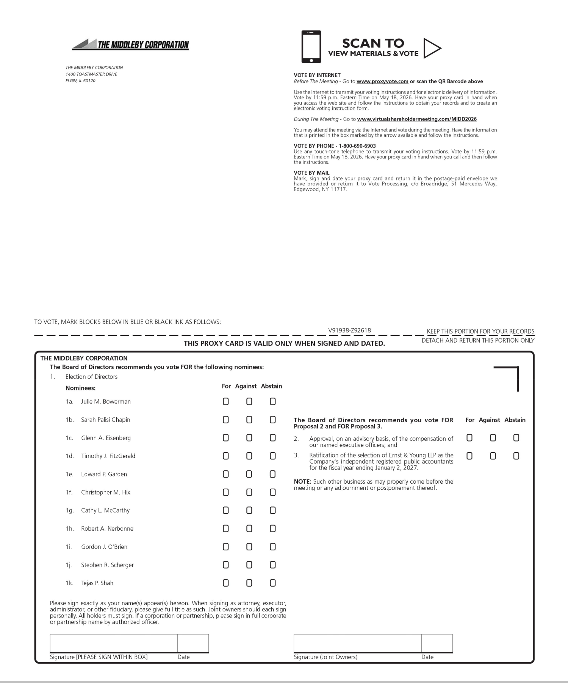

Back to Contents


