UNITED STATES
SECURITIES AND EXCHANGE COMMISSION
Washington, D.C. 20549

FORM 8-K

CURRENT REPORT
Pursuant to Section 13 or 15(d) of the Securities Exchange Act of 1934

Date of Report (Date of earliest event reported): September 10, 2026

THE MIDDLEBY CORPORATION
(Exact Name of Registrant as Specified in its Charter)

Delaware | 1-9973 | 36-3352497
(State or Other Jurisdiction  of Incorporation) | (Commission File Number) | (IRS Employer  Identification No.)

1400 Toastmaster Drive, Elgin, Illinois | 60120
(Address of Principal Executive Offices) | (Zip Code)

(847) 741-3300
(Registrant’s telephone number, including area code)

N/A
(Former Name or Former Address, if Changed Since Last Report)

Check the appropriate box below if the Form 8-K filing is intended to simultaneously satisfy the filing obligation of the registrant under any of the following provisions:

☐ Written communications pursuant to Rule 425 under the Securities Act (17 CFR 230.425)

☐ Soliciting material pursuant to Rule 14a-12 under the Exchange Act (17 CFR 240.14a-12)

☐ Pre-commencement communications pursuant to Rule 14d-2(b) under the Exchange Act (17 CFR 240.14d-2(b))

☐ Pre-commencement communications pursuant to Rule 13e-4(c) under the Exchange Act (17 CFR 240.13e-4(c))

Securities registered pursuant to Section 12(b) of the Act:

Title of Each Class | Trading Symbol(s) | Name of Each Exchange on Which Registered
Common Stock | MIDD | The Nasdaq Global Select Market

Indicate by check mark whether the registrant is an emerging growth company as defined in Rule 405 of the Securities Act of 1933 (§230.405 of this chapter) or Rule 12b-2 of the Securities Exchange Act of 1934 (§240.12b-2 of this chapter).

Emerging growth company ☐

If an emerging growth company, indicate by check mark if the registrant has elected not to use the extended transition period for complying with any new or revised financial accounting standards provided pursuant to Section 13(a) of the Exchange Act. ☐

 | Item 7.01 | Regulation FD Disclosure.

A copy of the presentation slides to be used by The Middleby Corporation (the “Company”) at the 2026 Jefferies Global Industrials Conference on September 10, 2026, is furnished as Exhibit 99.1 to this Current Report on Form 8-K and is incorporated herein by reference.

The information set forth in this Item 7.01, including Exhibit 99.1, is deemed to be “furnished” and shall not be deemed to be “filed” for purposes of Section 18 of the Securities Exchange Act of 1934, as amended (the “Exchange Act”), or otherwise subject to the liabilities of that Section. The information set forth in this Item 7.01, including Exhibit 99.1, shall not be deemed incorporated by reference into any filing under the Exchange Act or the Securities Act of 1933, as amended, regardless of any general incorporation language in such filing, except as shall be expressly set forth by specific reference in such filing.

 | Item 9.01 | Financial Statements and Exhibits.

(d) Exhibits

Exhibit No. |  | Description
99.1 |  | Presentation, dated September 10, 2026, issued by The Middleby Corporation.
104 |  | Cover Page Interactive Data File (the cover page XBRL tags are embedded within the Inline XBRL document).

SIGNATURES

Pursuant to the requirements of the Securities Exchange Act of 1934, the registrant has duly caused this report to be signed on its behalf by the undersigned hereunto duly authorized.

 | THE MIDDLEBY CORPORATION
Date: September 10, 2026 | By: | /s/ Brittany C. Cerwin
 |  | Brittany C. Cerwin
 |  | Chief Financial Officer

Exhibit 99.1

 | 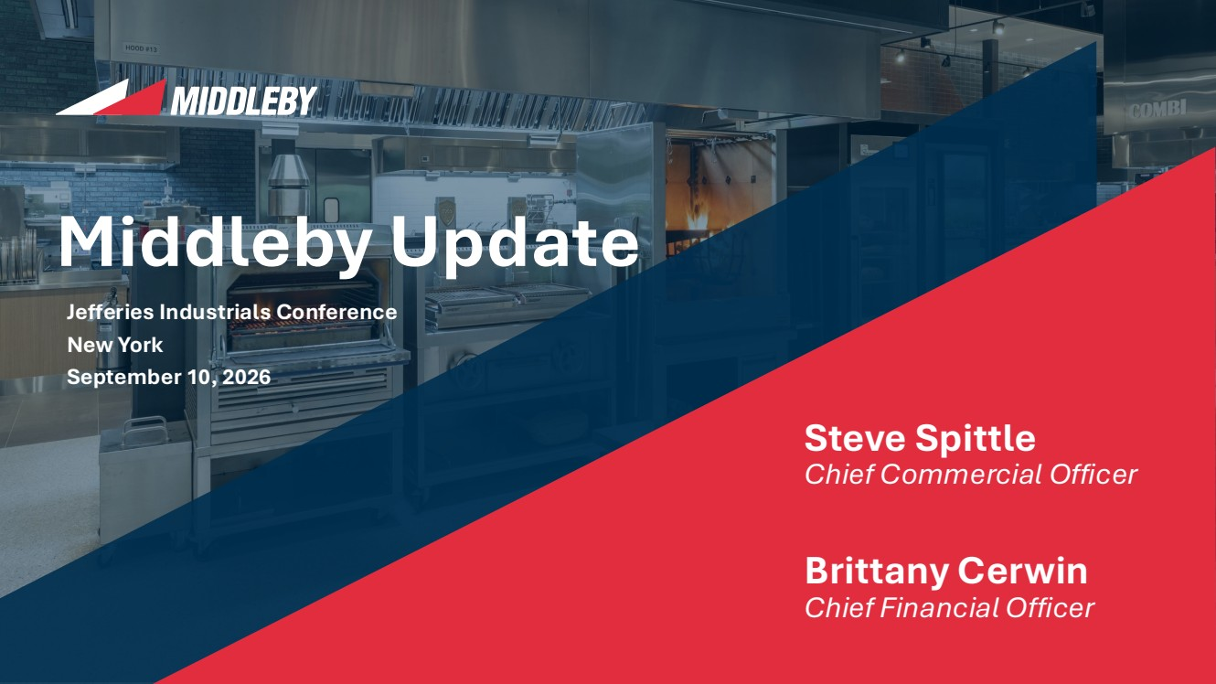 | Jefferies Industrials Conference New York September 10, 2026 Middleby Update Steve Spittle Chief Commercial Officer Brittany Cerwin Chief Financial Officer
 | 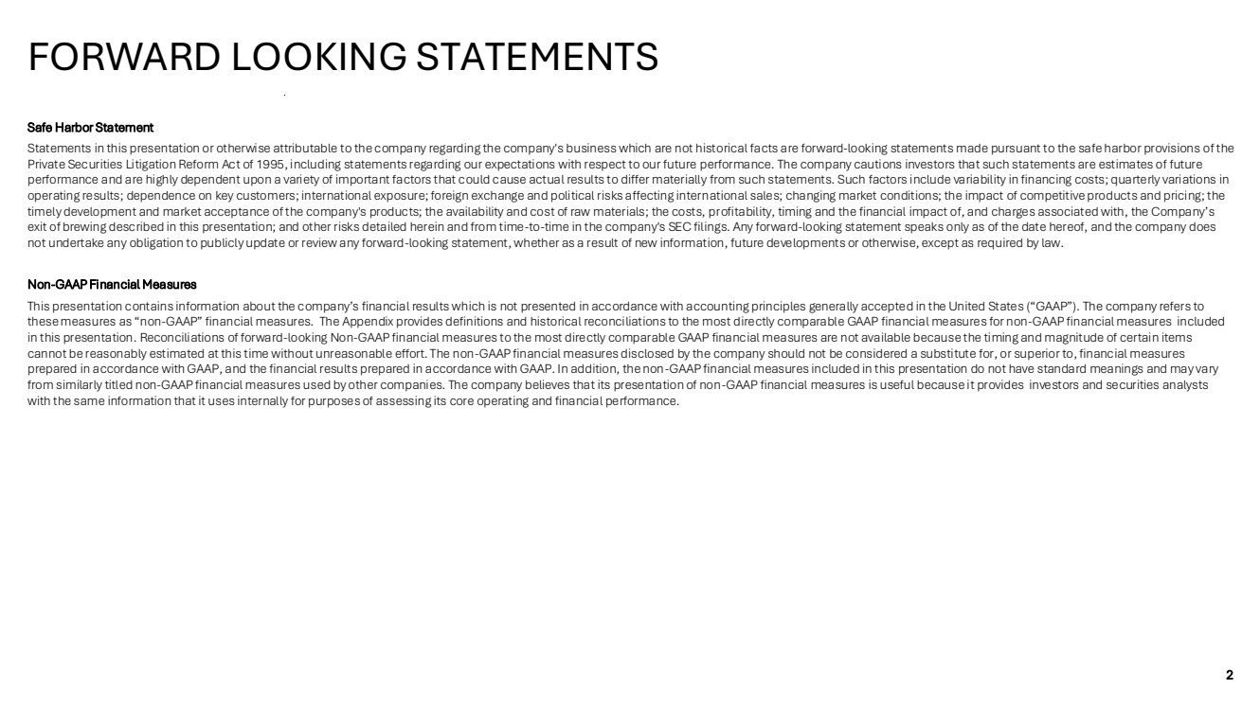 | 2 Styles Rounded Corners Y Shadows N Hierarchy of Highlights Gradients N Message Box Highlighted Boxes on the Page Highlight Table Rows / Maps Row Heading Cells in Tables Add doctop here Link to template Width: 33.867 cm Height: 19.05 cm Pages Setup Lines Headings on page Tables - Headings Tables - Rows Charts - Axes RGB 0,0,0 | Wgt: 1pt RGB 185,185,185 | Wgt: 0.5pt RGB 127,127,127 | Wgt: 0.75pt Charts - Lines Between Series: None N Lines Y (RGB and weight) Boxes Company Logos 0:47:80 0:110:182 226:45:63 228:222:212 139:178:221 191:191:191 205:219:224 161:188:196 129:179:224 244:242:238 217:217:217 229:229:229 255:255:255 0:0:0 23:60:93 Charts – Primary Colours Charts – Secondary Colours Background Text Colour Page Heading Colours 23:60:93 Subheading Safe Harbor Statement Statements in this presentation or otherwise attributable to the company regarding the company's business which are not historical facts are forward-looking statements made pursuant to the safe harbor provisions of the Private Securities Litigation Reform Act of 1995, including statements regarding our expectations with respect to our future performance. The company cautions investors that such statements are estimates of future performance and are highly dependent upon a variety of important factors that could cause actual results to differ materially from such statements. Such factors include variability in financing costs; quarterly variations in operating results; dependence on key customers; international exposure; foreign exchange and political risks affecting international sales; changing market conditions; the impact of competitive products and pricing; the timely development and market acceptance of the company's products; the availability and cost of raw materials; the costs, profitability, timing and the financial impact of, and charges associated with, the Company’s exit of brewing described in this presentation; and other risks detailed herein and from time-to-time in the company's SEC filings. Any forward-looking statement speaks only as of the date hereof, and the company does not undertake any obligation to publicly update or review any forward-looking statement, whether as a result of new information, future developments or otherwise, except as required by law. Non-GAAP Financial Measures This presentation contains information about the company’s financial results which is not presented in accordance with accounting principles generally accepted in the United States (“GAAP”). The company refers to these measures as “non-GAAP” financial measures. The Appendix provides definitions and historical reconciliations to the most directly comparable GAAP financial measures for non-GAAP financial measures included in this presentation. Reconciliations of forward-looking Non-GAAP financial measures to the most directly comparable GAAP financial measures are not available because the timing and magnitude of certain items cannot be reasonably estimated at this time without unreasonable effort. The non-GAAP financial measures disclosed by the company should not be considered a substitute for, or superior to, financial measures prepared in accordance with GAAP, and the financial results prepared in accordance with GAAP. In addition, the non-GAAP financial measures included in this presentation do not have standard meanings and may vary from similarly titled non-GAAP financial measures used by other companies. The company believes that its presentation of non-GAAP financial measures is useful because it provides investors and securities analysts with the same information that it uses internally for purposes of assessing its core operating and financial performance. FORWARD LOOKING STATEMENTS
 | 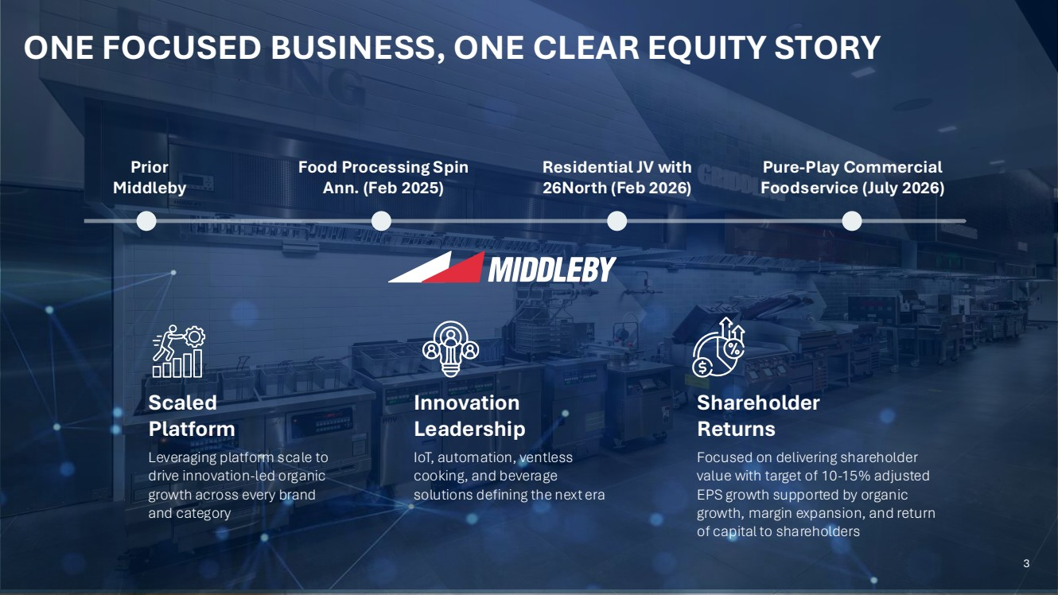 | 3 Styles Rounded Corners Y Shadows N Hierarchy of Highlights Gradients N Message Box Highlighted Boxes on the Page Highlight Table Rows / Maps Row Heading Cells in Tables Add doctop here Link to template Width: 33.867 cm Height: 19.05 cm Pages Setup Lines Headings on page Tables - Headings Tables - Rows Charts - Axes RGB 0,0,0 | Wgt: 1pt RGB 185,185,185 | Wgt: 0.5pt RGB 127,127,127 | Wgt: 0.75pt Charts - Lines Between Series: None N Lines Y (RGB and weight) Boxes Company Logos 0:47:80 0:110:182 226:45:63 228:222:212 139:178:221 191:191:191 205:219:224 161:188:196 129:179:224 244:242:238 217:217:217 229:229:229 255:255:255 0:0:0 23:60:93 Charts – Primary Colours Charts – Secondary Colours Background Text Colour Page Heading Colours 23:60:93 Subheading ONE FOCUSED BUSINESS, ONE CLEAR EQUITY STORY Prior Middleby Food Processing Spin Ann. (Feb 2025) Residential JV with 26North (Feb 2026) Pure-Play Commercial Foodservice (July 2026) Scaled Platform Leveraging platform scale to drive innovation-led organic growth across every brand and category Innovation Leadership IoT, automation, ventless cooking, and beverage solutions defining the next era Shareholder Returns Focused on delivering shareholder value with target of 10-15% adjusted EPS growth supported by organic growth, margin expansion, and return of capital to shareholders 3
 | 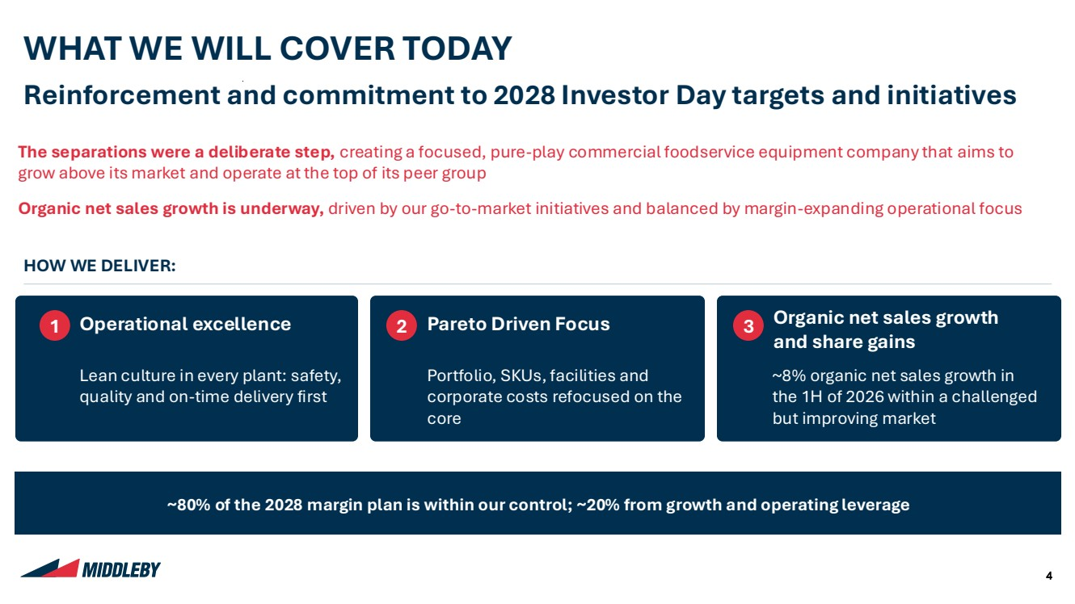 | 4 Styles Rounded Corners Y Shadows N Hierarchy of Highlights Gradients N Message Box Highlighted Boxes on the Page Highlight Table Rows / Maps Row Heading Cells in Tables Add doctop here Link to template Width: 33.867 cm Height: 19.05 cm Pages Setup Lines Headings on page Tables - Headings Tables - Rows Charts - Axes RGB 0,0,0 | Wgt: 1pt RGB 185,185,185 | Wgt: 0.5pt RGB 127,127,127 | Wgt: 0.75pt Charts - Lines Between Series: None N Lines Y (RGB and weight) Boxes Company Logos 0:47:80 0:110:182 226:45:63 228:222:212 139:178:221 191:191:191 205:219:224 161:188:196 129:179:224 244:242:238 217:217:217 229:229:229 255:255:255 0:0:0 23:60:93 Charts – Primary Colours Charts – Secondary Colours Background Text Colour Page Heading Colours 23:60:93 Subheading WHAT WE WILL COVER TODAY Reinforcement and commitment to 2028 Investor Day targets and initiatives The separations were a deliberate step, creating a focused, pure-play commercial foodservice equipment company that aims to grow above its market and operate at the top of its peer group Organic net sales growth is underway, driven by our go-to-market initiatives and balanced by margin-expanding operational focus HOW WE DELIVER: 1 Operational excellence Lean culture in every plant: safety, quality and on-time delivery first 2 Pareto Driven Focus Portfolio, SKUs, facilities and corporate costs refocused on the core 3 Organic net sales growth and share gains ~8% organic net sales growth in the 1H of 2026 within a challenged but improving market ~80% of the 2028 margin plan is within our control; ~20% from growth and operating leverage
 | 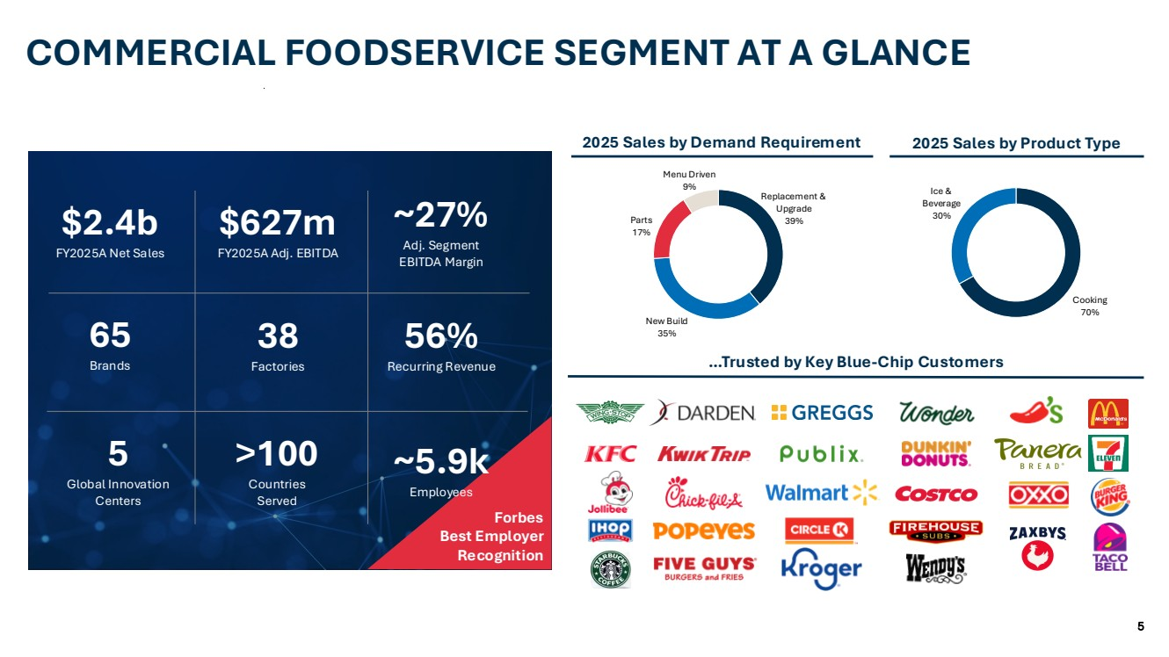 | 5 Styles Rounded Corners Y Shadows N Hierarchy of Highlights Gradients N Message Box Highlighted Boxes on the Page Highlight Table Rows / Maps Row Heading Cells in Tables Add doctop here Link to template Width: 33.867 cm Height: 19.05 cm Pages Setup Lines Headings on page Tables - Headings Tables - Rows Charts - Axes RGB 0,0,0 | Wgt: 1pt RGB 185,185,185 | Wgt: 0.5pt RGB 127,127,127 | Wgt: 0.75pt Charts - Lines Between Series: None N Lines Y (RGB and weight) Boxes Company Logos 0:47:80 0:110:182 226:45:63 228:222:212 139:178:221 191:191:191 205:219:224 161:188:196 129:179:224 244:242:238 217:217:217 229:229:229 255:255:255 0:0:0 23:60:93 Charts – Primary Colours Charts – Secondary Colours Background Text Colour Page Heading Colours 23:60:93 Subheading COMMERCIAL FOODSERVICE SEGMENT AT A GLANCE Replacement & Upgrade 39% New Build 35% Parts 17% Menu Driven 9% Cooking 70% Ice & Beverage 30% 5 Global Innovation Centers >100 Countries Served 65 Brands 38 Factories 56% Recurring Revenue $2.4b FY2025A Net Sales $627m FY2025A Adj. EBITDA ~27% Adj. Segment EBITDA Margin 2025 Sales by Demand Requirement 2025 Sales by Product Type …Trusted by Key Blue-Chip Customers Forbes Best Employer Recognition ~5.9k Employees
 | 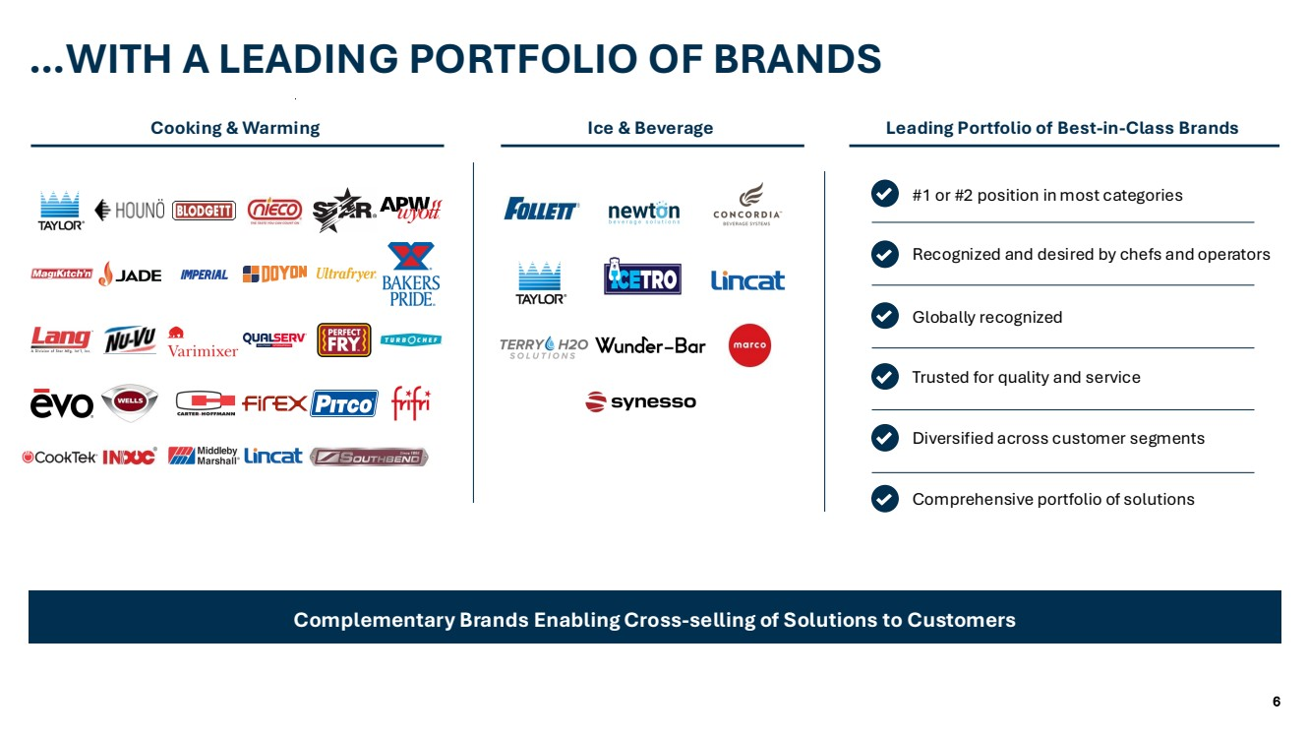 | 6 Styles Rounded Corners Y Shadows N Hierarchy of Highlights Gradients N Message Box Highlighted Boxes on the Page Highlight Table Rows / Maps Row Heading Cells in Tables Add doctop here Link to template Width: 33.867 cm Height: 19.05 cm Pages Setup Lines Headings on page Tables - Headings Tables - Rows Charts - Axes RGB 0,0,0 | Wgt: 1pt RGB 185,185,185 | Wgt: 0.5pt RGB 127,127,127 | Wgt: 0.75pt Charts - Lines Between Series: None N Lines Y (RGB and weight) Boxes Company Logos 0:47:80 0:110:182 226:45:63 228:222:212 139:178:221 191:191:191 205:219:224 161:188:196 129:179:224 244:242:238 217:217:217 229:229:229 255:255:255 0:0:0 23:60:93 Charts – Primary Colours Charts – Secondary Colours Background Text Colour Page Heading Colours 23:60:93 Subheading …WITH A LEADING PORTFOLIO OF BRANDS Complementary Brands Enabling Cross-selling of Solutions to Customers #1 or #2 position in most categories Recognized and desired by chefs and operators Globally recognized Trusted for quality and service Diversified across customer segments Comprehensive portfolio of solutions Cooking & Warming Ice & Beverage Leading Portfolio of Best-in-Class Brands
 | 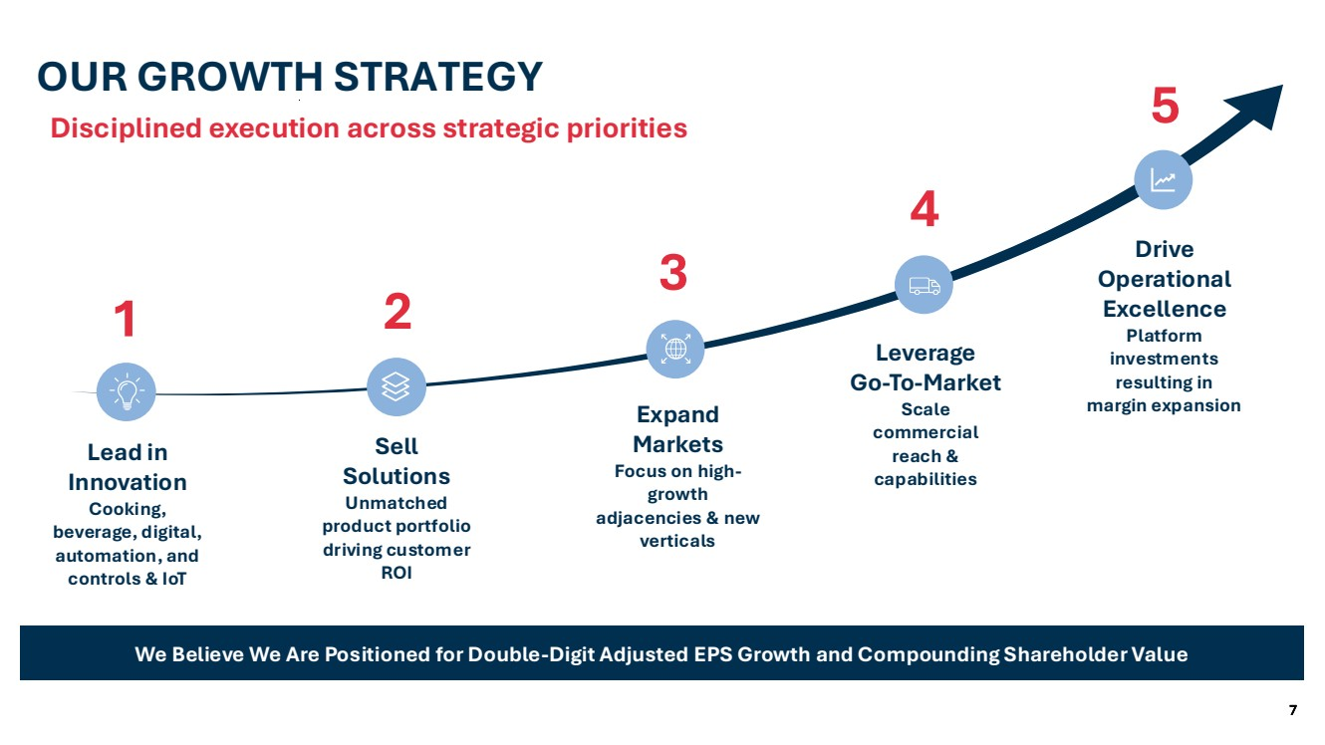 | 7 Styles Rounded Corners Y Shadows N Hierarchy of Highlights Gradients N Message Box Highlighted Boxes on the Page Highlight Table Rows / Maps Row Heading Cells in Tables Add doctop here Link to template Width: 33.867 cm Height: 19.05 cm Pages Setup Lines Headings on page Tables - Headings Tables - Rows Charts - Axes RGB 0,0,0 | Wgt: 1pt RGB 185,185,185 | Wgt: 0.5pt RGB 127,127,127 | Wgt: 0.75pt Charts - Lines Between Series: None N Lines Y (RGB and weight) Boxes Company Logos 0:47:80 0:110:182 226:45:63 228:222:212 139:178:221 191:191:191 205:219:224 161:188:196 129:179:224 244:242:238 217:217:217 229:229:229 255:255:255 0:0:0 23:60:93 Charts – Primary Colours Charts – Secondary Colours Background Text Colour Page Heading Colours 23:60:93 Subheading 7 OUR GROWTH STRATEGY Disciplined execution across strategic priorities We Believe We Are Positioned for Double-Digit Adjusted EPS Growth and Compounding Shareholder Value Lead in Innovation Cooking, beverage, digital, automation, and controls & IoT 1 Sell Solutions Unmatched product portfolio driving customer ROI Expand Markets Focus on high-growth adjacencies & new verticals Leverage Go-To-Market Scale commercial reach & capabilities Drive Operational Excellence Platform investments resulting in margin expansion 2 3 4 5
 | 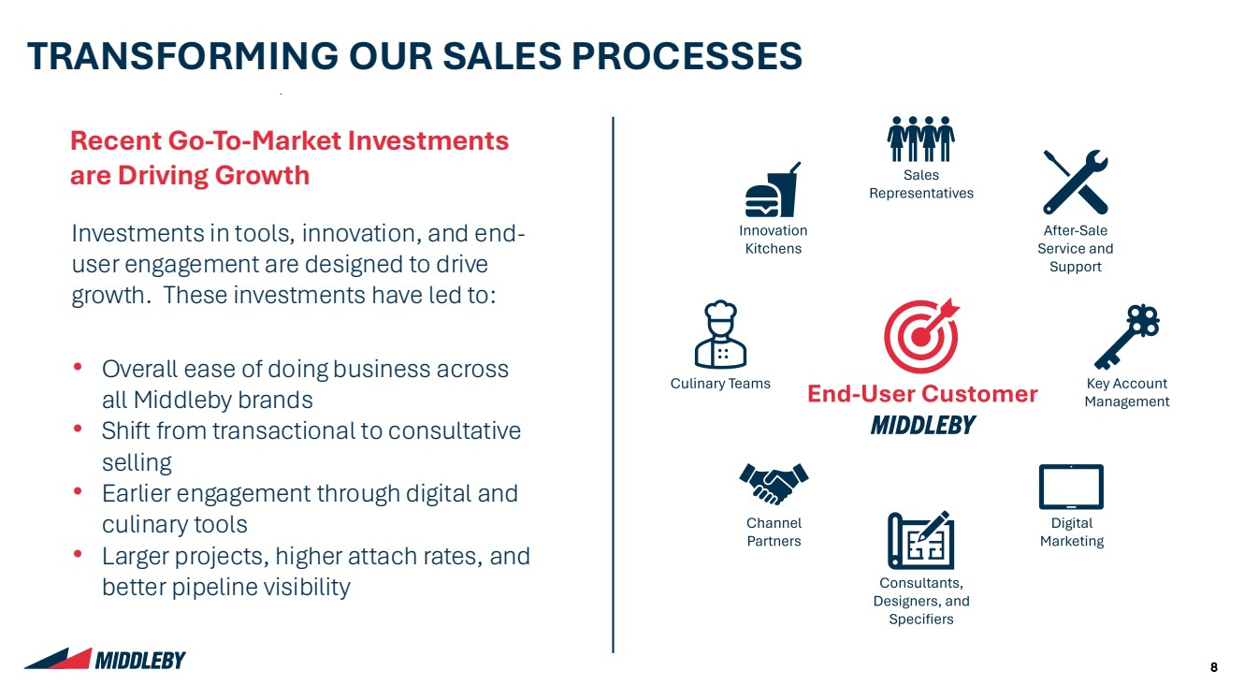 | 8 Styles Rounded Corners Y Shadows N Hierarchy of Highlights Gradients N Message Box Highlighted Boxes on the Page Highlight Table Rows / Maps Row Heading Cells in Tables Add doctop here Link to template Width: 33.867 cm Height: 19.05 cm Pages Setup Lines Headings on page Tables - Headings Tables - Rows Charts - Axes RGB 0,0,0 | Wgt: 1pt RGB 185,185,185 | Wgt: 0.5pt RGB 127,127,127 | Wgt: 0.75pt Charts - Lines Between Series: None N Lines Y (RGB and weight) Boxes Company Logos 0:47:80 0:110:182 226:45:63 228:222:212 139:178:221 191:191:191 205:219:224 161:188:196 129:179:224 244:242:238 217:217:217 229:229:229 255:255:255 0:0:0 23:60:93 Charts – Primary Colours Charts – Secondary Colours Background Text Colour Page Heading Colours 23:60:93 Subheading TRANSFORMING OUR SALES PROCESSES Recent Go-To-Market Investments are Driving Growth Investments in tools, innovation, and end-user engagement are designed to drive growth. These investments have led to: • Overall ease of doing business across all Middleby brands • Shift from transactional to consultative selling • Earlier engagement through digital and culinary tools • Larger projects, higher attach rates, and better pipeline visibility
 | 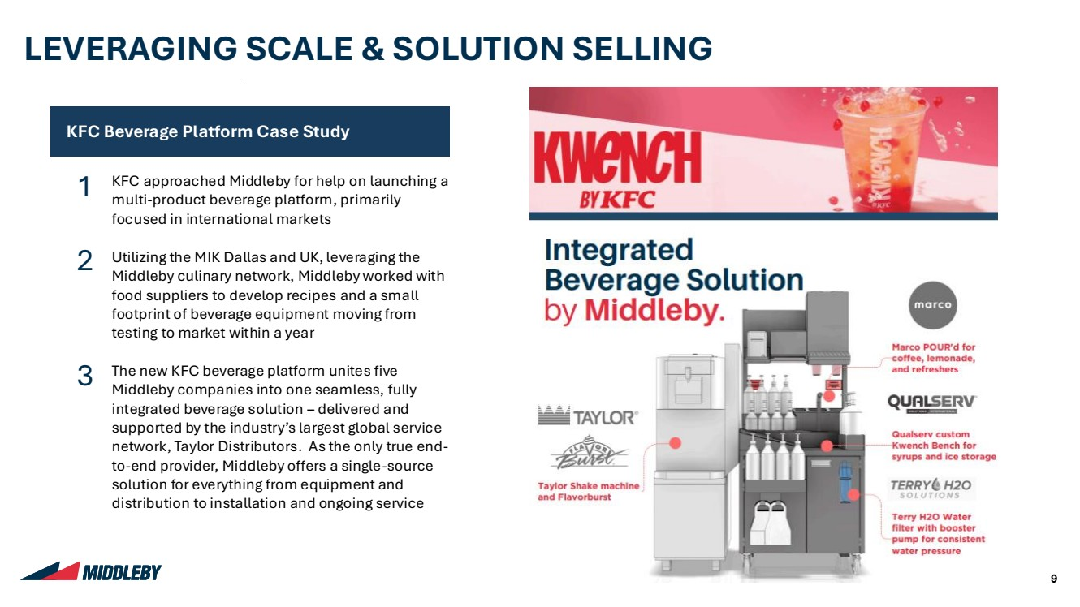 | 9 Styles Rounded Corners Y Shadows N Hierarchy of Highlights Gradients N Message Box Highlighted Boxes on the Page Highlight Table Rows / Maps Row Heading Cells in Tables Add doctop here Link to template Width: 33.867 cm Height: 19.05 cm Pages Setup Lines Headings on page Tables - Headings Tables - Rows Charts - Axes RGB 0,0,0 | Wgt: 1pt RGB 185,185,185 | Wgt: 0.5pt RGB 127,127,127 | Wgt: 0.75pt Charts - Lines Between Series: None N Lines Y (RGB and weight) Boxes Company Logos 0:47:80 0:110:182 226:45:63 228:222:212 139:178:221 191:191:191 205:219:224 161:188:196 129:179:224 244:242:238 217:217:217 229:229:229 255:255:255 0:0:0 23:60:93 Charts – Primary Colours Charts – Secondary Colours Background Text Colour Page Heading Colours 23:60:93 Subheading 9 LEVERAGING SCALE & SOLUTION SELLING KFC Beverage Platform Case Study KFC approached Middleby for help on launching a multi-product beverage platform, primarily focused in international markets Utilizing the MIK Dallas and UK, leveraging the Middleby culinary network, Middleby worked with food suppliers to develop recipes and a small footprint of beverage equipment moving from testing to market within a year The new KFC beverage platform unites five Middleby companies into one seamless, fully integrated beverage solution – delivered and supported by the industry’s largest global service network, Taylor Distributors. As the only true end-to-end provider, Middleby offers a single-source solution for everything from equipment and distribution to installation and ongoing service 1 2 3
 | 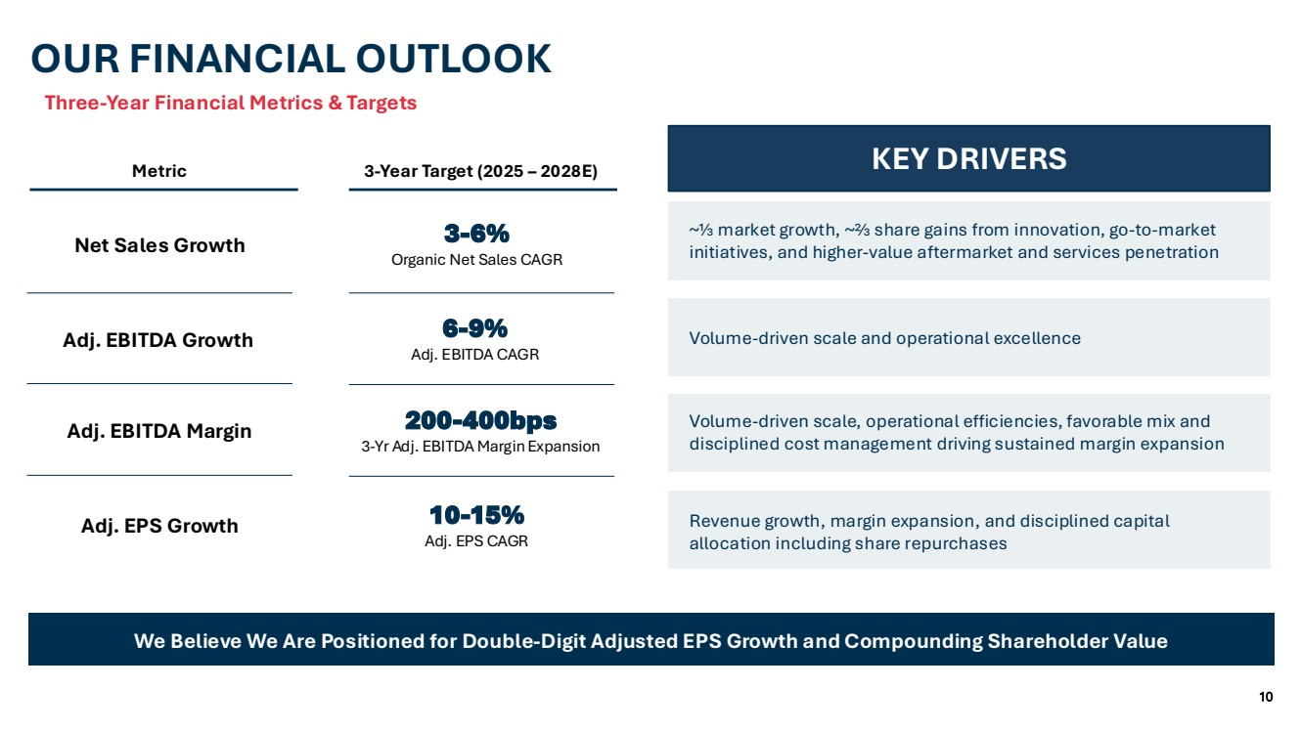 | 10 Styles Rounded Corners Y Shadows N Hierarchy of Highlights Gradients N Message Box Highlighted Boxes on the Page Highlight Table Rows / Maps Row Heading Cells in Tables Add doctop here Link to template Width: 33.867 cm Height: 19.05 cm Pages Setup Lines Headings on page Tables - Headings Tables - Rows Charts - Axes RGB 0,0,0 | Wgt: 1pt RGB 185,185,185 | Wgt: 0.5pt RGB 127,127,127 | Wgt: 0.75pt Charts - Lines Between Series: None N Lines Y (RGB and weight) Boxes Company Logos 0:47:80 0:110:182 226:45:63 228:222:212 139:178:221 191:191:191 205:219:224 161:188:196 129:179:224 244:242:238 217:217:217 229:229:229 255:255:255 0:0:0 23:60:93 Charts – Primary Colours Charts – Secondary Colours Background Text Colour Page Heading Colours 23:60:93 Subheading OUR FINANCIAL OUTLOOK We Believe We Are Positioned for Double-Digit Adjusted EPS Growth and Compounding Shareholder Value Revenue growth, margin expansion, and disciplined capital allocation including share repurchases 10-15% Adj. EPS CAGR Adj. EPS Growth 6 Volume-driven scale and operational excellence -9% Adj. EBITDA CAGR Adj. EBITDA Growth ~⅓ market growth, ~⅔ share gains from innovation, go-to-market initiatives, and higher-value aftermarket and services penetration 3-6% Organic Net Sales CAGR Net Sales Growth 200-400bps 3-Yr Adj. EBITDA Margin Expansion Adj. EBITDA Margin Volume-driven scale, operational efficiencies, favorable mix and disciplined cost management driving sustained margin expansion Metric 3-Year Target (2025 – 2028E) KEY DRIVERS Three-Year Financial Metrics & Targets
 | 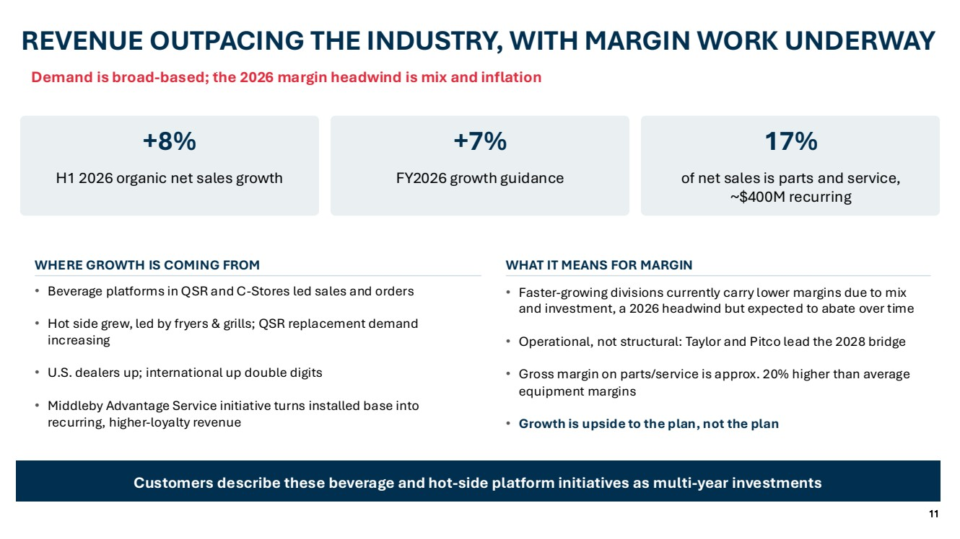 | 11 Styles Rounded Corners Y Shadows N Hierarchy of Highlights Gradients N Message Box Highlighted Boxes on the Page Highlight Table Rows / Maps Row Heading Cells in Tables Add doctop here Link to template Width: 33.867 cm Height: 19.05 cm Pages Setup Lines Headings on page Tables - Headings Tables - Rows Charts - Axes RGB 0,0,0 | Wgt: 1pt RGB 185,185,185 | Wgt: 0.5pt RGB 127,127,127 | Wgt: 0.75pt Charts - Lines Between Series: None N Lines Y (RGB and weight) Boxes Company Logos 0:47:80 0:110:182 226:45:63 228:222:212 139:178:221 191:191:191 205:219:224 161:188:196 129:179:224 244:242:238 217:217:217 229:229:229 255:255:255 0:0:0 23:60:93 Charts – Primary Colours Charts – Secondary Colours Background Text Colour Page Heading Colours 23:60:93 Subheading Demand is broad-based; the 2026 margin headwind is mix and inflation REVENUE OUTPACING THE INDUSTRY, WITH MARGIN WORK UNDERWAY +8% H1 2026 organic net sales growth +7% FY2026 growth guidance 17% of net sales is parts and service, ~$400M recurring WHERE GROWTH IS COMING FROM • Beverage platforms in QSR and C-Stores led sales and orders • Hot side grew, led by fryers & grills; QSR replacement demand increasing • U.S. dealers up; international up double digits • Middleby Advantage Service initiative turns installed base into recurring, higher-loyalty revenue WHAT IT MEANS FOR MARGIN • Faster-growing divisions currently carry lower margins due to mix and investment, a 2026 headwind but expected to abate over time • Operational, not structural: Taylor and Pitco lead the 2028 bridge • Gross margin on parts/service is approx. 20% higher than average equipment margins • Growth is upside to the plan, not the plan Customers describe these beverage and hot-side platform initiatives as multi-year investments
 | 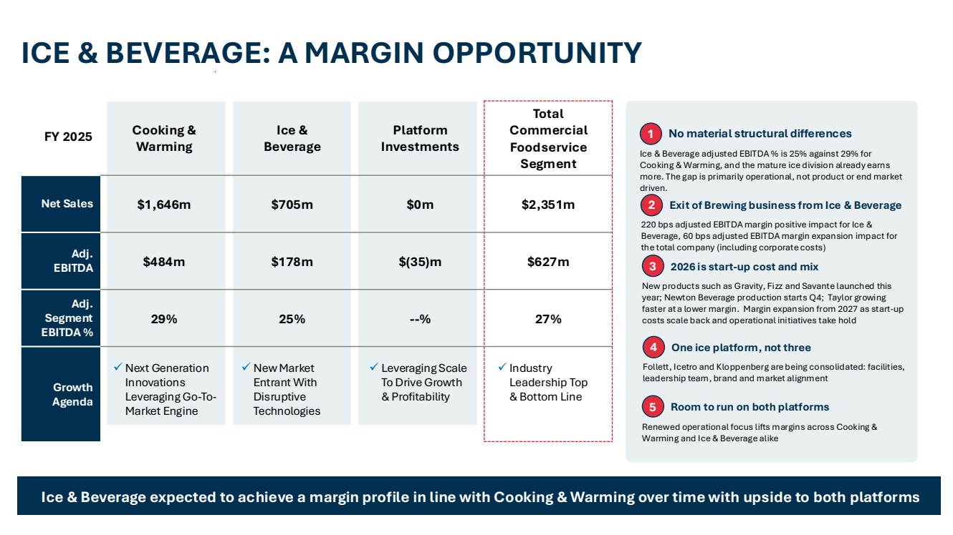 | 12 Styles Rounded Corners Y Shadows N Hierarchy of Highlights Gradients N Message Box Highlighted Boxes on the Page Highlight Table Rows / Maps Row Heading Cells in Tables Add doctop here Link to template Width: 33.867 cm Height: 19.05 cm Pages Setup Lines Headings on page Tables - Headings Tables - Rows Charts - Axes RGB 0,0,0 | Wgt: 1pt RGB 185,185,185 | Wgt: 0.5pt RGB 127,127,127 | Wgt: 0.75pt Charts - Lines Between Series: None N Lines Y (RGB and weight) Boxes Company Logos 0:47:80 0:110:182 226:45:63 228:222:212 139:178:221 191:191:191 205:219:224 161:188:196 129:179:224 244:242:238 217:217:217 229:229:229 255:255:255 0:0:0 23:60:93 Charts – Primary Colours Charts – Secondary Colours Background Text Colour Page Heading Colours 23:60:93 Subheading Cooking & Warming Ice & Beverage Platform Investments Total Commercial Foodservice Segment Net Sales $1,646m $705m $0m $2,351m Adj. EBITDA $484m $178m $(35)m $627m Adj. Segment EBITDA % 29% 25% --% 27% Growth Agenda ✓ Next Generation Innovations Leveraging Go-To-Market Engine ✓ New Market Entrant With Disruptive Technologies ✓ Leveraging Scale To Drive Growth & Profitability ✓ Industry Leadership Top & Bottom Line ICE & BEVERAGE: A MARGIN OPPORTUNITY Ice & Beverage expected to achieve a margin profile in line with Cooking & Warming over time with upside to both platforms 1 No material structural differences Ice & Beverage adjusted EBITDA % is 25% against 29% for Cooking & Warming, and the mature ice division already earns more. The gap is primarily operational, not product or end market driven. 2 Exit of Brewing business from Ice & Beverage 220 bps adjusted EBITDA margin positive impact for Ice & Beverage, 60 bps adjusted EBITDA margin expansion impact for the total company (including corporate costs) 4 One ice platform, not three Follett, Icetro and Kloppenberg are being consolidated: facilities, leadership team, brand and market alignment 5 Room to run on both platforms Renewed operational focus lifts margins across Cooking & Warming and Ice & Beverage alike 3 2026 is start-up cost and mix New products such as Gravity, Fizz and Savante launched this year; Newton Beverage production starts Q4; Taylor growing faster at a lower margin. Margin expansion from 2027 as start-up costs scale back and operational initiatives take hold FY 2025
 | 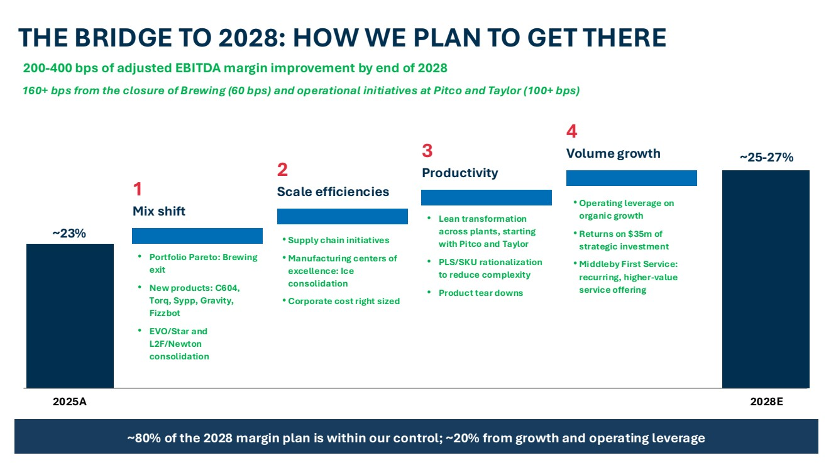 | 13 Styles Rounded Corners Y Shadows N Hierarchy of Highlights Gradients N Message Box Highlighted Boxes on the Page Highlight Table Rows / Maps Row Heading Cells in Tables Add doctop here Link to template Width: 33.867 cm Height: 19.05 cm Pages Setup Lines Headings on page Tables - Headings Tables - Rows Charts - Axes RGB 0,0,0 | Wgt: 1pt RGB 185,185,185 | Wgt: 0.5pt RGB 127,127,127 | Wgt: 0.75pt Charts - Lines Between Series: None N Lines Y (RGB and weight) Boxes Company Logos 0:47:80 0:110:182 226:45:63 228:222:212 139:178:221 191:191:191 205:219:224 161:188:196 129:179:224 244:242:238 217:217:217 229:229:229 255:255:255 0:0:0 23:60:93 Charts – Primary Colours Charts – Secondary Colours Background Text Colour Page Heading Colours 23:60:93 Subheading 200-400 bps of adjusted EBITDA margin improvement by end of 2028 THE BRIDGE TO 2028: HOW WE PLAN TO GET THERE ~80% of the 2028 margin plan is within our control; ~20% from growth and operating leverage ~23% 2025A ~25-27% 2028E 1 Mix shift • Portfolio Pareto: Brewing exit • New products: C604, Torq, Sypp, Gravity, Fizzbot • EVO/Star and L2F/Newton consolidation 2 Scale efficiencies • Supply chain initiatives • Manufacturing centers of excellence: Ice consolidation • Corporate cost right sized 3 Productivity • Lean transformation across plants, starting with Pitco and Taylor • PLS/SKU rationalization to reduce complexity • Product tear downs 4 Volume growth • Operating leverage on organic growth • Returns on $35m of strategic investment • Middleby First Service: recurring, higher-value service offering 160+ bps from the closure of Brewing (60 bps) and operational initiatives at Pitco and Taylor (100+ bps)
 | 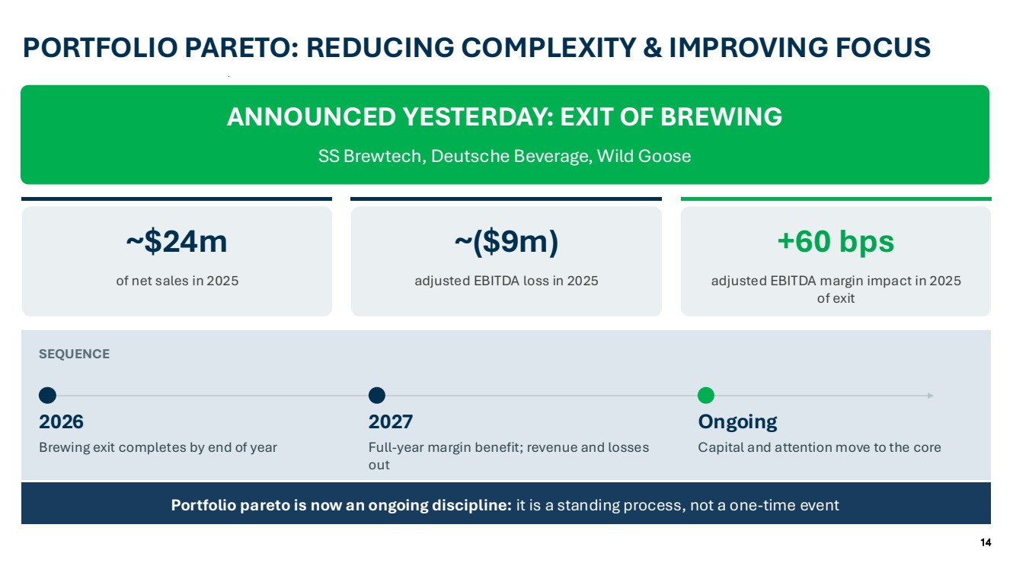 | 14 Styles Rounded Corners Y Shadows N Hierarchy of Highlights Gradients N Message Box Highlighted Boxes on the Page Highlight Table Rows / Maps Row Heading Cells in Tables Add doctop here Link to template Width: 33.867 cm Height: 19.05 cm Pages Setup Lines Headings on page Tables - Headings Tables - Rows Charts - Axes RGB 0,0,0 | Wgt: 1pt RGB 185,185,185 | Wgt: 0.5pt RGB 127,127,127 | Wgt: 0.75pt Charts - Lines Between Series: None N Lines Y (RGB and weight) Boxes Company Logos 0:47:80 0:110:182 226:45:63 228:222:212 139:178:221 191:191:191 205:219:224 161:188:196 129:179:224 244:242:238 217:217:217 229:229:229 255:255:255 0:0:0 23:60:93 Charts – Primary Colours Charts – Secondary Colours Background Text Colour Page Heading Colours 23:60:93 Subheading PORTFOLIO PARETO: REDUCING COMPLEXITY & IMPROVING FOCUS Portfolio pareto is now an ongoing discipline: it is a standing process, not a one-time event ANNOUNCED YESTERDAY: EXIT OF BREWING SS Brewtech, Deutsche Beverage, Wild Goose ~$24m of net sales in 2025 ~($9m) adjusted EBITDA loss in 2025 +60 bps adjusted EBITDA margin impact in 2025 of exit SEQUENCE 2026 Brewing exit completes by end of year 2027 Full-year margin benefit; revenue and losses out Ongoing Capital and attention move to the core
 | 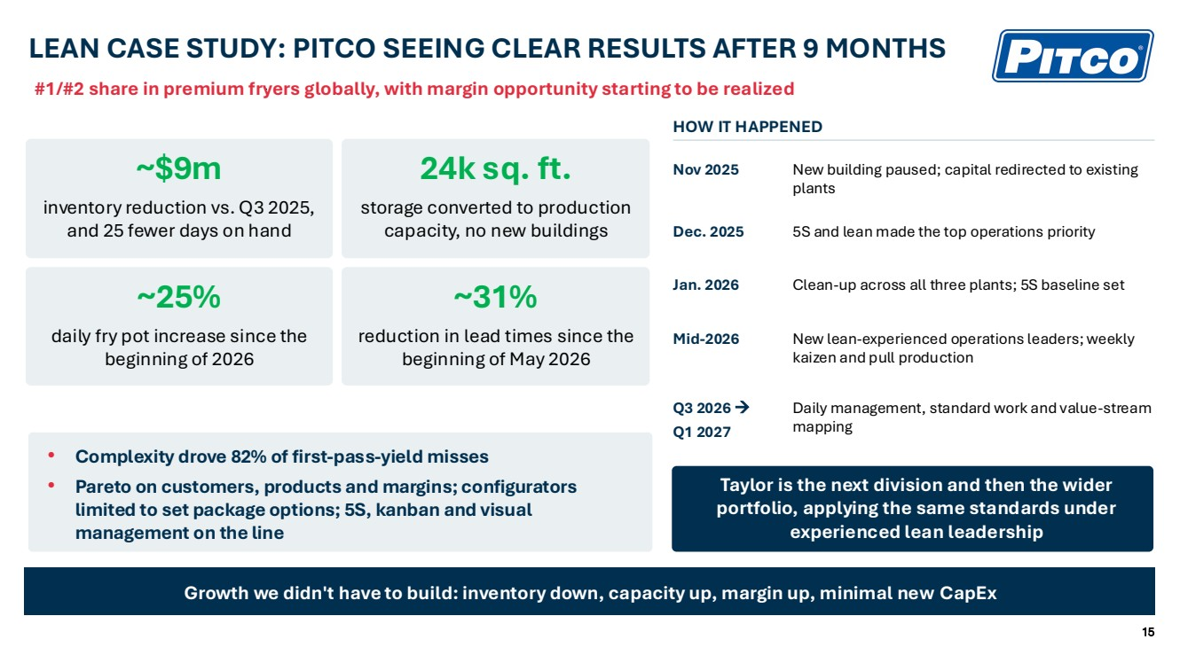 | 15 Styles Rounded Corners Y Shadows N Hierarchy of Highlights Gradients N Message Box Highlighted Boxes on the Page Highlight Table Rows / Maps Row Heading Cells in Tables Add doctop here Link to template Width: 33.867 cm Height: 19.05 cm Pages Setup Lines Headings on page Tables - Headings Tables - Rows Charts - Axes RGB 0,0,0 | Wgt: 1pt RGB 185,185,185 | Wgt: 0.5pt RGB 127,127,127 | Wgt: 0.75pt Charts - Lines Between Series: None N Lines Y (RGB and weight) Boxes Company Logos 0:47:80 0:110:182 226:45:63 228:222:212 139:178:221 191:191:191 205:219:224 161:188:196 129:179:224 244:242:238 217:217:217 229:229:229 255:255:255 0:0:0 23:60:93 Charts – Primary Colours Charts – Secondary Colours Background Text Colour Page Heading Colours 23:60:93 Subheading LEAN CASE STUDY: PITCO SEEING CLEAR RESULTS AFTER 9 MONTHS Growth we didn't have to build: inventory down, capacity up, margin up, minimal new CapEx #1/#2 share in premium fryers globally, with margin opportunity starting to be realized ~$9m inventory reduction vs. Q3 2025, and 25 fewer days on hand 24k sq. ft. storage converted to production capacity, no new buildings ~25% daily fry pot increase since the beginning of 2026 ~31% reduction in lead times since the beginning of May 2026 HOW IT HAPPENED Nov 2025 New building paused; capital redirected to existing plants Dec. 2025 5S and lean made the top operations priority Jan. 2026 Clean-up across all three plants; 5S baseline set Mid-2026 New lean-experienced operations leaders; weekly kaizen and pull production Q3 2026 → Q1 2027 Daily management, standard work and value-stream mapping Taylor is the next division and then the wider portfolio, applying the same standards under experienced lean leadership • Complexity drove 82% of first-pass-yield misses • Pareto on customers, products and margins; configurators limited to set package options; 5S, kanban and visual management on the line
 | 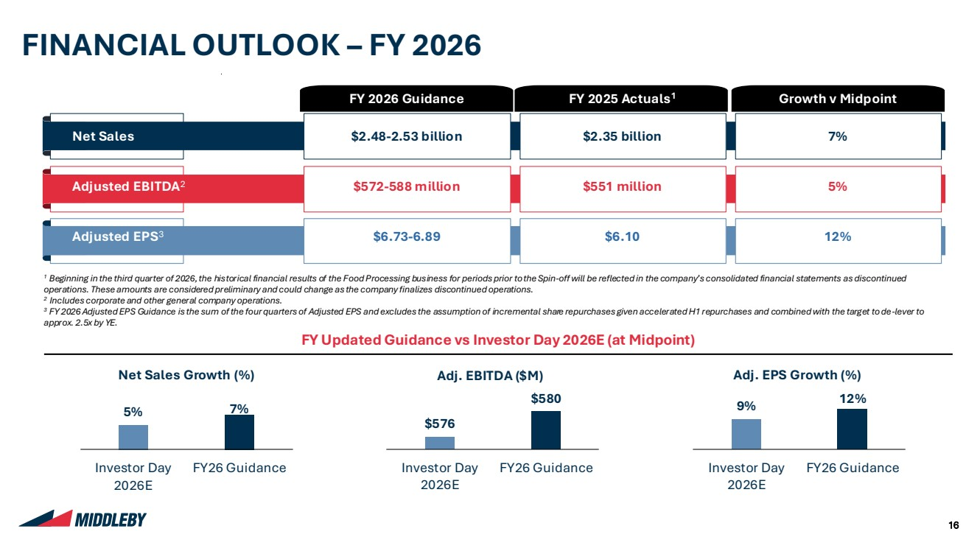 | 16 Styles Rounded Corners Y Shadows N Hierarchy of Highlights Gradients N Message Box Highlighted Boxes on the Page Highlight Table Rows / Maps Row Heading Cells in Tables Add doctop here Link to template Width: 33.867 cm Height: 19.05 cm Pages Setup Lines Headings on page Tables - Headings Tables - Rows Charts - Axes RGB 0,0,0 | Wgt: 1pt RGB 185,185,185 | Wgt: 0.5pt RGB 127,127,127 | Wgt: 0.75pt Charts - Lines Between Series: None N Lines Y (RGB and weight) Boxes Company Logos 0:47:80 0:110:182 226:45:63 228:222:212 139:178:221 191:191:191 205:219:224 161:188:196 129:179:224 244:242:238 217:217:217 229:229:229 255:255:255 0:0:0 23:60:93 Charts – Primary Colours Charts – Secondary Colours Background Text Colour Page Heading Colours 23:60:93 Subheading 1 Beginning in the third quarter of 2026, the historical financial results of the Food Processing business for periods prior tothe Spin-off will be reflected in the company’s consolidated financial statements as discontinued operations. These amounts are considered preliminary and could change as the company finalizes discontinued operations. 2 Includes corporate and other general company operations. 3 FY 2026 Adjusted EPS Guidance is the sum of the four quarters of Adjusted EPS and excludes the assumption of incremental share repurchases given accelerated H1 repurchases and combined with the target to de-lever to approx. 2.5x by YE. FINANCIAL OUTLOOK – FY 2026 FY 2026 Guidance FY 2025 Actuals1 Growth v Midpoint Net Sales $2.48-2.53 billion $2.35 billion 7% Adjusted EBITDA2 $572-588 million $551 million 5% Adjusted EPS3 $6.73-6.89 $6.10 12% FY Updated Guidance vs Investor Day 2026E (at Midpoint) 5% 7% Investor Day 2026E FY26 Guidance $576 $580 Investor Day 2026E FY26 Guidance 9% 12% Investor Day 2026E FY26 Guidance Net Sales Growth (%) Adj. EBITDA ($M) Adj. EPS Growth (%)
 | 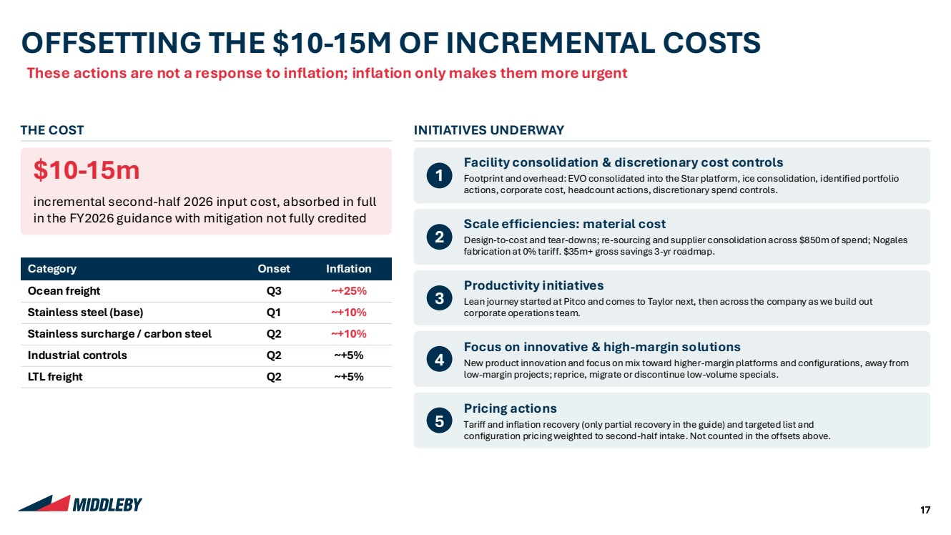 | 17 Styles Rounded Corners Y Shadows N Hierarchy of Highlights Gradients N Message Box Highlighted Boxes on the Page Highlight Table Rows / Maps Row Heading Cells in Tables Add doctop here Link to template Width: 33.867 cm Height: 19.05 cm Pages Setup Lines Headings on page Tables - Headings Tables - Rows Charts - Axes RGB 0,0,0 | Wgt: 1pt RGB 185,185,185 | Wgt: 0.5pt RGB 127,127,127 | Wgt: 0.75pt Charts - Lines Between Series: None N Lines Y (RGB and weight) Boxes Company Logos 0:47:80 0:110:182 226:45:63 228:222:212 139:178:221 191:191:191 205:219:224 161:188:196 129:179:224 244:242:238 217:217:217 229:229:229 255:255:255 0:0:0 23:60:93 Charts – Primary Colours Charts – Secondary Colours Background Text Colour Page Heading Colours 23:60:93 Subheading These actions are not a response to inflation; inflation only makes them more urgent OFFSETTING THE $10-15M OF INCREMENTAL COSTS THE COST $10-15m incremental second-half 2026 input cost, absorbed in full in the FY2026 guidance with mitigation not fully credited Category Onset Inflation Ocean freight Q3 ~+25% Stainless steel (base) Q1 ~+10% Stainless surcharge / carbon steel Q2 ~+10% Industrial controls Q2 ~+5% LTL freight Q2 ~+5% INITIATIVES UNDERWAY 1 Facility consolidation & discretionary cost controls Footprint and overhead: EVO consolidated into the Star platform, ice consolidation, identified portfolio actions, corporate cost, headcount actions, discretionary spend controls. 2 Scale efficiencies: material cost Design-to-cost and tear-downs; re-sourcing and supplier consolidation across $850m of spend; Nogales fabrication at 0% tariff. $35m+ gross savings 3-yr roadmap. 3 Productivity initiatives Lean journey started at Pitco and comes to Taylor next, then across the company as we build out corporate operations team. 4 Focus on innovative & high-margin solutions New product innovation and focus on mix toward higher-margin platforms and configurations, away from low-margin projects; reprice, migrate or discontinue low-volume specials. 5 Pricing actions Tariff and inflation recovery (only partial recovery in the guide) and targeted list and configuration pricing weighted to second-half intake. Not counted in the offsets above.
 | 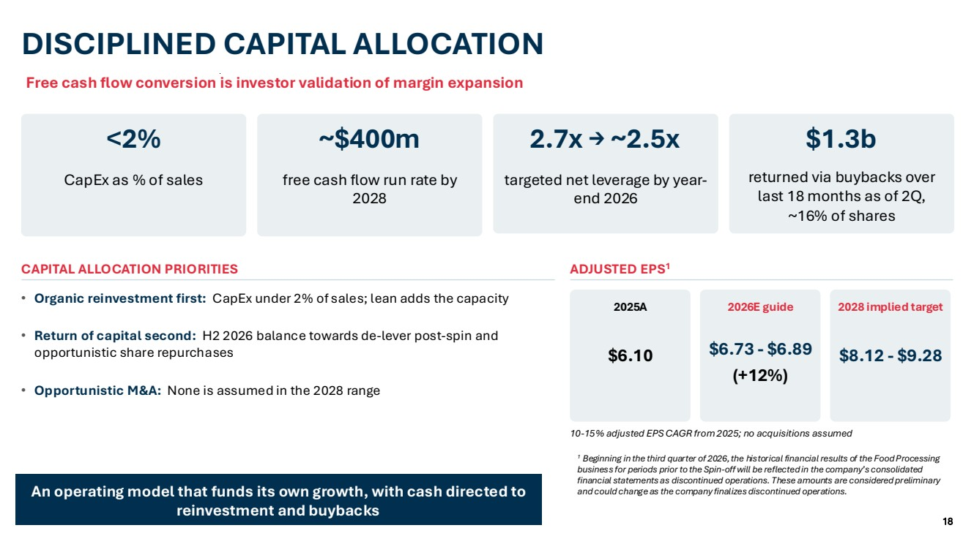 | 18 Styles Rounded Corners Y Shadows N Hierarchy of Highlights Gradients N Message Box Highlighted Boxes on the Page Highlight Table Rows / Maps Row Heading Cells in Tables Add doctop here Link to template Width: 33.867 cm Height: 19.05 cm Pages Setup Lines Headings on page Tables - Headings Tables - Rows Charts - Axes RGB 0,0,0 | Wgt: 1pt RGB 185,185,185 | Wgt: 0.5pt RGB 127,127,127 | Wgt: 0.75pt Charts - Lines Between Series: None N Lines Y (RGB and weight) Boxes Company Logos 0:47:80 0:110:182 226:45:63 228:222:212 139:178:221 191:191:191 205:219:224 161:188:196 129:179:224 244:242:238 217:217:217 229:229:229 255:255:255 0:0:0 23:60:93 Charts – Primary Colours Charts – Secondary Colours Background Text Colour Page Heading Colours 23:60:93 Subheading Free cash flow conversion is investor validation of margin expansion DISCIPLINED CAPITAL ALLOCATION <2% CapEx as % of sales ~$400m free cash flow run rate by 2028 2.7x → ~2.5x targeted net leverage by year-end 2026 $1.3b returned via buybacks over last 18 months as of 2Q, ~16% of shares CAPITAL ALLOCATION PRIORITIES • Organic reinvestment first: CapEx under 2% of sales; lean adds the capacity • Return of capital second: H2 2026 balance towards de-lever post-spin and opportunistic share repurchases • Opportunistic M&A: None is assumed in the 2028 range ADJUSTED EPS1 2025A $6.10 2026E guide $6.73 - $6.89 (+12%) 2028 implied target $8.12 - $9.28 10-15% adjusted EPS CAGR from 2025; no acquisitions assumed An operating model that funds its own growth, with cash directed to reinvestment and buybacks 1 Beginning in the third quarter of 2026, the historical financial results of the Food Processing business for periods prior to the Spin-off will be reflected in the company’s consolidated financial statements as discontinued operations. These amounts are considered preliminary and could change as the company finalizes discontinued operations.
 | 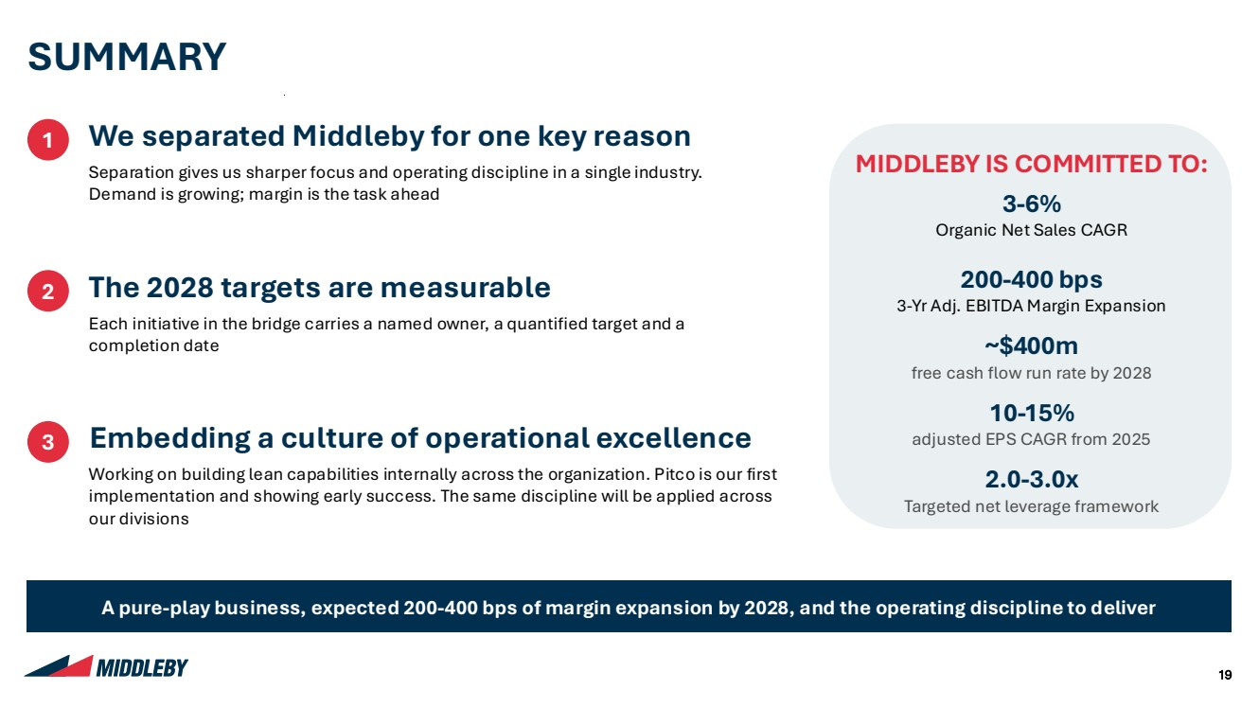 | 19 Styles Rounded Corners Y Shadows N Hierarchy of Highlights Gradients N Message Box Highlighted Boxes on the Page Highlight Table Rows / Maps Row Heading Cells in Tables Add doctop here Link to template Width: 33.867 cm Height: 19.05 cm Pages Setup Lines Headings on page Tables - Headings Tables - Rows Charts - Axes RGB 0,0,0 | Wgt: 1pt RGB 185,185,185 | Wgt: 0.5pt RGB 127,127,127 | Wgt: 0.75pt Charts - Lines Between Series: None N Lines Y (RGB and weight) Boxes Company Logos 0:47:80 0:110:182 226:45:63 228:222:212 139:178:221 191:191:191 205:219:224 161:188:196 129:179:224 244:242:238 217:217:217 229:229:229 255:255:255 0:0:0 23:60:93 Charts – Primary Colours Charts – Secondary Colours Background Text Colour Page Heading Colours 23:60:93 Subheading SUMMARY 1 We separated Middleby for one key reason Separation gives us sharper focus and operating discipline in a single industry. Demand is growing; margin is the task ahead 2 The 2028 targets are measurable Each initiative in the bridge carries a named owner, a quantified target and a completion date 3 Embedding a culture of operational excellence Working on building lean capabilities internally across the organization. Pitco is our first implementation and showing early success. The same discipline will be applied across our divisions A pure-play business, expected 200-400 bps of margin expansion by 2028, and the operating discipline to deliver MIDDLEBY IS COMMITTED TO: 3-6% Organic Net Sales CAGR 200-400 bps 3-Yr Adj. EBITDA Margin Expansion ~$400m free cash flow run rate by 2028 10-15% adjusted EPS CAGR from 2025 2.0-3.0x Targeted net leverage framework
 |  | 20 Styles Rounded Corners Y Shadows N Hierarchy of Highlights Gradients N Message Box Highlighted Boxes on the Page Highlight Table Rows / Maps Row Heading Cells in Tables Add doctop here Link to template Width: 33.867 cm Height: 19.05 cm Pages Setup Lines Headings on page Tables - Headings Tables - Rows Charts - Axes RGB 0,0,0 | Wgt: 1pt RGB 185,185,185 | Wgt: 0.5pt RGB 127,127,127 | Wgt: 0.75pt Charts - Lines Between Series: None N Lines Y (RGB and weight) Boxes Company Logos 0:47:80 0:110:182 226:45:63 228:222:212 139:178:221 191:191:191 205:219:224 161:188:196 129:179:224 244:242:238 217:217:217 229:229:229 255:255:255 0:0:0 23:60:93 Charts – Primary Colours Charts – Secondary Colours Background Text Colour Page Heading Colours 23:60:93 Subheading QUESTIONS & DISCUSSION

 | 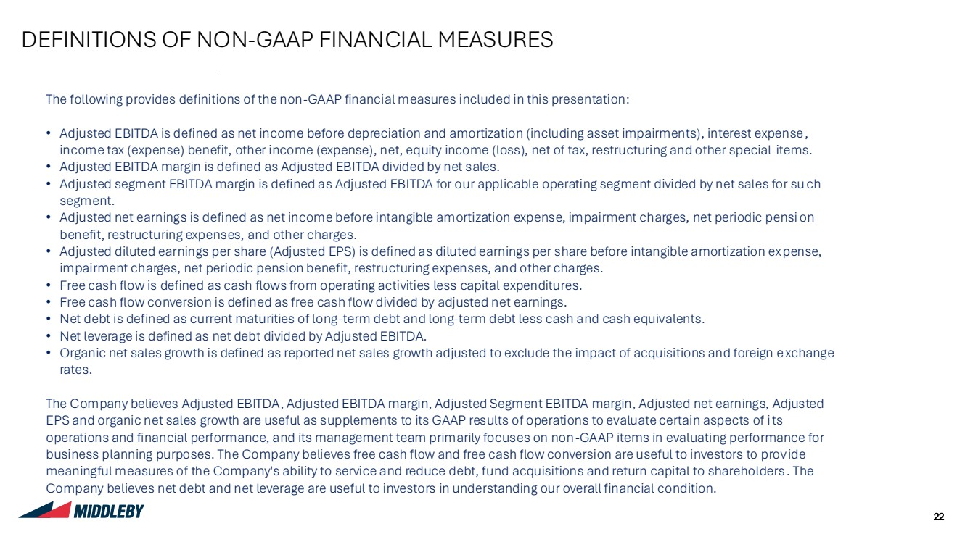 | 22 Styles Rounded Corners Y Shadows N Hierarchy of Highlights Gradients N Message Box Highlighted Boxes on the Page Highlight Table Rows / Maps Row Heading Cells in Tables Add doctop here Link to template Width: 33.867 cm Height: 19.05 cm Pages Setup Lines Headings on page Tables - Headings Tables - Rows Charts - Axes RGB 0,0,0 | Wgt: 1pt RGB 185,185,185 | Wgt: 0.5pt RGB 127,127,127 | Wgt: 0.75pt Charts - Lines Between Series: None N Lines Y (RGB and weight) Boxes Company Logos 0:47:80 0:110:182 226:45:63 228:222:212 139:178:221 191:191:191 205:219:224 161:188:196 129:179:224 244:242:238 217:217:217 229:229:229 255:255:255 0:0:0 23:60:93 Charts – Primary Colours Charts – Secondary Colours Background Text Colour Page Heading Colours 23:60:93 Subheading DEFINITIONS OF NON-GAAP FINANCIAL MEASURES The following provides definitions of the non-GAAP financial measures included in this presentation: • Adjusted EBITDA is defined as net income before depreciation and amortization (including asset impairments), interest expense, income tax (expense) benefit, other income (expense), net, equity income (loss), net of tax, restructuring and other special items. • Adjusted EBITDA margin is defined as Adjusted EBITDA divided by net sales. • Adjusted segment EBITDA margin is defined as Adjusted EBITDA for our applicable operating segment divided by net sales for such segment. • Adjusted net earnings is defined as net income before intangible amortization expense, impairment charges, net periodic pensi on benefit, restructuring expenses, and other charges. • Adjusted diluted earnings per share (Adjusted EPS) is defined as diluted earnings per share before intangible amortization expense, impairment charges, net periodic pension benefit, restructuring expenses, and other charges. • Free cash flow is defined as cash flows from operating activities less capital expenditures. • Free cash flow conversion is defined as free cash flow divided by adjusted net earnings. • Net debt is defined as current maturities of long-term debt and long-term debt less cash and cash equivalents. • Net leverage is defined as net debt divided by Adjusted EBITDA. • Organic net sales growth is defined as reported net sales growth adjusted to exclude the impact of acquisitions and foreign exchange rates. The Company believes Adjusted EBITDA, Adjusted EBITDA margin, Adjusted Segment EBITDA margin, Adjusted net earnings, Adjusted EPS and organic net sales growth are useful as supplements to its GAAP results of operations to evaluate certain aspects of its operations and financial performance, and its management team primarily focuses on non-GAAP items in evaluating performance for business planning purposes. The Company believes free cash flow and free cash flow conversion are useful to investors to prov ide meaningful measures of the Company's ability to service and reduce debt, fund acquisitions and return capital to shareholders . The Company believes net debt and net leverage are useful to investors in understanding our overall financial condition.
 | 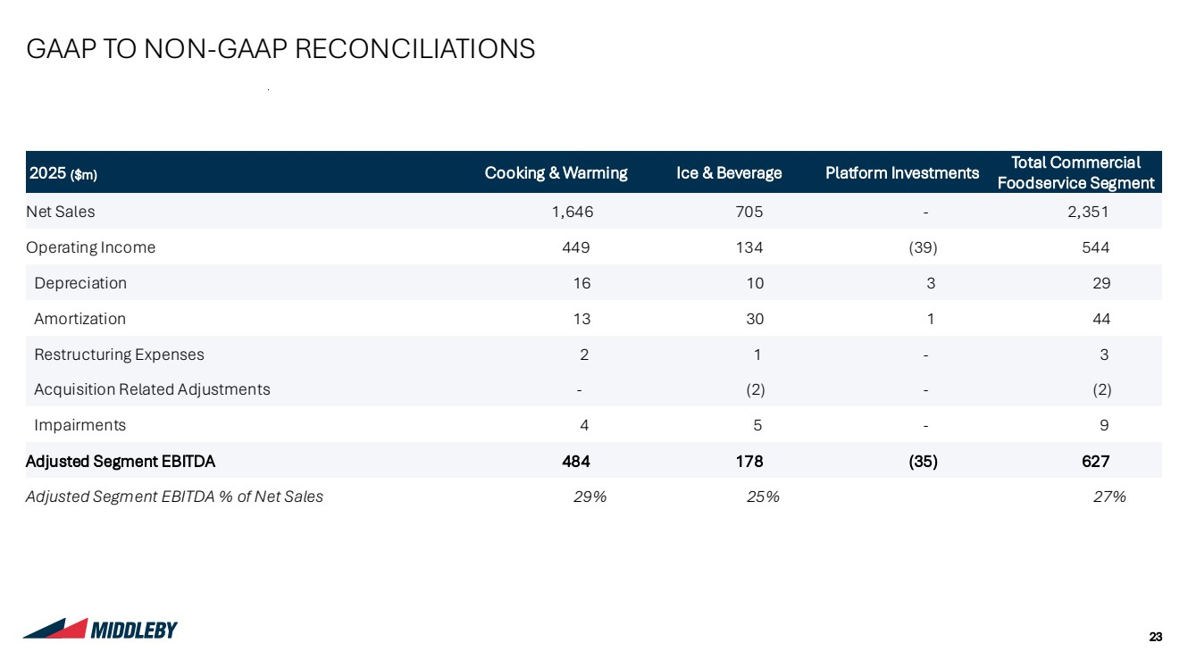 | 23 Styles Rounded Corners Y Shadows N Hierarchy of Highlights Gradients N Message Box Highlighted Boxes on the Page Highlight Table Rows / Maps Row Heading Cells in Tables Add doctop here Link to template Width: 33.867 cm Height: 19.05 cm Pages Setup Lines Headings on page Tables - Headings Tables - Rows Charts - Axes RGB 0,0,0 | Wgt: 1pt RGB 185,185,185 | Wgt: 0.5pt RGB 127,127,127 | Wgt: 0.75pt Charts - Lines Between Series: None N Lines Y (RGB and weight) Boxes Company Logos 0:47:80 0:110:182 226:45:63 228:222:212 139:178:221 191:191:191 205:219:224 161:188:196 129:179:224 244:242:238 217:217:217 229:229:229 255:255:255 0:0:0 23:60:93 Charts – Primary Colours Charts – Secondary Colours Background Text Colour Page Heading Colours 23:60:93 Subheading 2025 ($m) Cooking & Warming Ice & Beverage Platform Investments Total Commercial Foodservice Segment Net Sales 1,646 705 - 2,351 Operating Income 449 134 (39) 544 Depreciation 16 10 3 29 Amortization 13 30 1 44 Restructuring Expenses 2 1 - 3 Acquisition Related Adjustments - (2) - (2) Impairments 4 5 - 9 Adjusted Segment EBITDA 484 178 (35) 627 Adjusted Segment EBITDA % of Net Sales 29% 25% 27% GAAP TO NON-GAAP RECONCILIATIONS
 | 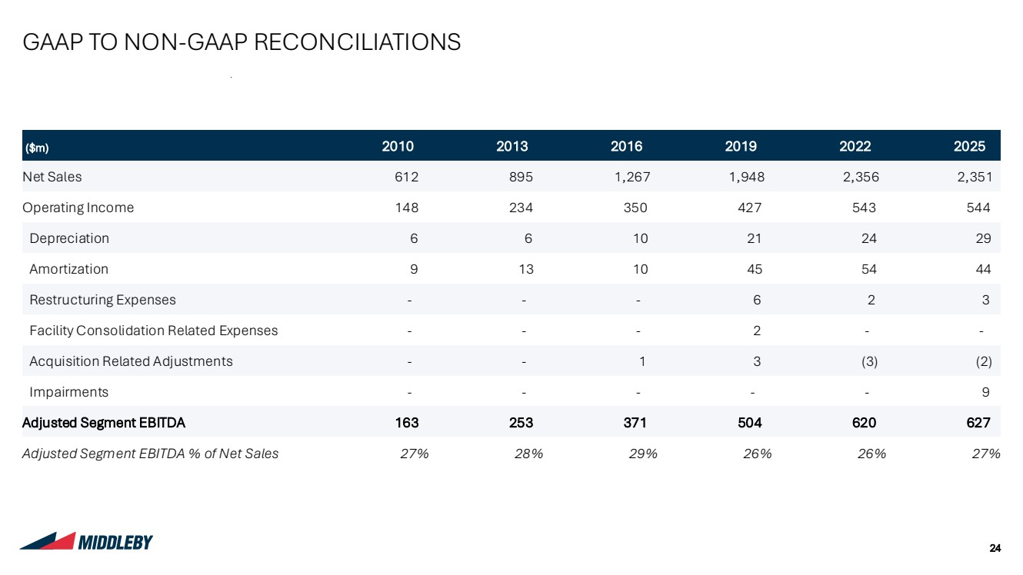 | 24 Styles Rounded Corners Y Shadows N Hierarchy of Highlights Gradients N Message Box Highlighted Boxes on the Page Highlight Table Rows / Maps Row Heading Cells in Tables Add doctop here Link to template Width: 33.867 cm Height: 19.05 cm Pages Setup Lines Headings on page Tables - Headings Tables - Rows Charts - Axes RGB 0,0,0 | Wgt: 1pt RGB 185,185,185 | Wgt: 0.5pt RGB 127,127,127 | Wgt: 0.75pt Charts - Lines Between Series: None N Lines Y (RGB and weight) Boxes Company Logos 0:47:80 0:110:182 226:45:63 228:222:212 139:178:221 191:191:191 205:219:224 161:188:196 129:179:224 244:242:238 217:217:217 229:229:229 255:255:255 0:0:0 23:60:93 Charts – Primary Colours Charts – Secondary Colours Background Text Colour Page Heading Colours 23:60:93 Subheading GAAP TO NON-GAAP RECONCILIATIONS ($m) 2010 2013 2016 2019 2022 2025 Net Sales 612 895 1,267 1,948 2,356 2,351 Operating Income 148 234 350 427 543 544 Depreciation 6 6 10 21 24 29 Amortization 9 13 10 45 54 44 Restructuring Expenses - - - 6 2 3 Facility Consolidation Related Expenses - - - 2 - - Acquisition Related Adjustments - - 1 3 (3) (2) Impairments - - - - - 9 Adjusted Segment EBITDA 163 253 371 504 620 627 Adjusted Segment EBITDA % of Net Sales 27% 28% 29% 26% 26% 27%
 | 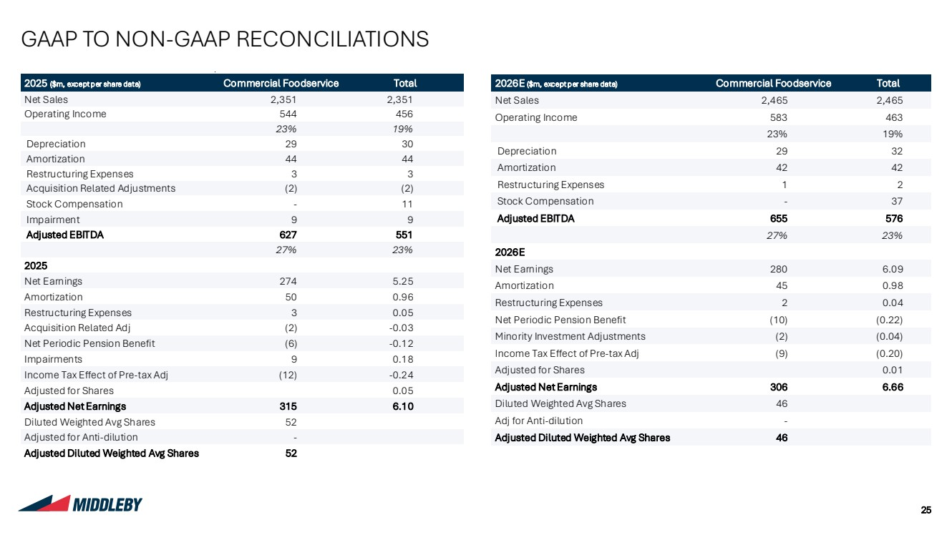 | 25 Styles Rounded Corners Y Shadows N Hierarchy of Highlights Gradients N Message Box Highlighted Boxes on the Page Highlight Table Rows / Maps Row Heading Cells in Tables Add doctop here Link to template Width: 33.867 cm Height: 19.05 cm Pages Setup Lines Headings on page Tables - Headings Tables - Rows Charts - Axes RGB 0,0,0 | Wgt: 1pt RGB 185,185,185 | Wgt: 0.5pt RGB 127,127,127 | Wgt: 0.75pt Charts - Lines Between Series: None N Lines Y (RGB and weight) Boxes Company Logos 0:47:80 0:110:182 226:45:63 228:222:212 139:178:221 191:191:191 205:219:224 161:188:196 129:179:224 244:242:238 217:217:217 229:229:229 255:255:255 0:0:0 23:60:93 Charts – Primary Colours Charts – Secondary Colours Background Text Colour Page Heading Colours 23:60:93 Subheading GAAP TO NON-GAAP RECONCILIATIONS 2025 ($m, except per share data) Commercial Foodservice Total Net Sales 2,351 2,351 Operating Income 544 456 23% 19% Depreciation 29 30 Amortization 44 44 Restructuring Expenses 3 3 Acquisition Related Adjustments (2) (2) Stock Compensation - 11 Impairment 9 9 Adjusted EBITDA 627 551 27% 23% 2025 Net Earnings 274 5.25 Amortization 50 0.96 Restructuring Expenses 3 0.05 Acquisition Related Adj (2) -0.03 Net Periodic Pension Benefit (6) -0.12 Impairments 9 0.18 Income Tax Effect of Pre-tax Adj (12) -0.24 Adjusted for Shares 0.05 Adjusted Net Earnings 315 6.10 Diluted Weighted Avg Shares 52 Adjusted for Anti-dilution - Adjusted Diluted Weighted Avg Shares 52 2026E ($m, except per share data) Commercial Foodservice Total Net Sales 2,465 2,465 Operating Income 583 463 23% 19% Depreciation 29 32 Amortization 42 42 Restructuring Expenses 1 2 Stock Compensation - 37 Adjusted EBITDA 655 576 27% 23% 2026E Net Earnings 280 6.09 Amortization 45 0.98 Restructuring Expenses 2 0.04 Net Periodic Pension Benefit (10) (0.22) Minority Investment Adjustments (2) (0.04) Income Tax Effect of Pre-tax Adj (9) (0.20) Adjusted for Shares 0.01 Adjusted Net Earnings 306 6.66 Diluted Weighted Avg Shares 46 Adj for Anti-dilution - Adjusted Diluted Weighted Avg Shares 46

